HCSS Accounting

User Manual

Invoices and Purchase Credit Notes
(when not using GRN)

Contents
1 Introduction 3
2 Invoices 3
a Create an Invoice from a Purchase Order 3
b Non-Order Invoice (Invoice without an Order) 6
c Browse and View an Invoice 8
d Export Invoices to Excel 9
e Approve or Reject Invoice 10
f Duplicate an Invoice 10
g Create a Purchase Credit Note 12
h View a Purchase Credit Note 13
i Using a Purchase Credit Note 14
3 Adding Supplier during the Transaction – Quick Add 16

Introduction

The process of recording Invoices is slightly different for schools depending on whether they use the Goods Receipting functionality or not. This guide covers functionality for schools not using Goods Receipting.

Invoices are normally matched to the corresponding purchase order(s), however if a purchase order has not been raised or is not required then they can be entered on their own as a non-order Invoice.

Non-order Invoices can be coded direct to balance sheet codes, and previous non-order invoices can be duplicated.

Purchase Credit Notes can be matched against specific Invoices, used to offset against Invoices being paid on BACs or Printed Cheque runs or converted into refunds. Alternatively, purchase credit notes can be matched to invoices in Payments>Cash Matching.

The Aged Creditor Report can be used to monitor Unpaid Purchase Invoices, and the Codes – Suppliers menu can be used to view a breakdown of paid, unpaid and reversed invoices against a given Supplier. Please refer to the relevant sections of the User Guide for more details.

Invoices

If the Purchase Invoice relates to a Purchase Order/GRN then it will need to be linked to the GRN. If a Purchase Order has not been raised then then Invoice can be entered as a Non-Order Invoice.

Create an Invoice from a Purchase Order

In the Transactions menu, select Invoices, click on the and select Invoice From PO

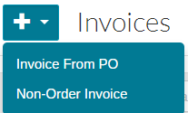

The invoice screen will now be displayed.

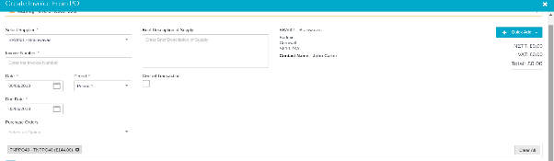

All fields with * are mandatory and must be completed

Supplier* | Select the supplier from the drop down list, only those suppliers with an unmatched Purchase Order will be selectable. You can search for a supplier by typing in the blank box after clicking on the drop down arrow.
Brief Description of Supply | This description is optional, but will be displayed on the main invoice screen against the invoice and on the VAT126 report.
Invoice Number* | Enter the invoice number/ref from the invoice.
Invoice Date* | Enter the invoice date from the invoice. The invoice date is used to populate the payment due date based on the terms of payment from the Supplier record.
Period* | Enter the period to be posted to.
Due Date* | Pre-populated based on the invoice date, but can be amended.
Central Transaction | This tick box will only appear when MAT functionality has been enabled. It should be ticked for invoices that are to be paid from the central Trust bank account.
Purchase Orders* | From the pick list showing all outstanding Purchase Orders for the selected supplier, select those that are on the invoice. Multiple PO’s can be selected.

All the data from the Purchase Order(s) will now be displayed. Additional lines can be added if required e.g. P&P not included on original order. To add additional line items, click on Any blank lines must be deleted before submitting, by clicking on the icon.

On each PO line you will need to record the quantity of goods received (and reflected on the invoice) in the Quanity Received field, if all goods have been received you can use the

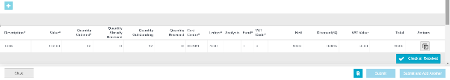

The description, value and coding fields can all be amended at this stage if required. It is important to check the calculated VAT and total invoice value agrees to the invoice. If you have updated value fields, then click in a blank area on the screen to update the calculated totals.

To upload an attachment click on at the bottom of the screen. Up to 5 attachments or 3mb can be added.

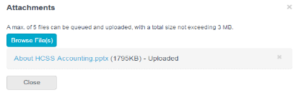

Click on Browse Files find file. This will load file and be attached. To Delete click next to file. Click close to close screen and go back to Purchase requisition.

Click on Submit or Submit and Add Another (keeps you on the same screen to add another invoice).

This will create the Invoice and depending on the inputting user’s profile the status will be ‘Awaiting Approval’ or ‘Ready to Pay’.

Non-Order Invoice (Invoice without an Order)

Use this option where you are entering a Purchase Invoice that does not link to a Purchase Order. In the Transactions menu, select Invoices, click on the and select Non-Order Invoice.

To create the Invoice click on Non-Order Invoice

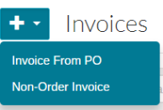

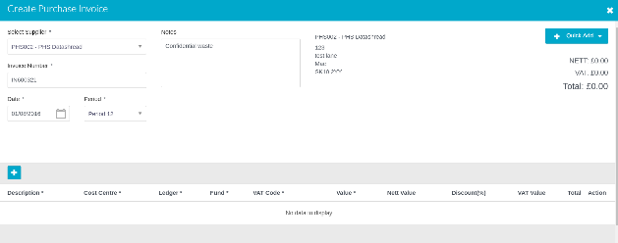

All fields marked with * are mandatory.

Supplier* | Pick the Supplier from the pick list. The Quick Add button can be used to add a supplier (subject to user access profile), this allows basic details to be set up, further detail can then be added later (Codes – Suppliers). For more details on this function see the end of this guide.
Brief Description of Supply | This description is optional, but will be displayed on the main invoice screen against the invoice and on the VAT126 report.
Invoice Number* | Enter the invoice number from the invoice reference.
Invoice Date* | Enter the invoice date from the invoice. The invoice date is used to populate the payment due date using the terms of payment from the Supplier record.
Period* | Enter the period to be posted to.
Due Date* | Pre-populated based on the invoice date, but can be amended.
Central Transaction | This tick box will only appear where MAT functionality has been enabled. It should be ticked for invoices that are to be paid from the central Trust bank account.

When all mandatory fields have been completed you can add the invoice lines.

To add a line click on you can add mutiple lines if required.

Any blank lines must be deleted before submitting, by clicking on the icon.

Description* | Enter the description of goods / services ordered.
Cost Centre* | The cost centre(s) the Invoice lines are to be coded to. Users will be restricted to the cost centres they have access to. The invoice can be coded to a balance sheet code then select ‘N/A – None’. You can search within the drop down.
Ledger* | The ledger code(s) the Invoice lines should be coded against (only ledger codes mapped to the selected cost centre will appear). You can search within the drop down.
Analysis | If required an analysis code can be selected.
Fund* | The fund code the Purchase Invoice line(s) should be coded to
VAT Code* | The VAT code that each Invoice Line should be posted against
Value* | Enter the Net value of the items and goods.
Discount % | Put the % value of any discounts that are applicable.
Net Value, VAT Value, Total | These fields are all system generated, to get them to populate or update click in any blank area of the screen.
To add attachments click on at the bottom of the screen. 5 attachments can be added or 3mb. Attachments can also be added later if required.

It is important to check the calculated VAT and total invoice value agrees to the invoice. If you have updated value fields, then click in a blank area of the screen to update the caluclated totals.

Click on Submit or Submit and Add Another (keeps you same screen to add another invoice).

This will create the Invoice and subject to User Profile the status will be ‘Awaiting Approval’ or ‘Ready to Pay’. Whilst the invoice is ‘Awaiting Approval’ it can be amended, by clicking on the invoice number on the main invoice screen.

Browse and View an Invoice

The main Invoice screen will show all Invoices for the current financial year. Those orders created from a Purchase Order/GRN will show the relevant PO number(s).

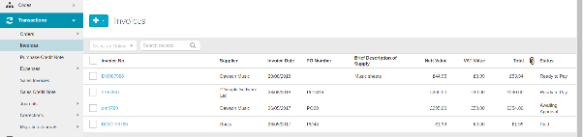

Status | Description
Awaiting Approval | Invoice needs to be approved by a user with approver rights
Ready to Pay | Invoice is awaiting payment
Paid | Invoice has been paid

A search can be completed in the search box and all columns can be sorted by ascending or descending order.

You can view an invoice by Clicking on the invoice number by the side of the invoice, this also enables you to add attachments, and if the invoice hasn’t been approved amendments can be made.

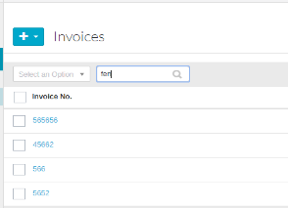

The view invoice screen is not be editable.

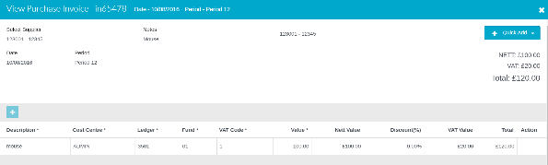

To view attachments click on to the right of the Invoice on the front screen.

Export Invoices to Excel

To export all invoices to excel for more information and analysis

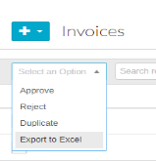

Approve or Reject Invoice

The authoriser can view an Invoice by clicking on the ref alongside the invoice. Having done this if they click ‘confirm’ the Invoice will become authorised, to exit the Invoice without authorising, click on the in the top right of the screen. The invoice can be amended prior to authorisation.

To approve from the main Invoice screen, select the Invoice(s) using the check box alongside them followed by Actions pick list

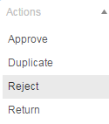

Click on Reject or Approve

A message to confirm this action will appear.

Duplicate an Invoice

Non-Order Invoices can be duplicated. To duplicate an Invoice put a tick to the left of the Invoice and select Duplicate from the actions box.

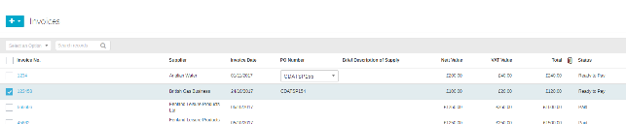

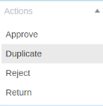

This will create a copy of the orignal Invoice

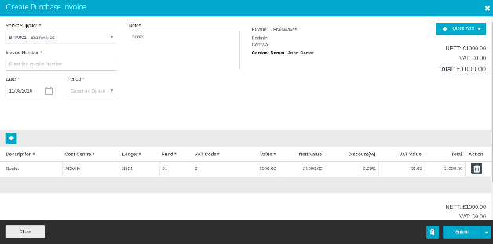

Details can be changed and attachments added.

Once completed click on Submit.

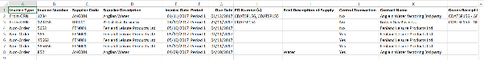

Create a Purchase Credit Note

Where a purchase credit note has been received, also use this screen if a refund has been given rather than a credit note. A refund is enterred in the system by converting the Credit Note in Transactions – Correction – Refunds.

Credit notes can be offset against future invoices when processing Payments - BACs or Payments - Printed Cheque Runs. Alternatively if they match exactly to an invoice(s) the Payments - Cash Matching screen can be used.
Credit Notes are usally coded to same codes as the invoice to which they relate, so you may want to have these to hand, prior to enterring the credit note.

Click on to add a new Purchase Credit Note.

Supplier* | Select the Supplier using the Pick list, you can search within the drop down list.
Credit Note Number* | Enter the Credit Note Reference that appears on the credit note
Description | Enter a description for the reason and any other text applicable for the credit note. Whilst this is optional, it will show on the main credit note screen alongside the credit note.
Date* | Enter the Credit Note date from the original. This will be used to calculate and populate the Due Date field based on the payment terms set up against the Supplier.
Period | Enter the period to be posted into.

Click the to add the lines for the Purchase Credit Note

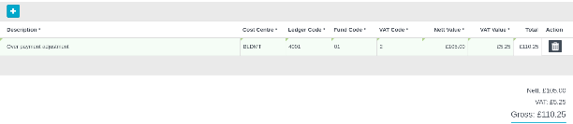

Description* | Enter a description for each line
Cost Centre* | Enter the code from the pick list
Ledger* | Enter the code from the pick list only the ledger codes mapped to the Cost Centre selected will appear.
Fund* | Enter the code from the pick list
VAT* | Enter the code from the pick list
NET value* | Enter the Net value and the VAT will be calculated in the next field.

To include attachments click on at the bottom of the screen. 5 attachments can be added or 3mb.

To save the document click on Submit or Submit and Add Another

This will create the Purchase Credit Note and subject to inputting User Profile the status will be ‘Awaiting Approval’ or ‘Ready to Pay’. Whilst the Purchase Credit Note is ‘Awaiting Approval’ it can be amended, by clicking on the credit note number on the main invoice screen.

View a Purchase Credit Note

The main Purchase Credit Note screen will show all Credit Notes for the current financial year, and unused Credit Notes from the previous year.

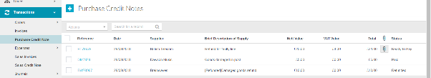

Status | Description
Awaiting Approval | needs to be approved by a user with approver rights
Ready to Pay | not yet used against an invoice or as a refund
Paid | has been matched/paid against an invoice
Refunded | value has been refunded (see Transactions - Corrections – Refunds)

A search can be completed in the search box and all columns can be sorted by ascending or descending order by clicking on the column heading.

You can view a Credit Note by Clicking on the Credit Note number by the side of the Credit Note in the Reference column, this also enables you to add attachments, and if the Credit Note hasn’t been approved amendments can be made.

To view attachments click on to the right of the Purchase Credit Note.

Using a Purchase Credit Note

There are 3 ways in which a Purchase Credit Note can be used:

- Offset against invoices to the same supplier on a BACS or Printed Cheque run
- Matched to invoice(s) where the value matches that of the credit note
- Converted to a refund into the bank account

- Offset against Invoices on BACS/Printed Cheque Run
Purchase Credit Notes will appear when selectng invoices for payment by BACS or Printed Cheque run (see guidance notes for these functions). The Credit note can be selected on these payment runs as long as Invoices to the same supplier that are of greater value than the credit note are selected as well. The Credit note will then be deducted from the amount paid to the supplier.

- Matched to Invoices

If the credit note matches exactly to an invoice(s) then the Payments – Cash Matching screen. (Central bank MAT’s also need to tick ‘show central payments and invoices)
Select the supplier from the dropdown box, (you can search by typing in the blank cell) and then click Filter

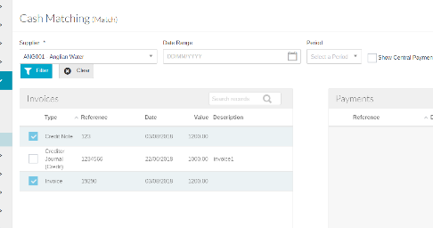
This will pull through a list of unmatched Invoices and Payments for that supplier. Credit notes will appear on the same side as the invoices. Put a tick against the Credit Note and the Invoice(s) that it is to be matched to, and then select Match.

- Convert to a refund

Where a Credit Note is being provided as a refund or a straight refund is given (for a reason other than where goods are returned) you first need to enter a purchase Credit Note as per the guidance above.

Having done this select Transactions – Corrections – Supplier Refunds

Select the supplier from the dropdown box, (you can search by typing in the blank cell) and then click Filter

This will pull through all unmatched/used Credit Notes for that supplier. To convert to a refund click on the icon in the Clear column. This will pull through a copy of the Credit Note

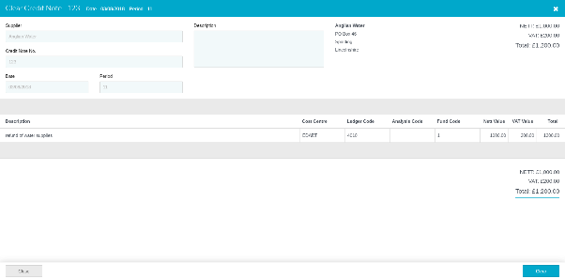

Now click Clear and then Confirm, this will now post the amount of the Credit Note to your main bank account.

Adding Supplier during the Transaction – Quick Add

This feature enables user to add supplier while entering a transaction, without the need to exit and visit the main Add New Supplier screen.

This option is only available to users who have the permission to create new Suppliers, and you could only populate a small number of fields using this function. Other details can be added later.

Suppliers can be quick added on the following screens:
- Create Purchase Requisition
- Create Purchase Order
- Non order Purchase Invoice
- Create Purchase credit note
- Petty Cash Expenses
- Credit Card Expenses
- Direct Debit Expenses

Click on in the header section of the screen and select New Supplier.

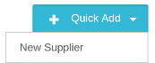
The following screen will appear.

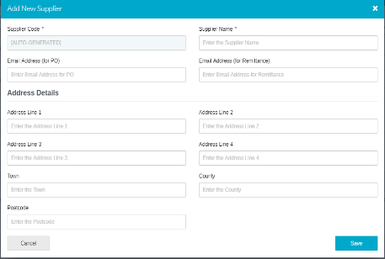

Required Fields

Supplier Code* | Auto-generated through a setting in Defaults, unless not set up in which case manually entered
Supplier Name* | Supplier Name
*mandatory fields

Once all fields are entered click on Save.

The Supplier will then appear in then drop down supplier list.

