HCSS Accounting

User Manual

Sales Invoice and Credit Notes

Contents
1 Introduction 3
2 Sales Invoices 4
a Create a Sales Invoice 4
b Approve a Sales Invoice 6
c Print a Sales Invoice 6
d Browse and View a Sales Invoice 6
e Duplicate a Sales Invoice 7
3 Sales Credit Note 9
a Create a Sales Credit Note linked to a Sales Invoice 9
b Create a Sales Credit Note (not linked to an invoice) 11
c Approve a Credit Note 12
d Print a Sales Credit Note 13
e Browse and View a Sales Credit Note 13

Introduction

Sales Invoices and Sales Credit Notes are created in a PDF format. A logo, authorised signature and custom text can be added to the templates.

Sales Credit Notes can be created to replicate a specific Sales Invoice(s) detail or can be used to match to Sales Invoice along with a balancing payment from the customer.

It is important that all income received that relates to a Sales Invoice is matched to the Sales Invoice(s) using the Receipts menu. Income is reflected at the point the Sales Invoice is posted along with a Debtor which is cleared when the receipt (or Credit Note) is matched to the Sales Invoice. The Aged Debtor Report can be used for monitoring unpaid Invoices, and a Customer Statement can also be generated from the Codes – Customers menu. Please refer to the relevant sections of the User Guide for more details.

Both transactions can be set up so that they require Authorisation from a second user before they are posted, this can be found in User and Access Profiles in the System Setup Menu.

You can also create a Sales Invoice by duplicating an earlier Sales Invoice.

Please ensure you also refer to the Receipts section of the User Guide, as this will be needed to match Receipts and Credit Notes to Sales Invoices, if they have not been matched at time of entry

The Sales Invoice and Sales Credit Note are found under Transactions > Sales Invoice or Sales Credit Note

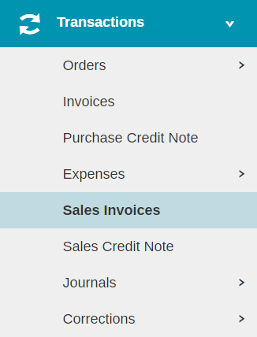

Sales Invoices

Create a Sales Invoice
To create Sales Invoice click on Sales Invoices

The following screen will appear, all mandatory fields are marked with a *:

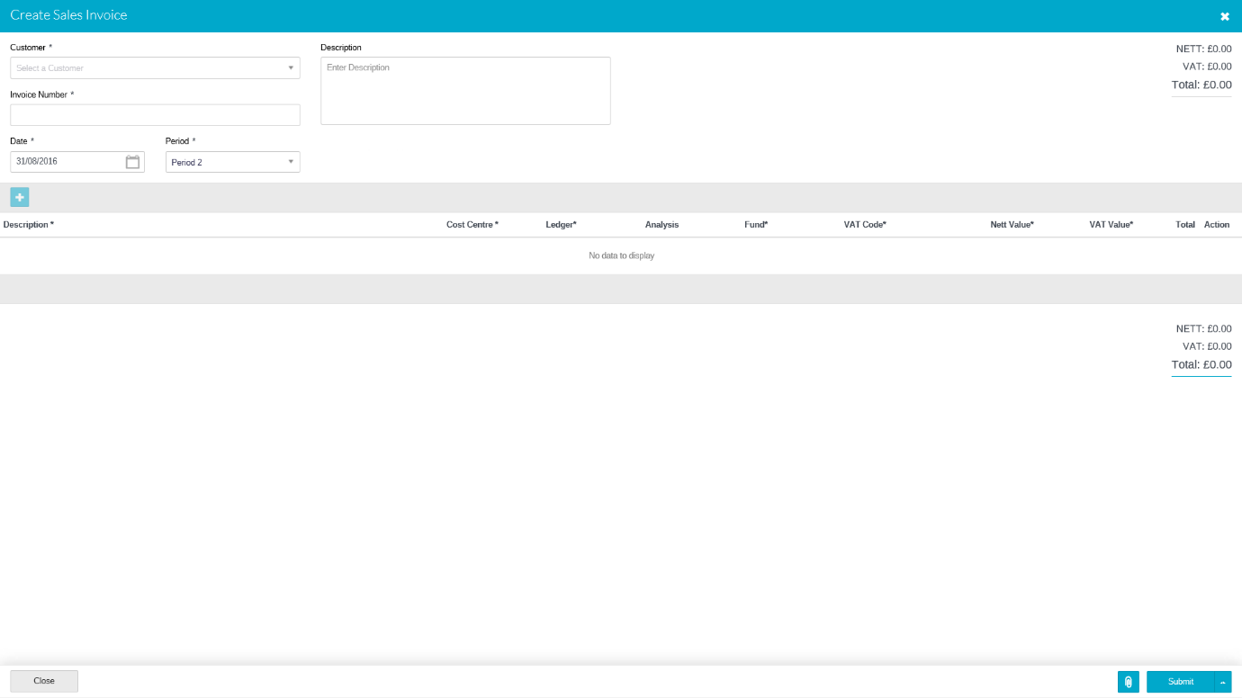

Customer* | Select the customer from the list
Invoice Number* | Automatically generated by the system (if set up in defaults), if not a manual invoice number can be entered.
Date* | Defaults to today’s date it can be overwritten with the invoice date.
Period* | Enter the period to be posted to.
Description | Enter a description for the whole invoice, this will appear on the main Sales invoice screen alongside the Sales Invoice, it does not appear on the Sales Invoice. If it is a one line Sales Invoice you may want to use Copy to Paste to put the same description in the line description(see below)

To add a line for items click on

Description* | Enter the description of goods / services provided, including any relevant calculation eg. Hire of Hall 2 Hours @ £30
Cost Centre* | The Cost Centre for this line to be coded to. Users will be restricted to the cost centres they have access to. You can search within the drop down.
Ledger* | The ledger code(s) the Sales Invoice lines should be coded against (only ledger codes mapped to the selected cost centre will appear). You can search within the drop down.
Analysis | If required an analysis code can be selected.
Fund* | The fund code the Sales Invoice line(s) should be coded to.
VAT* | Use the pick list to use the correct code
Nett Value* | Enter the NET value of the line items.

Multiple lines can be added with a running total displayed at the top and bottom of the grid by clicking on the button.

Any blank lines must be deleted before submitting by clicking on the icon

Click on to upload any files relating to the Sales Invoice
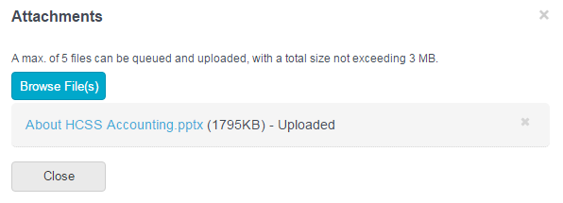

Click on Browse Files to find file. This will load file and be attached. To Delete click next to file. Click close to close screen and go back to Sales Invoices. Attachments can be added at a later date if required at any point prior to year end.

Once all the details have been added click on Submit or Submit and add another (to add another Sales Invoice straight away).

Approve a Sales Invoice

Depending on the user profile of the user who has input the Sales Invoice, it may require authorisation before the transaction is completed. If the status of the Sales Invoice on the main screen shows as ‘Ready to Receipt’ the authorisation is not required. Any Sales Invoice listed as Awaiting Approval will need to be approved by a use with the appropriate permissions. For more help on finding and searching for Sales Invoices see ‘Browse and View’ guidance below.

To Authorise a Sales Invoice(s) put a tick the tick box alongside the Sales Invoice(s) to be Authorised and from the Actions drop down box select Authorise, and the select confirm.

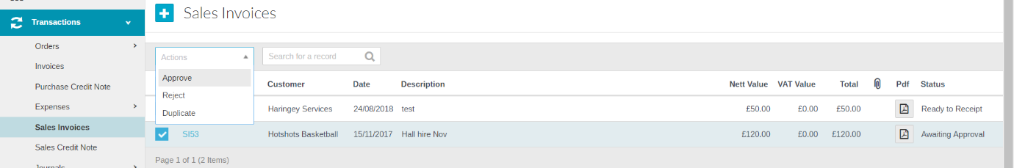
The same process is used for Rejection except Reject should be selected from the action list. If Reject is chosen any replacement Sales Invoice will need to be raised from scratch, so if only an amendment is required it is best for the authoriser to do nothing on the system and ask the invoice raiser to amend the transaction.

Print a Sales Invoice

To print a Sales Invoice click in the PDF column of the Invoice required. This will then upload a PDF format for the Sales invoice which can be saved (to your hard drive and then emailed) or printed.

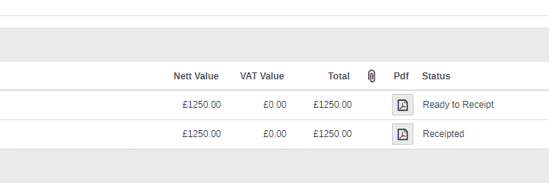
Use the guidance below to help you find and then pring a particular Sales Invoice

Browse and View a Sales Invoice

The main Sales Invoice screen will show all Sales Invoices for the current financial year.

To sort the Sales Invoices click on the column heading, click once for ascending or twice fordescending order. Use the search box to help find a specific Sales Invoice, type a search string and the system will find any Sales Invoice with that string in any of the fields shown, delete the search string to return to a full list.

To view attachments click on . This will open in PDF format.

To view the Sales Invoice input document click on the hyperlink in the Invoice No column.

The Sales Invoice will not be editable unless the status is awaiting authorisation.

Duplicate a Sales Invoice

To duplicate an earlier Sales Invoice click in the tick box to the left of the relevant Sales Invoice and select Duplicate from the actions drop down box.

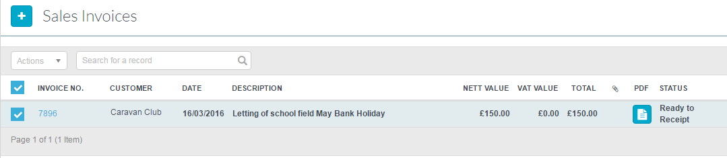

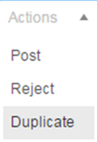

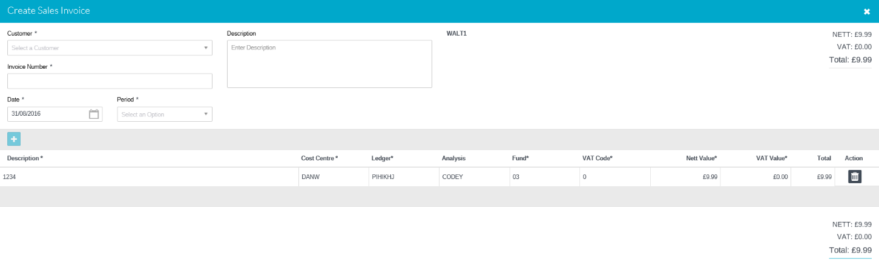
Details can be added or amended and attachments added, once completed click on Submit or Submit and Add Another.

Sales Credit Note

Sales Credit notes can be linked to a specific Sales Invoice, or created with no Invoice link and matched later as full or part payment of a Sales Invoice

Create a Sales Credit Note linked to a Sales Invoice

Click on 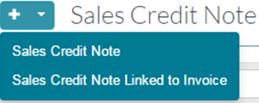 to add a Sales credit note linked to a Sales Invoice

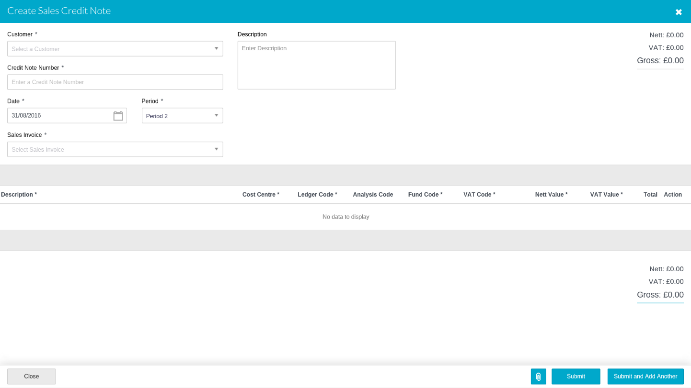

Customer* | Enter the Customer using the Pick list
Credit Note Number* | This field will only appear if not set to be automatically generated by the system (if set up in defaults), in which case you must manually enter a number.
Description | Enter a description for the reason and any other text applicable for the credit note. This will appear alongside the Credit Note on the main Credit note screen.
Date* | Defaults to today’s date it can be overwritten with the date of the Credit Note.
Period* | Enter the period to be posted.
Sales Invoice* | Select the Sales Invoice(s) the Credit note relates to from the drop down box, you can select more than one.

The details from the Selected Sales Invoice(s) will now populate the transaction lines for the Credit Note.

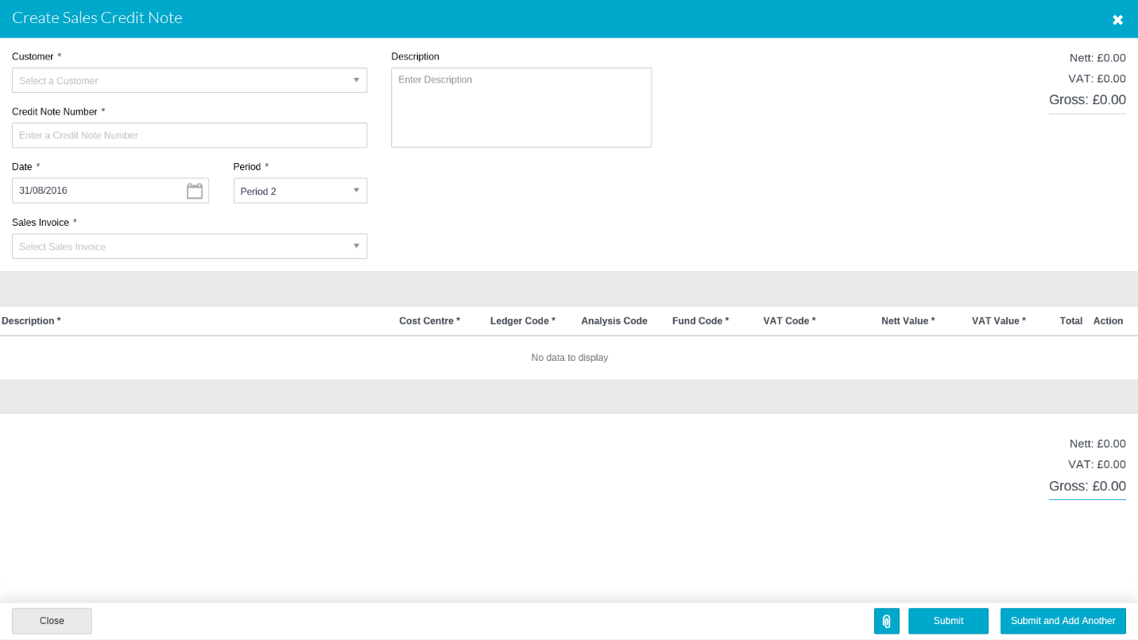

Description* | Enter a description for this line of the credit note
Cost Centre* | Select the appropriate
Ledger* | Populated from the Sales Invoice, but can be amended
Analysis | Populated from the Sales Invoice, but can be amended
Fund* | Populated from the Sales Invoice, but can be amended
VAT* | Populated from the Sales Invoice, but can be amended
NET Value* | Populated from the Sales Invoice. This can be overwritten if the credit is less than the full value of the Sales Invoice

To include attachments click on at the bottom of the screen. 5 attachments can be added or 3mb.

To save the document click on Submit or Submit and Add Another

Create a Sales Credit Note (not linked to an invoice)

Click on to add a Sales credit note

The following screen appears:

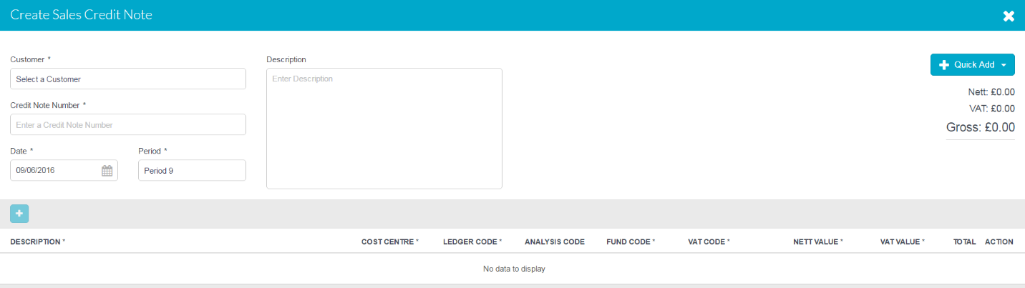

Customer* | Enter the Customer using the Pick list
Credit Note Number* | This field will only appear if not set to be automatically generated by the system (if set up in defaults), in which case you must manually enter a number.
Description | Enter a description for the reason and any other text applicable for the credit note. This will appear alongside the Credit Note on the main Credit note screen.
Date* | Defaults to today’s date, it can be overwritten with the date of the Credit Note.
Period* | Enter the period to be posted.

To add a line for items click on
Description* | Enter a description for this line of the credit note
Cost Centre* | The Cost Centre for this line to be coded to. Users will be restricted to the cost centres they have access to. You can search within the drop down.
Ledger* | The ledger code(s) for this line to be coded against (only ledger codes mapped to the selected cost centre will appear). You can search within the drop down.
Analysis | If required an analysis code can be selected.
Fund* | The fund code for this line.
VAT* | Use the pick list to use the correct code
NET Value* | Enter the NET value of the line items.

Multiple lines can be added with a running total displayed at the top and bottom of the grid by clicking on the button.

Any blank lines must be deleted before submitting by clicking on the icon

Click on to upload any files relating to the Sales Credit Note, 5 attachments can be added or 3mb.

To save the document click on Submit or Submit and Add Another.

Approve a Credit Note

Depending on the user profile of the user who has input the Credit Note, it may require authorisation before the transaction is completed. If the status of the Sales Invoice on the main screen shows as ‘Ready to Receipt’ the authorisation is not required. Any Sales Credit Note listed as Awaiting Approval will need to be approved by a use with the appropriate permissions. For more help on finding and searching for Sales Credit Notes see ‘Browse and View’ guidance below.

To Authorise a put a tick the tick box alongside the Sales Credit Notes(s) to be Authorised and from the Actions drop down box select Authorise, and then select confirm.

The same process is used for Rejection except Reject should be selected from the action list. If Reject is chosen any replacement Sales Credit Note will need to be raised from scratch, so if only an amendment is required it is best for the authoriser to do nothing on the system and ask the invoice raiser to amend the transaction.

Print a Sales Credit Note

To print a Sales Credit Note click in the PDF column of the Credit Note required. This will then upload a PDF format of the Credit Note which can be saved (to your hard drive and then emailed) or printed.

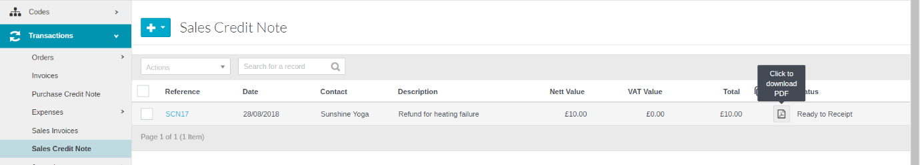
Use the guidance below to help you find and then print a particular Sales Credit Note.

Browse and View a Sales Credit Note

The main Sales Credit Note screen will show all Credit Notes for the current financial year.

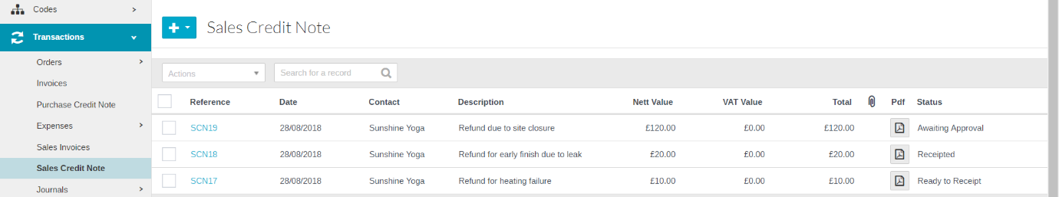

To sort click on the column heading, click once for ascending or twice for descending order. Use the search box to help find a specific Credit Note, type a search string and the system will find any Credit Note with that string in any of the fields shown, delete the search string to return to a full list.

To view attachments click on . This will open in PDF format.

To view the Sales Credit Note input document click on the hyperlink in the Reference column.

The Credit Note will not be editable unless the status is awaiting authorisation.

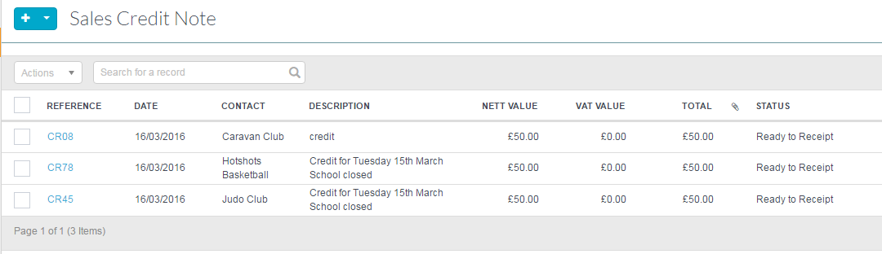

To view click on the hyperlink which can be found in the Reference column.

To view attachments click on to the right of the column.

The column can all be sorted ascending or descending or the search box can be used to find credit notes.

