

HCSS Accounting

User Manual

*System Set Up*

Contents

1 Introduction 3

2 System Set-Up 3

a Financial Year Setup 3

b Users and Access Profiles (to Codes only) 4

c Stationery Details 8

d Defaults 10

2.d.1 Auto Generation 10

2.d.2 Purchase Orders (including GRN switch off and PO Logo) 11

2.d.3 Sales 13

2.d.4 Petty Cash 14

2.d.5 Bank Accounts 15

2.d.6 Miscellaneous 16

2.d.7 Email 17

e Ledger Options 18

f Establishment 19

# Introduction

This is where all the system settings are managed and should be updated as and when the system changes are released.

The menu path is System Set-Up with the following options:

* Financial Year Setup – To open up new financial years and periods
* Users and Access Profiles – Manage User profiles for what areas to access
* Stationery Details – Update templates in the system i.e. PO, Sales Invoice
* Defaults – Update Bank details, auto-generation and emails
* Ledger Options – default ledger options for automation of certain transactions
* Establishment – manage link for budgeting and scenarios to import

# System Set-Up

## Financial Year Setup

The following screen will appear:

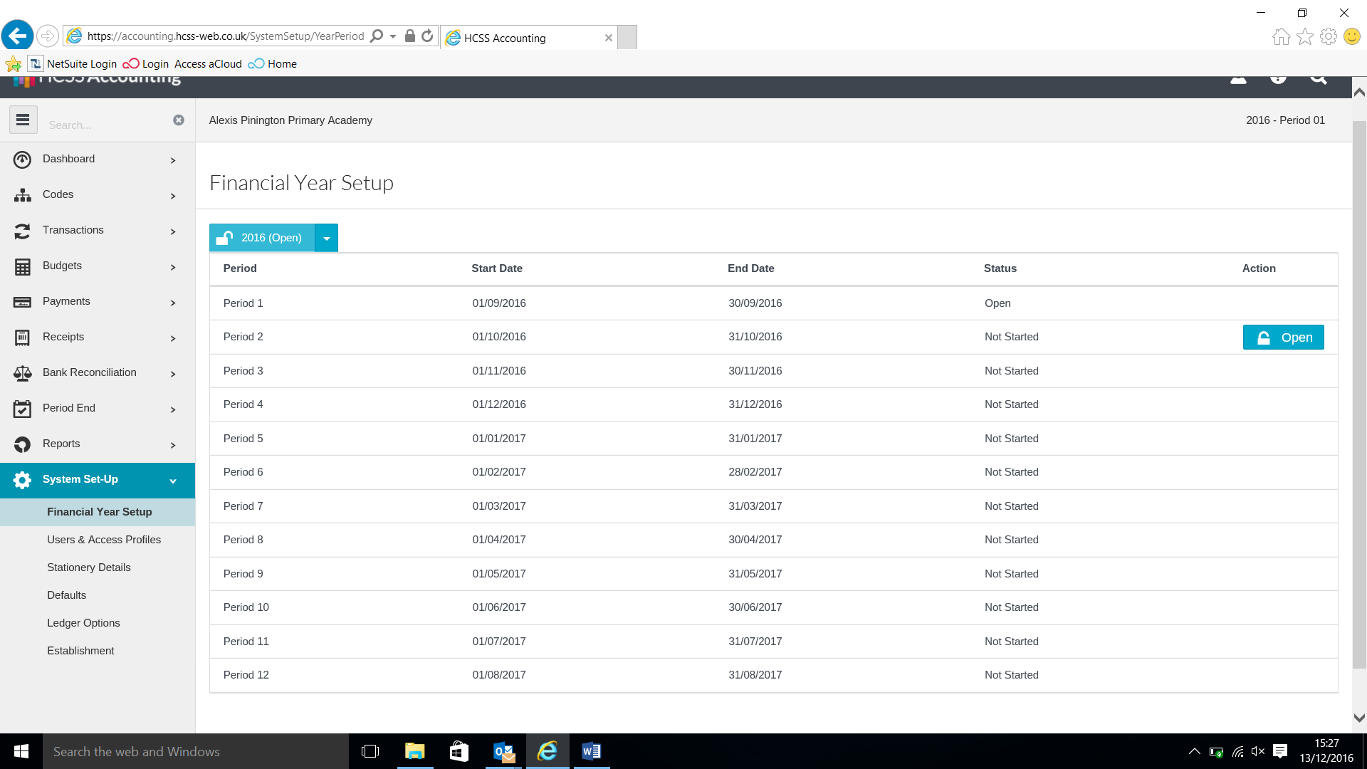

The screen will show you the Current Year and if it is open or closed. Period, Start date & End Date of the periods and the Status if the period is Open Closed and Not Started.

To open up a new period click on **Open** this will only be available on the 1st of the month

## Users and Access Profiles (to Codes only)

*(Please Note Users are created in HCSS Budgeting in the normal manner – a separate guide is set up for this)*

The following screen will appear:

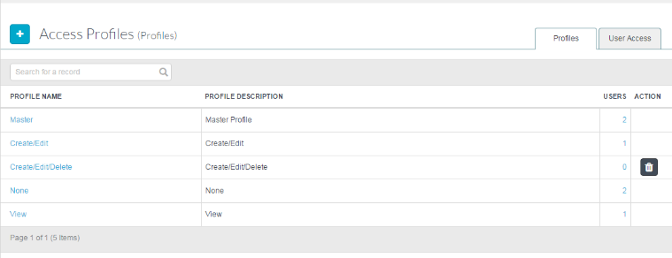

To Add a New profile click on 

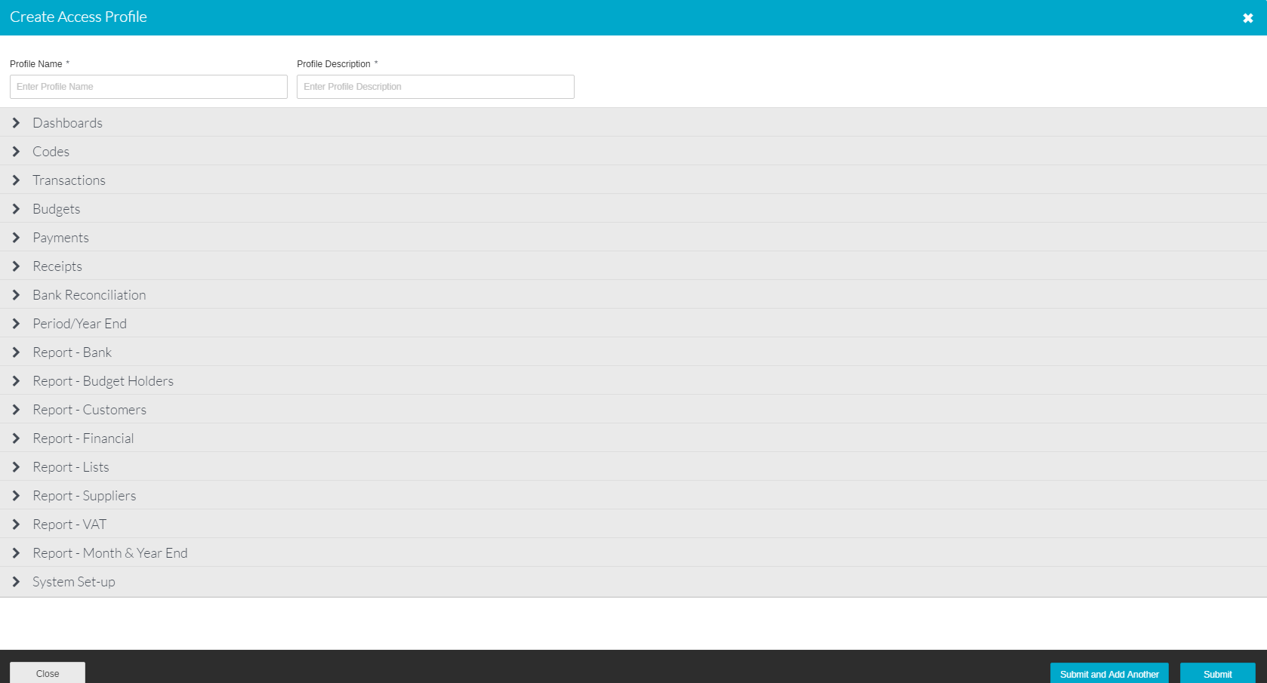

|  |  |
| --- | --- |
| **Profile Name** | Enter the name of the profile here  E.g. Budget Holder |
| **Description** | Enter a description |
| **Dashboards** | Select access level from the Pick List |
| **Codes** | Select access level from the Pick List |
| **Transactions** | Select access level from the Pick List |
| **Budgets** | Select access level from the Pick List |
| **Payments** | Select access level from the Pick List |
| **Receipts** | Select access level from the Pick List |
| **Bank Reconciliation** | Select access level from the Pick List |
| **Period / Year End** | Select access level from the Pick List |
| **Report – Bank** | Select access level from the Pick List Select access level from the Pick List |
| **Report – Budget Holders** | Select access level from the Pick List |
| **Report – Customers** | Select access level from the Pick List |
| **Reports – Financial** | Select access level from the Pick List |
| **Report – Lists** | Select access level from the Pick List |
| **Report – Suppliers** | Select access level from the Pick List |
| **Report – VAT** | Select access level from the Pick List |
| **Report – Month & Year End** | Select access level from the Pick List |
| **System Set-up** | Select access level from the Pick List |

Click on **Submit** to save the profile

To **Link** an Access Profile to a user, click on the **User Access** tab.

Next to each user is a drop down list showing the available Access Profiles.

Click on this to select a profile.

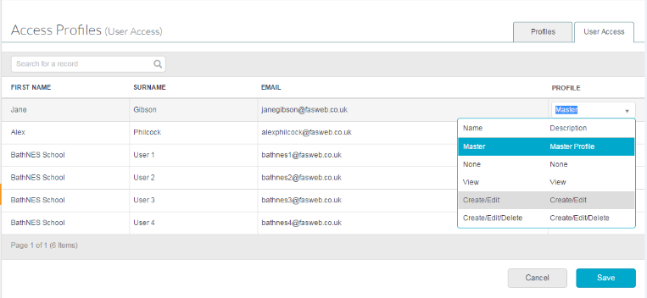

Click on **Save** to save your selection.

Note: An Access Profile cannot be deleted if it has users assigned to it.

To **Delete** an Access Profile, unlink any users attached and go to the **Profiles** tab

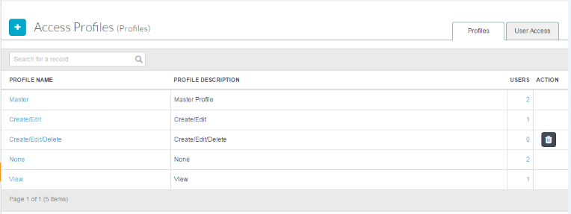

Click on the  to delete the Access Profile.

To **View** the users attached to an Access Profile, click on the **Users** column

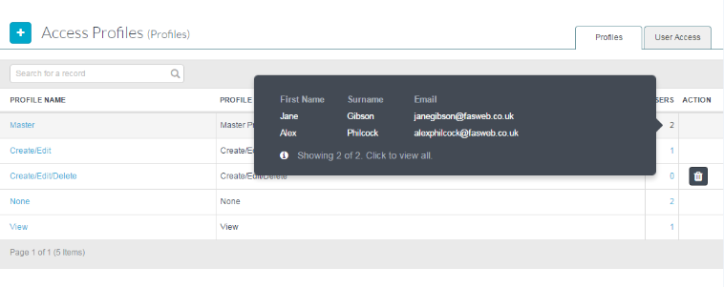

To view the full details, click on **Click to view all**

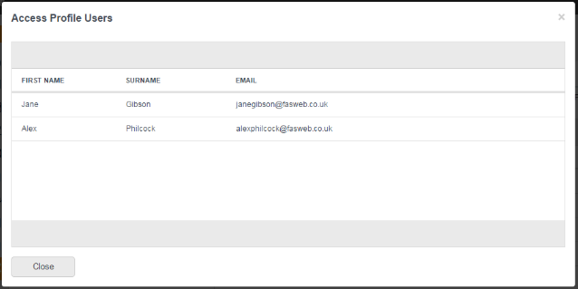

## Stationery Details

Stationery Details allows the user to customise the Purchase Order, Supplier Email and Purchase Requisition by adding their own custom text.

To view **Stationery Details** go to the Menu and click on **System Set-Up.**

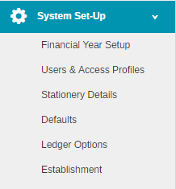

Click once on **Stationery Details** andthe following screen will open:

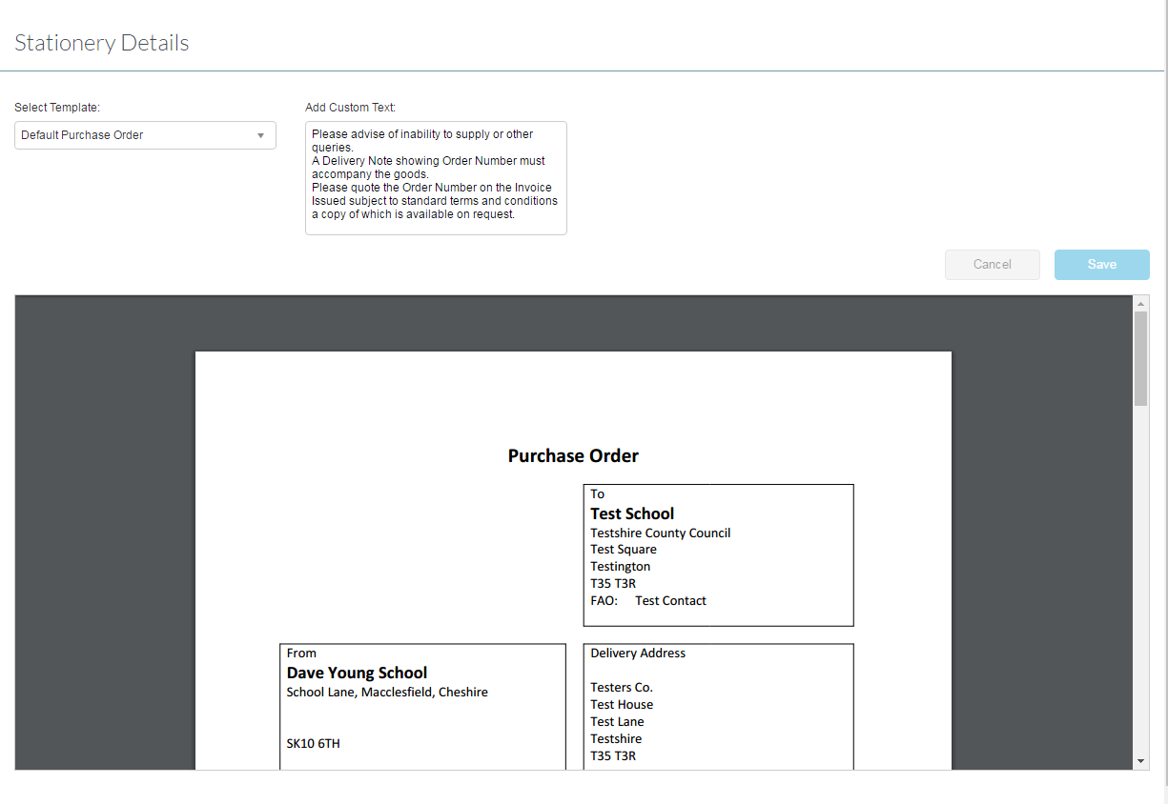

Select the doucment to be customised by clicking on the drop down list. A preview of the current form will appear.

Amend the text as required

Either click on **Save** or **Cancel.**

## Defaults

Click once on **Defaults** and the following screen will appear

### Auto Generation

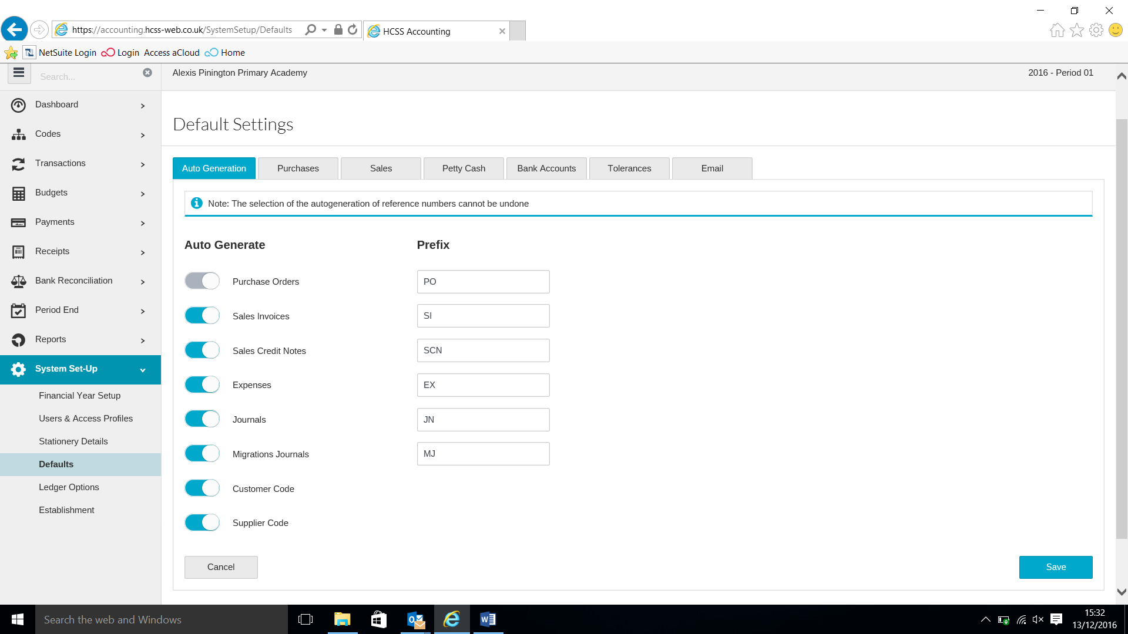

Set the Auto Generation by clicking on slider and then apply any prefixes followed by **Save**.

### Purchase Orders (including GRN switch off and PO Logo)

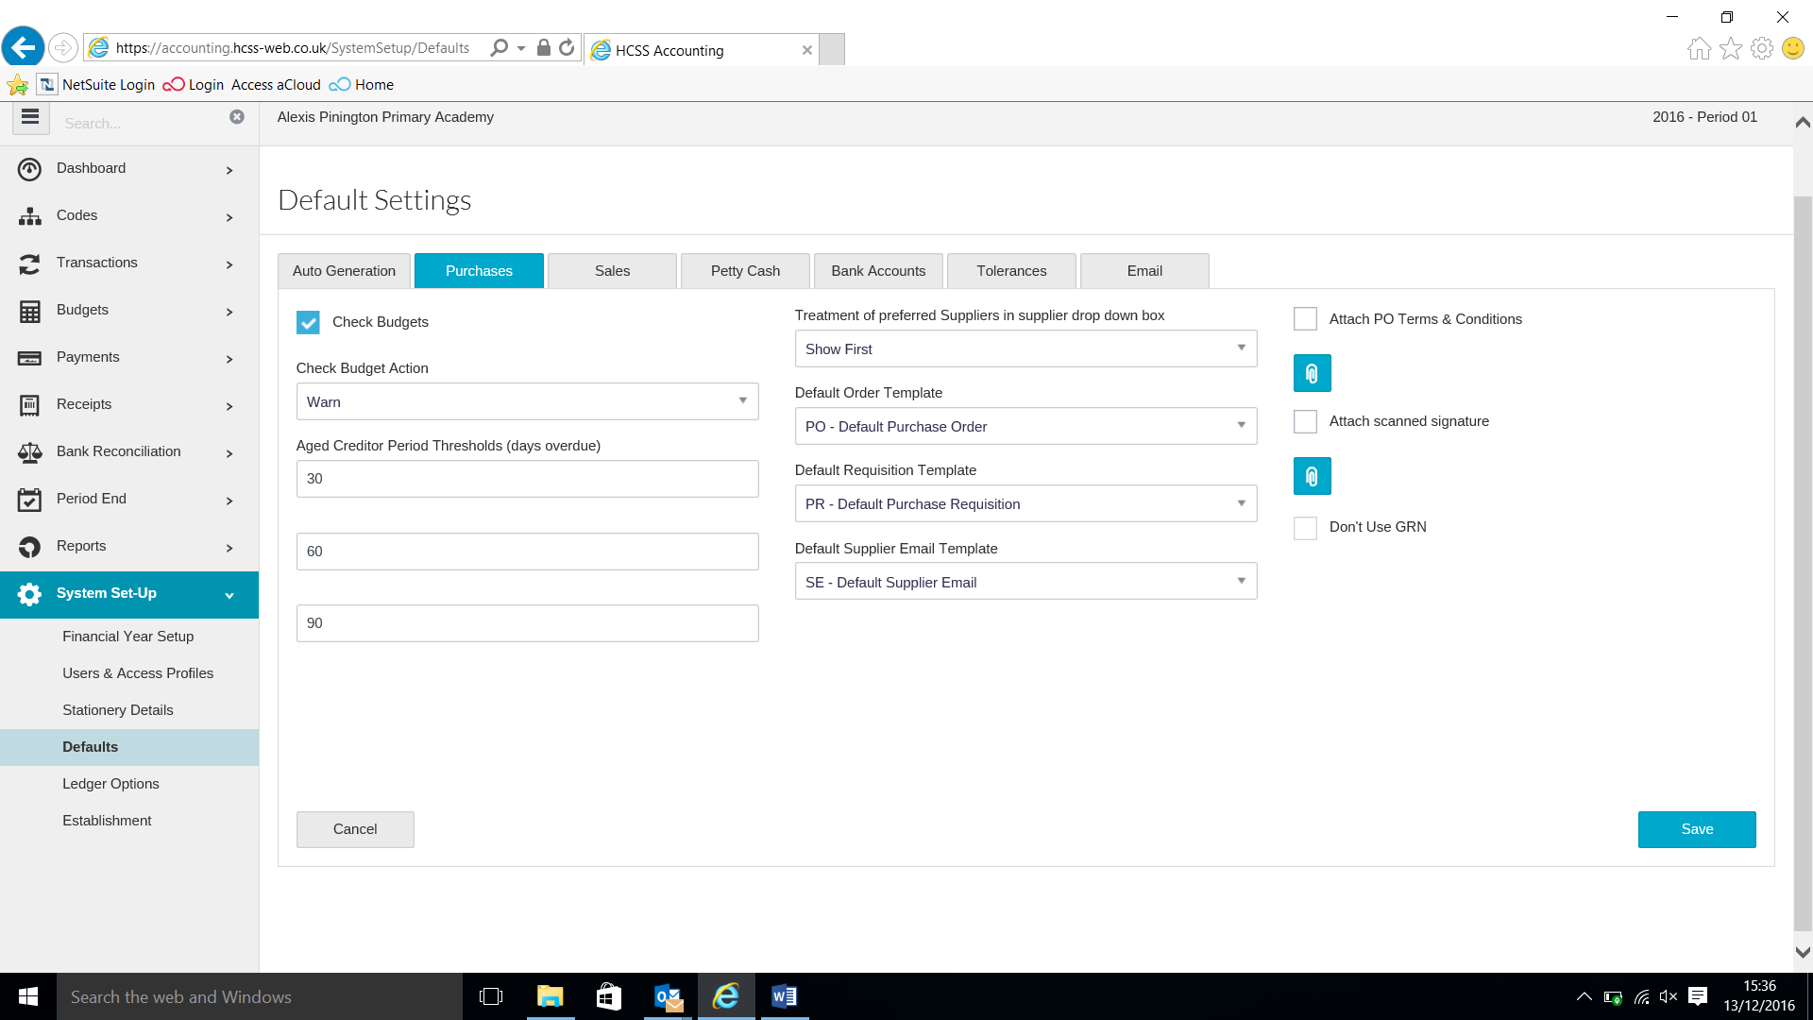

|  |  |
| --- | --- |
| **Check Budgets** | This will check there are sufficient funds available in the ledger/budget combination |
| **Check Budgets action** | A choice of warning or stopping the user if there are insufficient funds is available |
| **Aged Creditor Periods** | This allows the number of days to be set for the Aged Creditor Report |
| **Treatment of preferred Suppliers** | **I**f the preferred suppliers tick box is chosen in the supplier record this setting can be used to either **Show First** or **Show Only** |
| **Default Order Template** | Select the default template for printed orders from the customised orders created in Stationery Details  **Click on Purchase Order with Logo to include the school logo. Then upload the fiel in the format. Check in stationery details to see the template.** |
| **Default Requisition Template** | Select the default template for printed requisitions from the customised orders created in Stationery Details |
| **Default Supplier Email Template** | Select the default template for supplier emails from the customised orders created in Stationery Details |
| **Attach PO Terms & Conditions** | The school purchasing terms and conditions can be uploaded to be attached to the Purchase Order when emailed to the supplier |
| **Attach scanned signature** | An authorised signature can be uploaded to be used on the default templates for all forms. |
| **Do Not Use GRN** | Select this if you do not want to use the good receipt process. |

Click **Save** when completed.

### Sales



|  |  |
| --- | --- |
| **Aged Debtor Periods** | This allows the number of days to be set for the Aged Debtor Report |
| **Default Debtor Letter** | To come |
| **Default Sales Order Template** | Go to stationery to change some text. These can be printed off for transactions within the sales invoices under PDF column. |
| **Default Sales Credit Note Template** | Go to stationery to change some text. These can be printed off within the sales credit notes under PDF column. |
| **Default Customer Email Template** | To come |
| **Attach scanned signature** | An authorised signature can be uploaded to be used on the default templates for all forms. |

Click **Save** when completed.

### Petty Cash

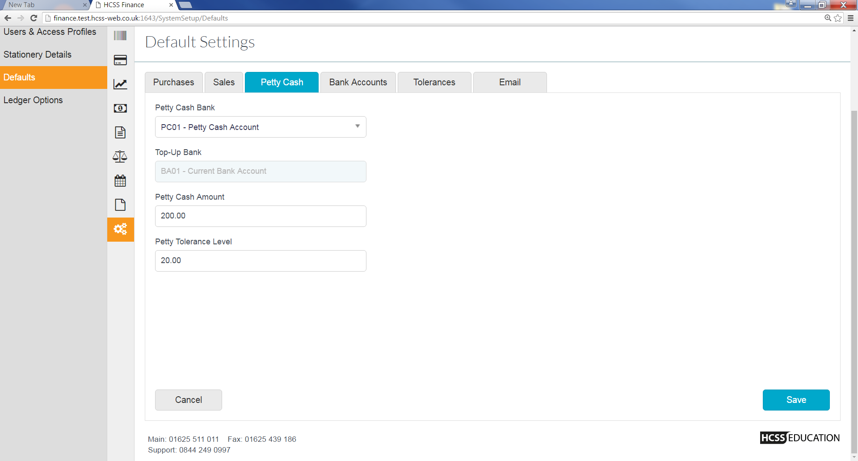

|  |  |
| --- | --- |
| **Petty Cash Bank** | Enter the petty cash bank account here |
| **Top Up Bank** | This is defaulted in and will be set up as part of the implementation plan |
| **Petty Cash Amount** | Amount of petty cash |
| **Petty Cash Tolerance Level** | Enter the tolerance level to provide a warning when it needs to be topped up |

Click **Save** when completed.

### Bank Accounts

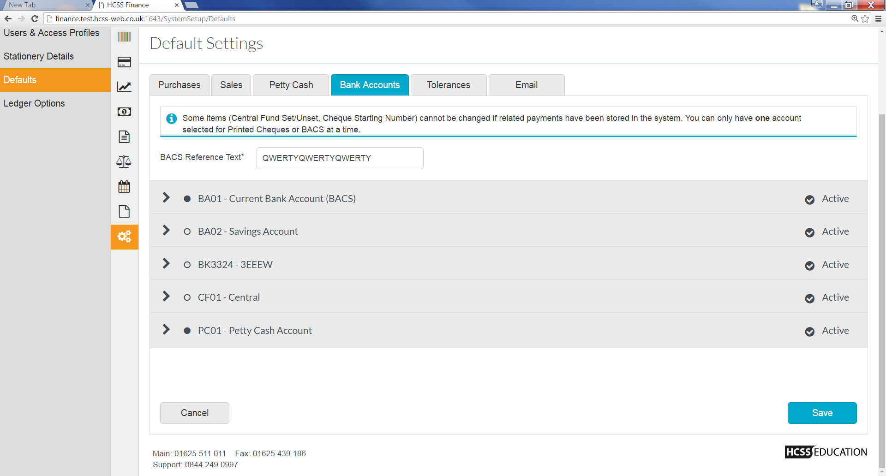

**The above screen lists the different bank accounts. Here users can nominate bank account they want to user for different payment methods.**

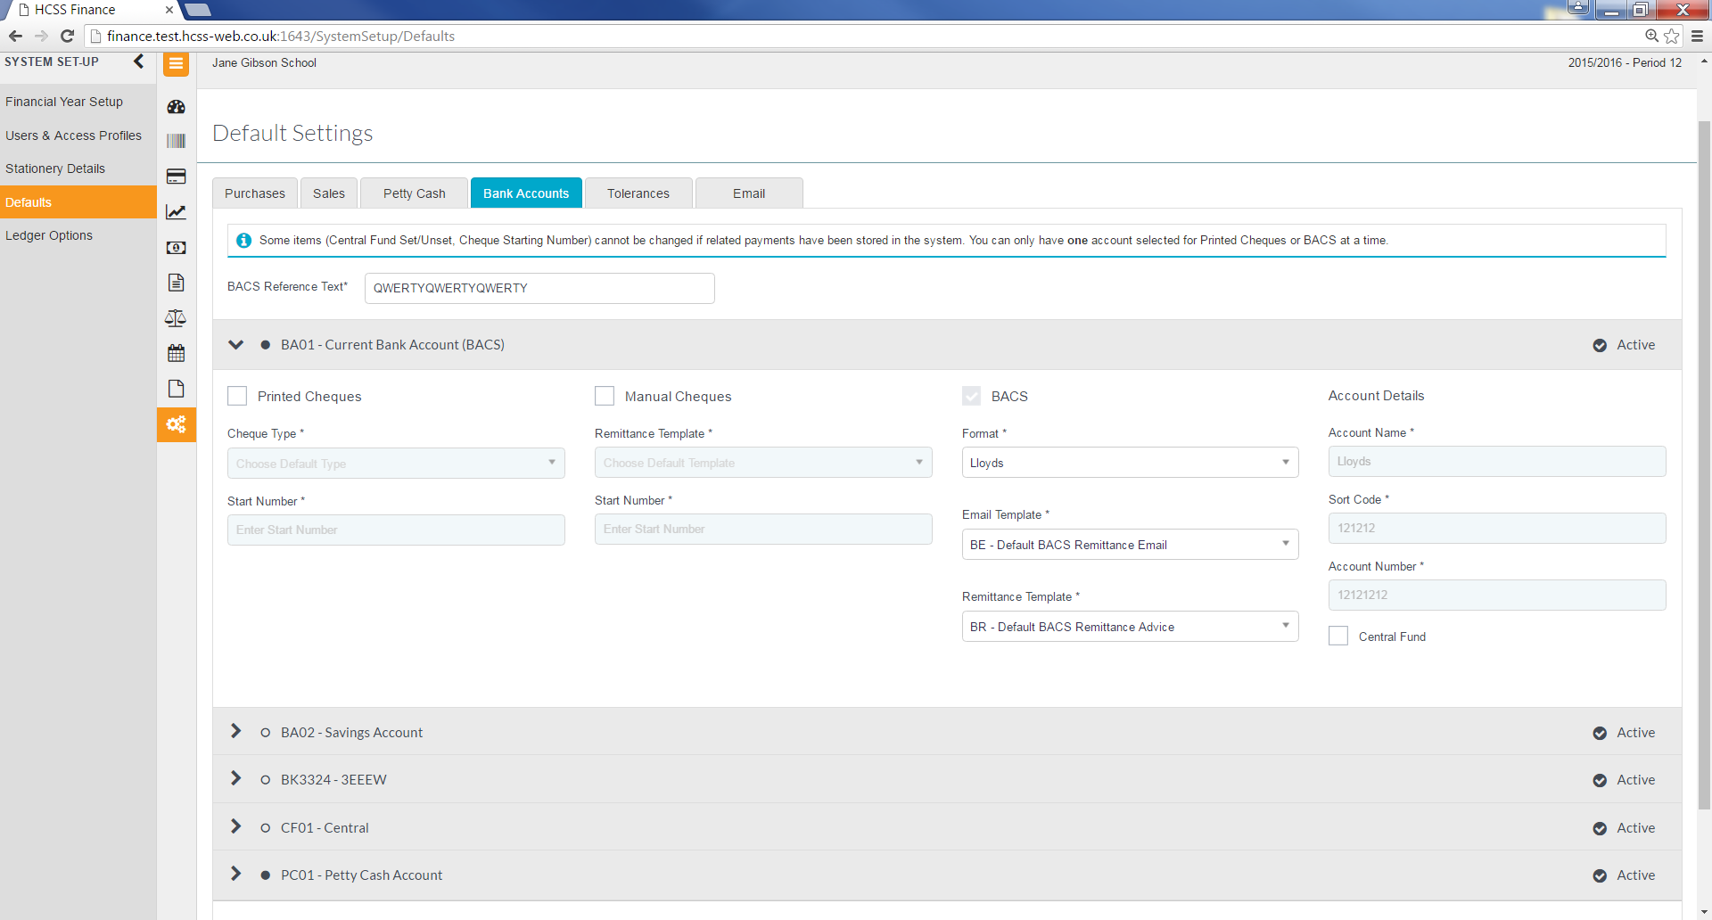

|  |  |
| --- | --- |
| **Printed Cheques** | Tick if you want cheques paid from this account |
| **Cheque Type\*** | Select Cheque type |
| **Start Number\*** | Cheque start number |

|  |  |
| --- | --- |
| **Manual Cheques** | Tick if you want cheques paid from this account |
| **Remittance Template\*** | Select remittance template |
| **Start Number\*** | Cheque start number |

|  |  |
| --- | --- |
| **BACS** | Tick if you want BACS payment paid from this account |
| **Format\*** | Select your bank’s BACS format |
| **Email Template\*** | Select email template to |
| **Remittance Template\*** | Select form Pick List |

|  |  |
| --- | --- |
| **Accounts Details** |  |
| **Account Name\*** | Name of Account holder |
| **Sort Code\*** | Sort code |
| **Account Number\*** | Account Number |
| **Central Fund** |  |

### Miscellaneous



|  |  |
| --- | --- |
| **Enable Tolerance Checking on VAT** | Enables a check to be carried out when the VAT is changed against an invoicethis can either warn the user that they are over the tolerance or stop them. |
| **Tolerance Mode** | Select **Stop** on Error or **Warn** on Error |
| **Tolerance Amount (Check to Pence )** | Enter the tolerance amount in pence |
| **Enable transaction Date Warning** | Enables a check on transactions to ensure they are being posted in the correct year or period |
| **Date Older than** | Enter the amount of days |
| **Attach Report Logo** | A logo can be attachedfor reports. To do this select Attach Report Logo and Upload the file using the paperclip |
| **Request Confirmation of bank account for cash book journal** | This is a check for cash book journals that can be enabled at this screen to do checks when posting cash book journals. |

Click **Save** when completed.

### Email

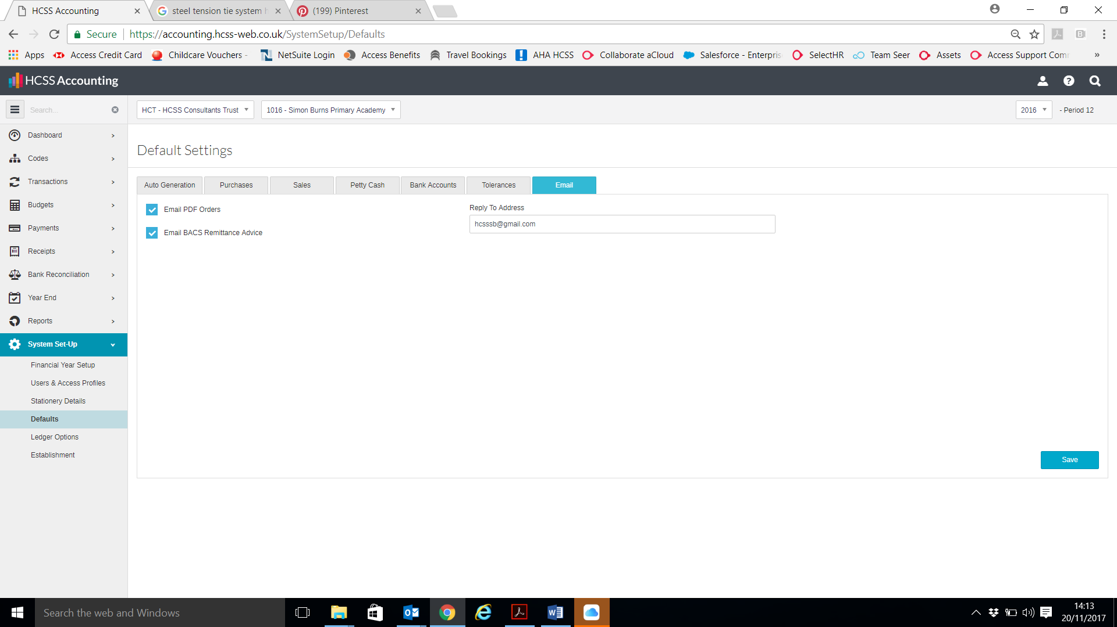

|  |  |
| --- | --- |
| **Setting** | **Detail** |
| Reply to Address | Enter the email address for any supplier correspondence. |

**\**Kindly note for Email PDF Orders and BACS Remittance Advice to work, user will need to add suppliers’ email under ‘Contact Details’ for the relevant supplier.***

***See Supplier guide to help.***

## Ledger Options

**Ledger Options** allows the System Manager to set the default control accounts within HCSS Accounting. The defaults will be used when entering transactions.

To view **Ledger Options** go to the Menu and click on **System Set-Up**



Click once on **Ledger Options** and the following screen will appear

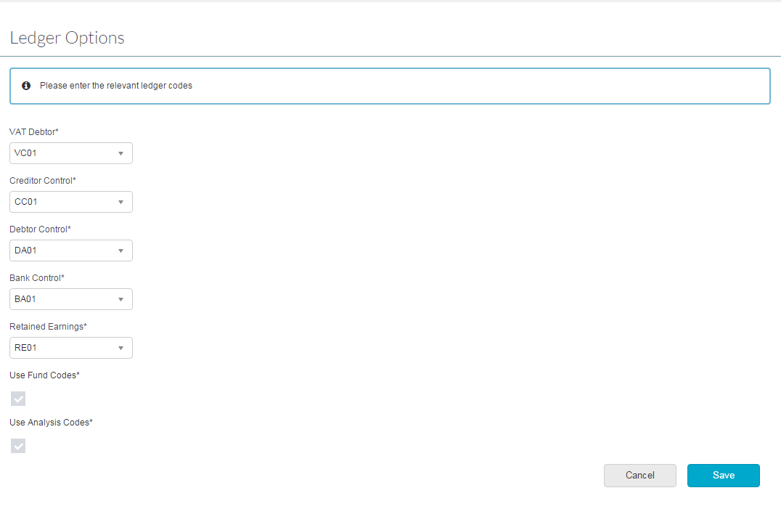

Select the relevant codes and click on **save** to set the defaults.

Within Ledger Defaults the System Manager can also select not to use Analysis Code

**Please Note**: if Analysis codes have been used it is not possible to unselect the setting

## Establishment



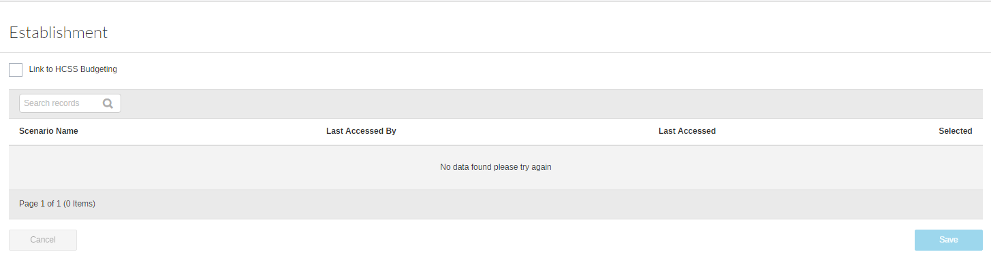

See budgeting area for full process on how to link the and upload Chart of Accounts.