HCSS Accounting

User Manual

Receipts

Contents
1 Receipts 3
a Manual Receipt 3
b Bulk Receipts 4
c Income Matching 6

Receipts

Manual Receipt

To create a Manual Receipt click on Receipts and Manual Receipts

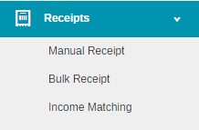
The following screen will open

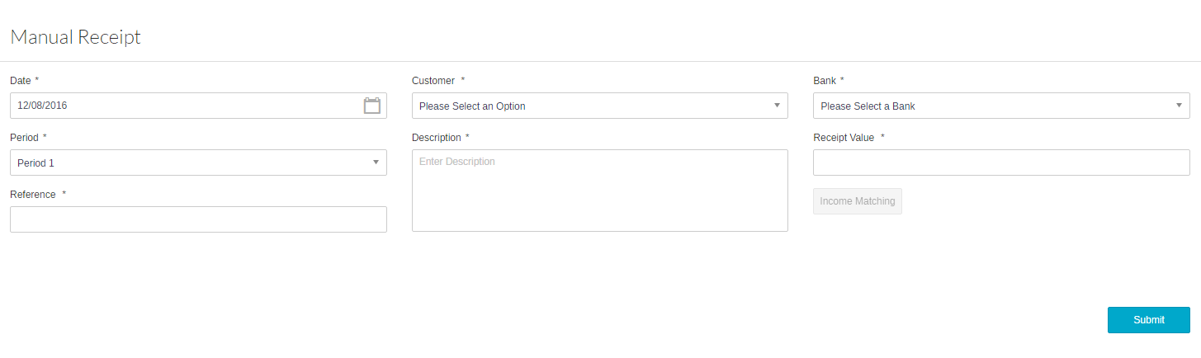
Enter the relevant information. Mandatory Fields are denoted with an *

Date | Enter the date of receipt
Customer | Enter the customer using the pick list
Bank | Enter the bank using the pick list
Period | Enter the period
Description | Enter a description for the receipt
Receipt Amount | Enter the receipt amount
Reference | Enter the Reference for audit trail

Click on income matching to match against the relevant invoice(s)

Note: only invoices/credit notes for the Customer selected in the Manual Receipt Screen will appear.

Select the relevant invoices/credit notes – these should balance to zero

Click on Match this will take you back to the input screen.

Click on Submit to post the Receipt

Bulk Receipts

To use Bulk Receipts click on Receipts and Bulk Receipts

The following screen will appear:
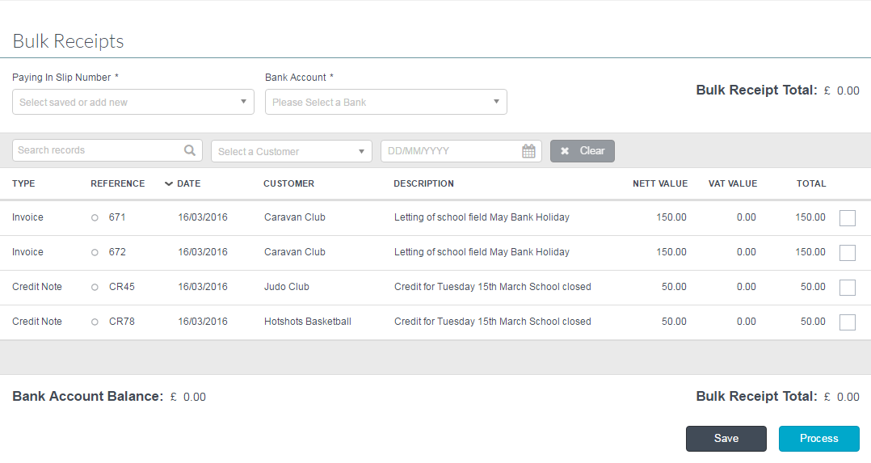

Paying In Slip Number | Enter the reference number for the Bulk Receipt  Or select a previously saved receipt
Bank Account | Enter the Bank Account the money is paid into

Select the relevant invoices and credit notes to be receipted by clicking in the Tick Box. A total will appear at the bottom of the screen.

Click on Save to save the selections to return to at a later time (these will not be posted)

Click Process to post the Bulk Receipt.

Income Matching

Income Matching allows the System Manager to match a receipt against invoices and credit notes or to unmatch a receipt from an Invoice if the receipt has not been accepted by the Bank

To use Income Matching click on Receipts and Income Matching

The following screen will appear

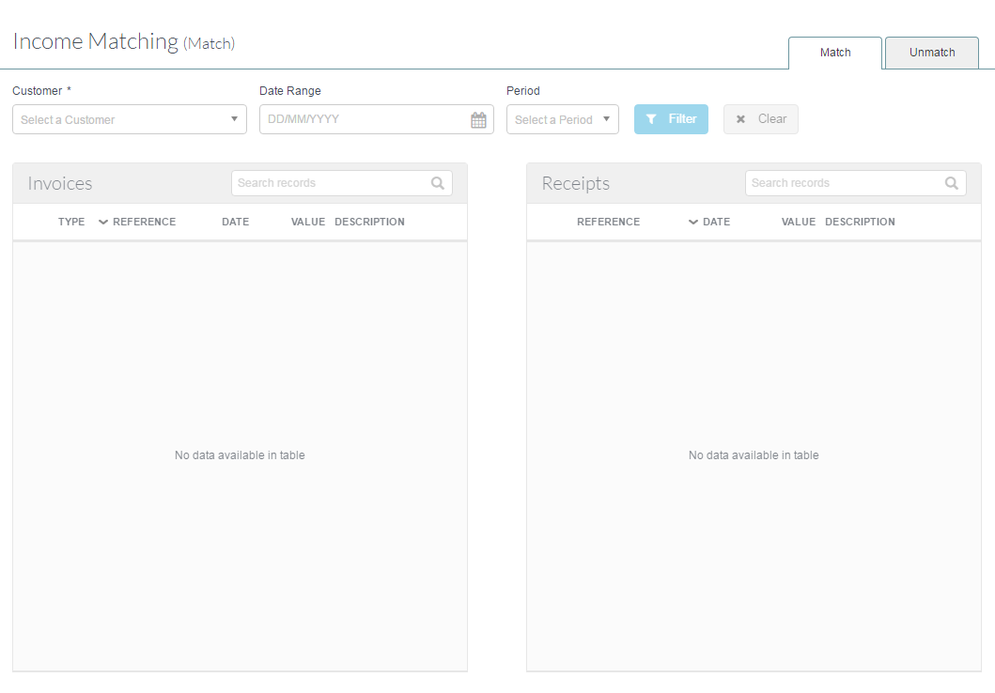
Enter a Customer (mandatory), date range or period and click on

The following screen will appear:
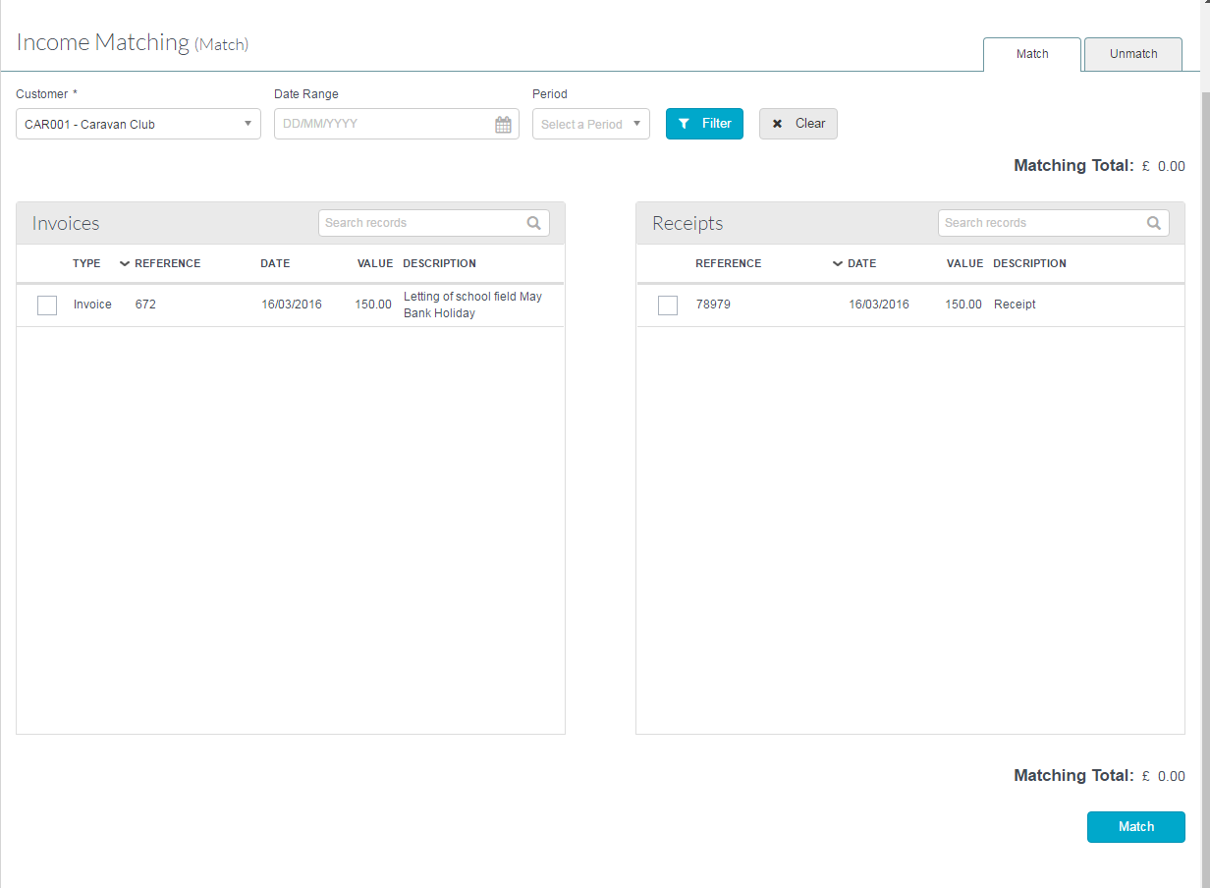
Tick the receipt and the invoices that you wish to match and click on

Note: The match cannot take place until the Matching Total balances to zero.

To unmatch a receipt and an invoice(s) click on the Unmatch tab in the Income Matching screen

Select a Customer (mandatory), period, date range or reference and click on

The following screen will appear:

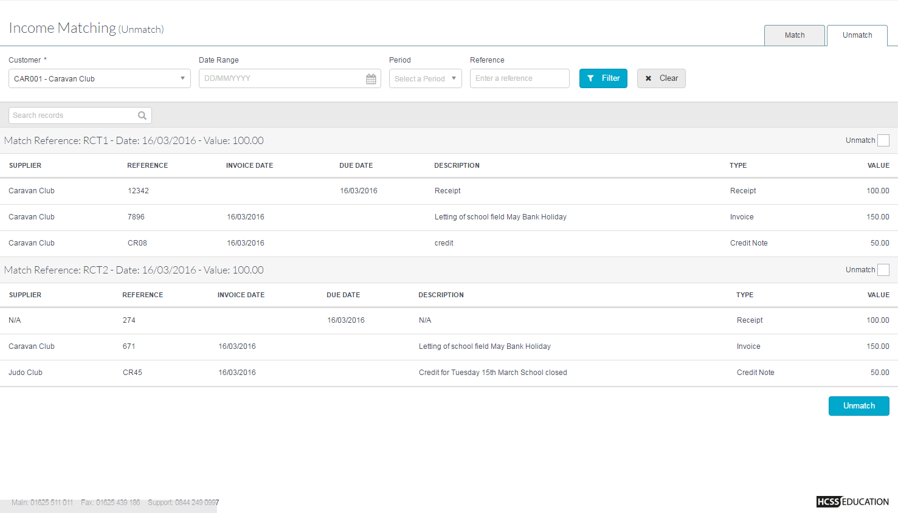
Tick the match you want to unmatch and click on. The invoice will be available to receipt again

Note: The invoice and or receipt will need to be reversed or rematched.

