HCSS Accounting

User Manual

Period End

Contents
1 Period End 3
a Run Period End 3
b View Pending Items 5

Period End

Run Period End

To Run the Period End, go to the Menu and Period End, Run Period End

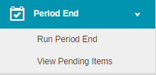

The following screen will appear:

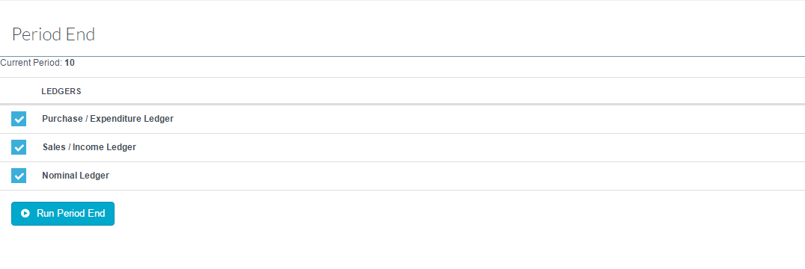

To run the Period End click on . A message appears with a reminder of actions that should be taken prior to a Period End.

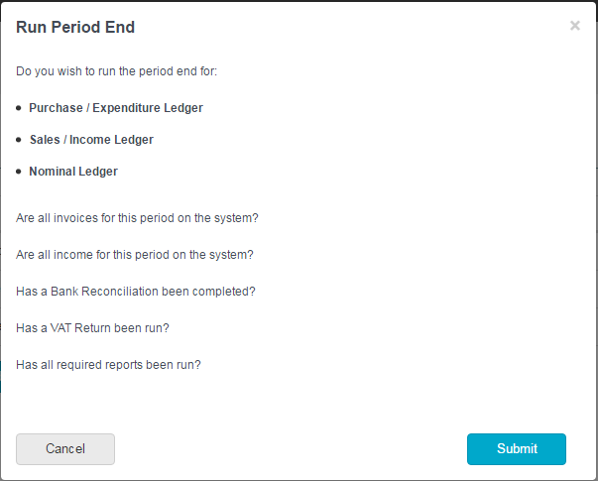
Click on this will move the period forward to the next period

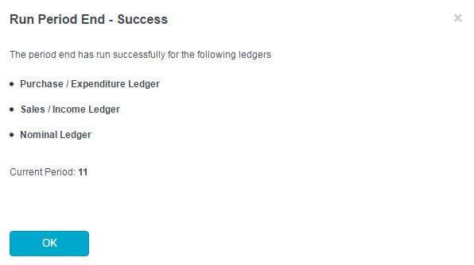

View Pending Items

To view Pending Items, go to the Menu and Period End, View Pending Items

The following screen will appear:

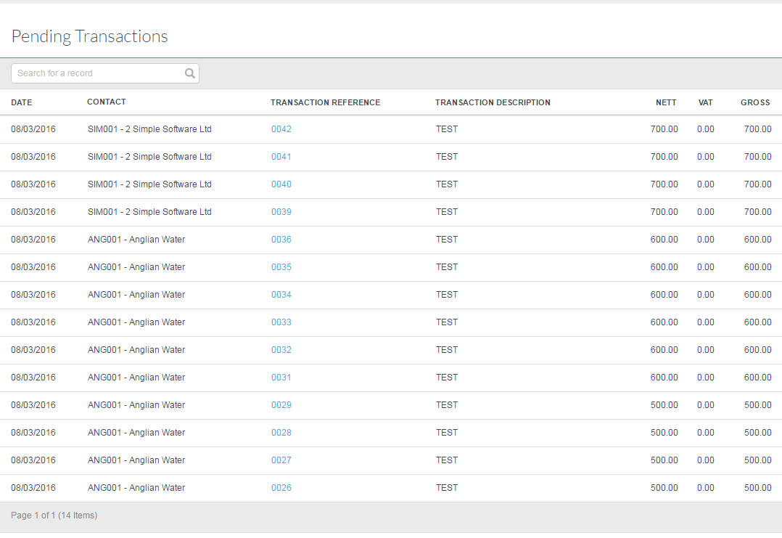
This shows transactions that have been saved but not posted.

To view the item click on the hyper-link under Transaction Reference
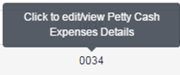

The transaction can be edited and posted. If the transaction is not posted it will nlt appear in the period that is in the process of closedown.

