HCSS Accounting

User Manual

Journals and Corrections

Contents
1 Introduction 3
a Journals 3
b Corrections 3
c Migration Journals 3
2 Journals 4
a View Journals 4
b Accrual – See year end procedures.(only for period 12 and 13) 5
c Cash Book Journal (including Balance Sheet Codes) 5
d VAT Reimbursement 6
e VAT Payment 8
f Payroll Control 9
g Payroll Payment 10
h Bank Transfer 10
i VAT Journal 11
j SBS Journal 12
k Internal Transfer 13
l Prepayment – See year end procedures.(only for period 12 and 13) 14
m Print Journals 14
3 Corrections 15
a Reversals 15
b Write –Offs 16
c Supplier Refunds 18
4 Migration Journals 19
a Creditor 19
b Debtor 20
c Opening Balances 21
d Unreconciled Transactions 22

Introduction

Journals

To view or create journals click on Transactions > Journals followed by the journal required:

- Accrual (Year End Journal) – see year-end notes.
- Cash Book Journal (incl. posting to balance sheet) – to bank/petty cash account
- VAT Reimbursement – VAT control to bank account (DR)
- VAT Payment – VAT control to bank account (CR)
- Payroll Control – to pay control accounts
- Payroll Payment – from payroll control accounts to bank account
- Bank Transfer – moving funds between bank accounts
- VAT Journal – correcting VAT entries
- SBS Journal – EFA/LA funding received to bank
- Internal Transfer – miscoding of funds
- Prepayments (Year End Journal) – see year-end notes.

Corrections

To generate a reversal click on Transaction > Reversals followed by type of reversal:

- Reversals – reverse cheques, BACS, sales invoice, receipts and journals
- Write Offs
- Supplier funds (credit note converted to cash at bank)

Migration Journals

When converting from a legacy system these journals are used to upload information required that may have been outstanding. These are found under Transactions > Migration Journals followed by:

- Creditor – a list of invoices that have not been paid by BACs/chq
- Debtor – a list of invoices due for payment
- Opening Balances – Balances from balance sheet and part year trial balance if applicable
- Unreconciled Items – Items that have not appeared on bank statement on legacy system

Journals

View Journals

This screen will show all the journals available and created

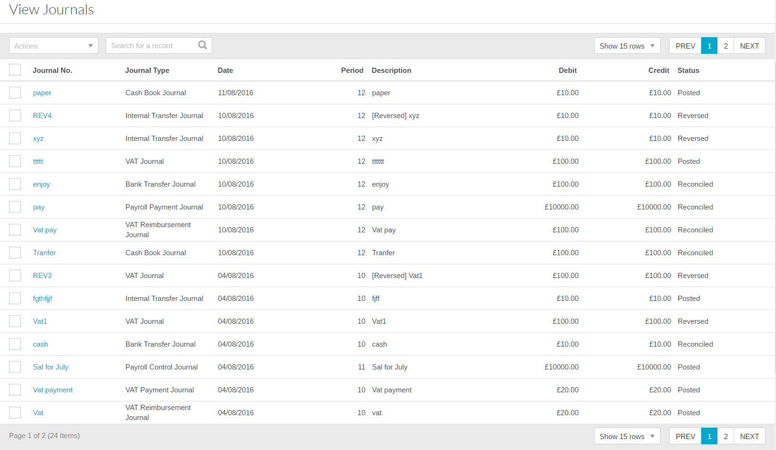

To view click on the hyperlink in the Journal No column

All columns can be sorted by ascending or descending order.

(See section below for each type of journal)

To duplicate any journals you can select the journal followed by Duplicate

Accrual – See year end procedures.(only for period 12 and 13)

Cash Book Journal (including Balance Sheet Codes)

* This can be used for Balance Sheet Journals to post direct to ledger accounts only.

Click on to open up the cash book journal

Enter the relevant information. Mandatory Fields are denoted with an *

Date | Enter the date of the journal
Description | Enter a description
Bank | Enter the bank from the pick list
Period | Enter the period
Reference | Enter the reference
Debit/Credit | Enter if it is a debit or credit to the account selected
Amount | Enter the overall amount for all line items

Click to enter the line item for the journal

Debit/Credit | Enter a debit or credit for line items there is a check to ensure debits and credits equal zero.
Description | Enter a line item description
Cost Centre | Enter the code from the pick list
Ledger | Enter the code from the pick list. This is the only element required for coding when posting direct to the balance sheet.
Analysis | Enter the code from the pick list
Fund | Enter the code from the pick list
VAT Code | Enter the VAT code for the line.
Amount | Enter the amount all debits and credits must add up to zero.

Click on Submit or Submit and Add Another once completed.

VAT Reimbursement
Click on to open up the VAT Reimbursement journal

Enter the relevant information. Mandatory Fields are denoted with an *

Date | Enter the date of the journal
Description | Enter a description
Bank | Enter the bank from the pick list
Period | Enter the period
Reference | Enter the reference
Amount | Enter the overall amount for all line items

Click on Submit or Submit and Add Another once completed.

VAT Payment

Click on to open up the VAT Payment journal

Enter the relevant information. Mandatory Fields are denoted with an *

Date | Enter the date of the journal
Description | Enter a description
Bank | Enter the bank from the pick list
Period | Enter the period
Reference | Enter the reference
Amount | Enter the overall amount for all line items

Click on Submit or Submit and Add Another once completed.

Payroll Control

Click on to open up the Payroll Control journal

Date | Enter the date of the journal
Description | Enter a description
Bank | Enter the bank from the pick list
Period | Enter the period
Reference | Enter the reference
Debit/Credit | Enter if it is a debit or credit to the account selected
Amount | Enter the overall amount for all line items
Click to enter the line item for the journal

Enter the relevant information. Mandatory Fields are denoted with an *

Debit/Credit | Enter a debit or credit for line items.
Description | Enter a line item description
Cost Centre | Enter the code from the pick list
Ledger | Enter the code from the pick list
Analysis | Enter the code from the pick list
Fund | Enter the code from the pick list
Amount | Enter the amount all debits and credits must add up to zero.

Click on Submit or Submit and Add Another once completed.

Payroll Payment

Click on to open up the Payroll Payment journal

Enter the relevant information. Mandatory Fields are denoted with an *
Date | Enter the date of the journal
Description | Enter a description
Bank | Enter the bank from the pick list
Period | Enter the period
Reference | Enter the reference
Amount | Enter the overall amount for all line items

Click on Submit or Submit and Add Another once completed.

Bank Transfer

Click on to open up the bank transfer

Enter the relevant information. Mandatory Fields are denoted with an *

Date | Enter the date of the journal
Description | Enter a description
Bank from | Enter the bank from the pick list money is coming from
Bank to | Enter the bank from the pick list money is coming from
Period | Enter the period
Reference | Enter the reference
Amount | Enter the overall amount for all line items

Click on Submit or Submit and Add Another once completed.

VAT Journal

Click on to open up the VAT journal

Enter the relevant information. Mandatory Fields are denoted with an *
Date | Enter the date of the journal
Description | Enter a description
Period | Enter the period
Reference | Enter the reference

Click to enter the line item for the journal

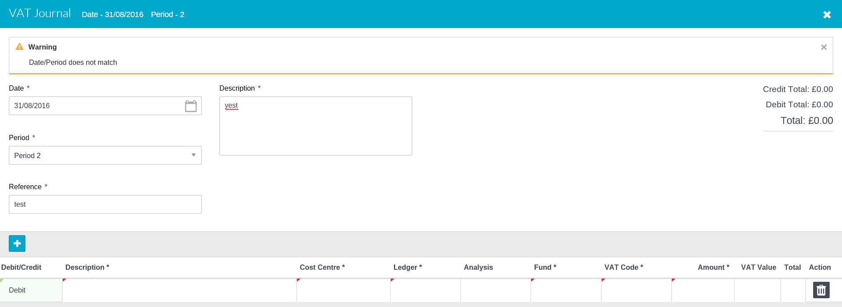

Debit/Credit | Enter a debit or credit for line items. For all lines this will add to zero.
Description | Enter a line item description
Cost Centre | Enter the code from the pick list
Ledger | Enter the code from the pick list
Analysis | Enter the code from the pick list
Fund | Enter the code from the pick list
Amount | Enter the amount all debits and credits must add up to zero.

Click on Submit or Submit and Add Another once completed.

SBS Journal

Click on to open up the SBS journal

Enter the relevant information. Mandatory Fields are denoted with an *
Date | Enter the date of the journal
Description | Enter a description
Bank | Enter the bank from the pick list
Period | Enter the period
Reference | Enter the reference
Debit/Credit | Enter if it is a debit or credit to the account selected
Amount | Enter the overall amount for all line items
Click to enter the line item for the journal

Debit/Credit | Enter a debit or credit for line items
Description | Enter a line item description
Cost Centre | Enter the code from the pick list
Ledger | Enter the code from the pick list
Analysis | Enter the code from the pick list
Fund | Enter the code from the pick list
VAT Code | Enter the relevant VAT code
Amount | Enter the amount all debits and credits must add up to zero.

Click on Submit or Submit and Add Another once completed.

Internal Transfer

Click on to open up the Internal Transfer journal

Enter the relevant information. Mandatory Fields are denoted with an *
Date | Enter the date of the journal
Description | Enter a description
Period | Enter the period
Reference | Enter the reference

Click to enter the line item for the journal

Debit/Credit | Enter a debit or credit for line items
Description | Enter a line item description
Cost Centre | Enter the code from the pick list
Ledger | Enter the code from the pick list
Analysis | Enter the code from the pick list
Fund | Enter the code from the pick list
Amount | Enter the amount all debits and credits must add up to zero.

Click on Submit or Submit and Add Another once completed.

Prepayment – See year end procedures.(only for period 12 and 13)

Print Journals

Select the journals that you want to print and in the actions box select export to excel

Or

Go into the journal and click on export in the bottom right.

Both ways will export the journals to excel.

Corrections

Reversals

The following screen will appear:
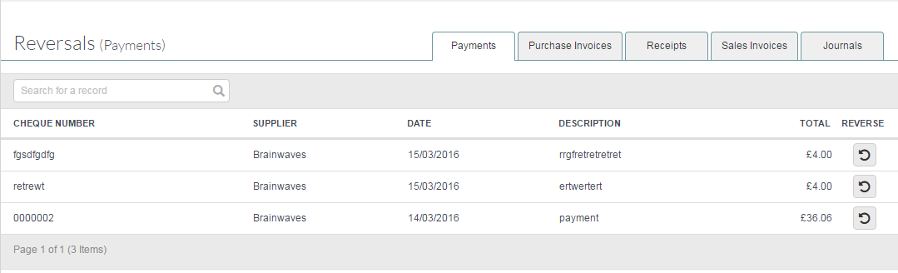

The Reversals screen separates the transactions between Payments, Purchase Invoices, Receipts, Sales invoices, Journals and BAC’s
To reverse a transaction, simply select the relevant tab and click on to reverse the transaction.

A message will appear asking for confirmation

For BAC’s payments you can reverse the whole file or just an individual payment (see below that reverse icon appears in both areas).

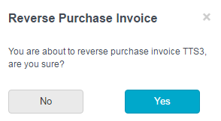

Clicking on Yes will reverse the transaction and remove it from the list. It will not be available to reverse again.

Clicking on No will take you back to the reversals screen.

The reversal will post an equal and opposite transaction and pre-fix the original transaction description with reversal.

Write –Offs

Write-offs allow the Finance Manager to write off a bad debt if approved by the governing body and in line with the Financial Regulations of the school.

The following screen will appear:

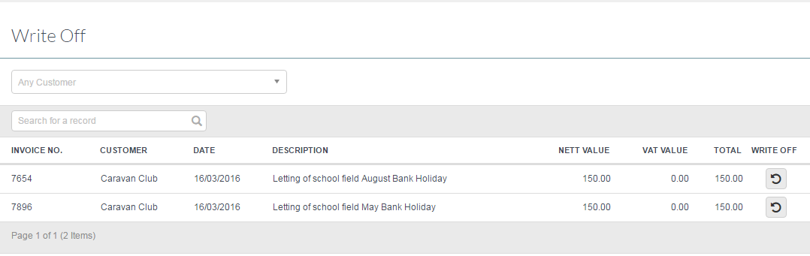

Select a customer from the drop down list and all pending invoices for that customer will appear.
Click on the next to the transaction to be written off. A Bad Debt ledger code will need to exist with a Ledger Type of BDT

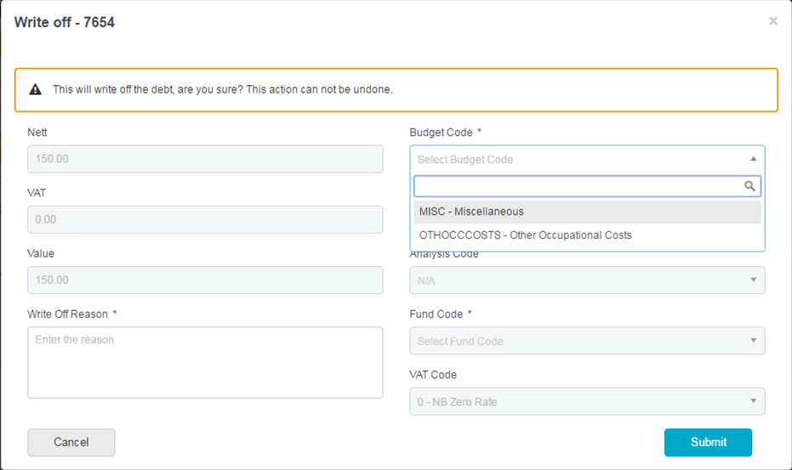
Write – Off Reason | Enter a reason for the write off
Cost Centre | If more than one cost centre is mapped to the ledger code a drop down list will appear for selection
Ledger Code | Bad Debt ledger Code with ledger type of BDT
Analysis Code | Defaulted from original transaction
Fund Code | Defaulted from original transaction
VAT Code | Defaulted from original transaction

Clicking on Submit will post the write-off and remove it from the list.

Supplier Refunds

Supplier Refunds can either posted against a Expenditure Credit Note that is refund to bank.

Choose the Supplier the refund has come from to populate the screen.
Click on to create the refund.

The following Screen will appear:
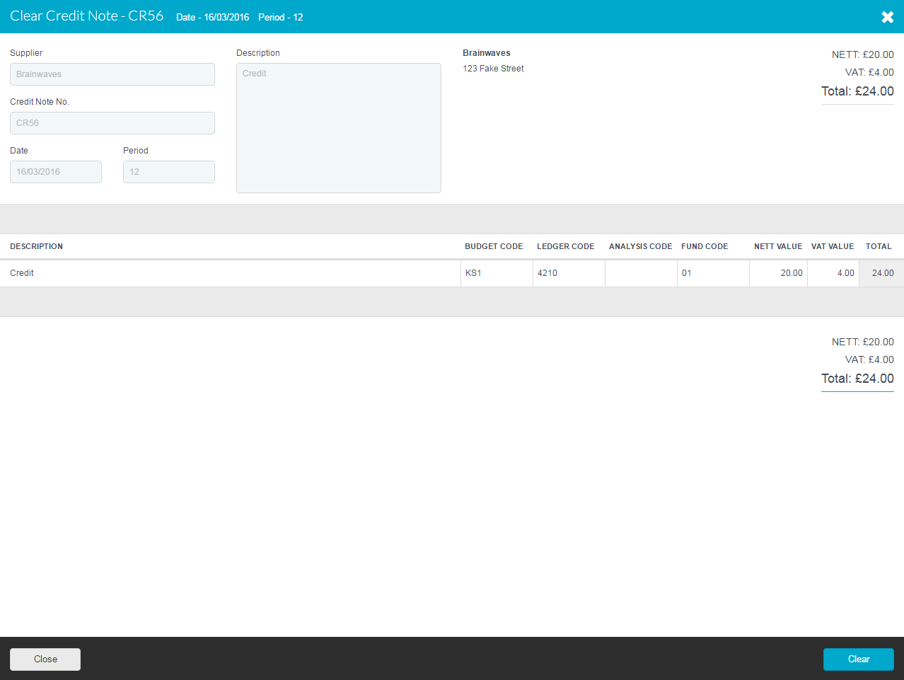

Migration Journals

At the time of migration, the school / academy may have balances that need to be added to HCSS Accounting. Mid-Year these can be obtained from a Trial Balance in their old system and at Year End these will be provided by the Balance Sheet in their old system.

Creditor

Posting individual creditor invoices that have been entered in the legacy system but not paid.

The Following screen will appear:

Click on to Create a Creditor journal

Enter the relevant information. Mandatory Fields are denoted with an *

Date | Enter the date of the journal
Description | Enter a description
Period | Enter period 0 at start and 5 in the middle of the year.
Reference | Enter the reference
Click to enter the line item for the journal

Debit/Credit | Enter a debit or credit for line items
Supplier | Select the supplier on a Credit Line only form the pick list
Description | Enter the description
Ledger | Enter the code from the pick list
Reference | Enter the reference
Amount | Enter the amount all debits and credits must add up to zero.

Click on Submit or Submit and Add Another once completed.

Debtor

This is for debtor invoices that have been entered on the legacy system but still outstanding.

Click on to Create a Debtor journal

Enter the relevant information. Mandatory Fields are denoted with an *

Date | Enter the date of the journal
Description | Enter a description
Period | Enter period 0 at start and 5 in the middle of the year.
Reference | Enter the reference

Click to enter the line item for the journal

Debit/Credit | Enter a debit or credit for line items
Supplier | Select the supplier on a Credit Line only form the pick list
Description | Enter the description
Ledger | Enter the code from the pick list
Reference | Enter the reference
Amount | Enter the amount all debits and credits must add up to zero.

Click on Submit or Submit and Add Another once completed.

Opening Balances

Enter balance sheet or trial balance balances

The Following screen will appear:

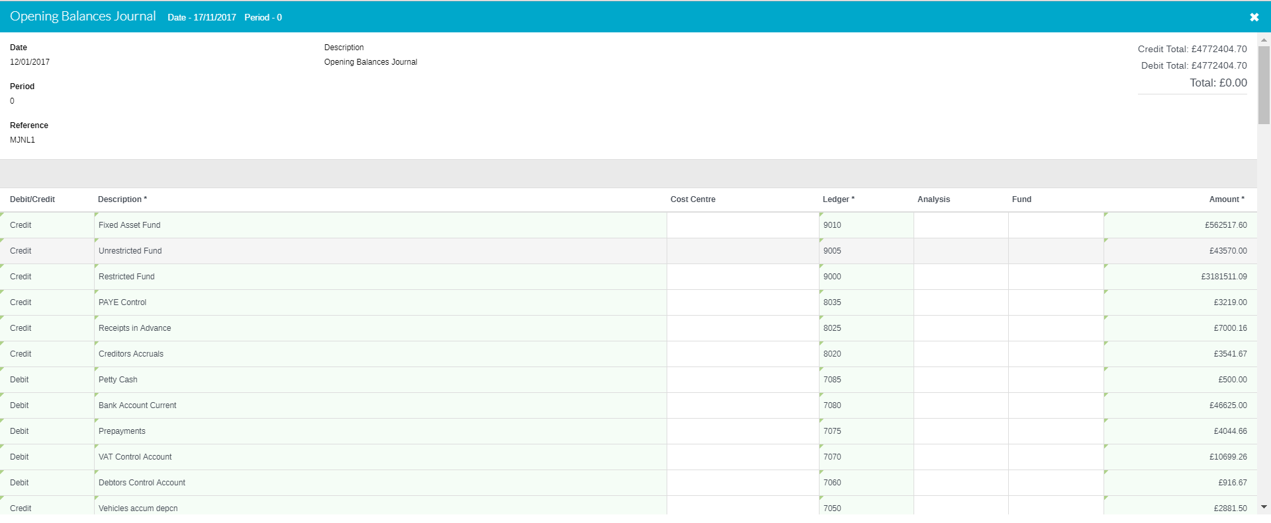

Unreconciled Transactions

Click on to Create a Unreconciled Transactions Journal

Enter the relevant information. Mandatory Fields are denoted with an *

Date | Enter the date of the journal
Description | Enter a description
Period | Enter period 0 at start and 5 in the middle of the year.
Reference | Enter the reference
Bank | Select the bank form the pick list
Debit/Credit | Select to debit or credit the bank
Amount | Enter the amount

Click to enter the line item for the journal

Debit/Credit | Enter a debit or credit for line items
Description | Enter the description
Ref/ Cheque No | Enter the reference or Chq number
Amount | Enter the amount all debits and credits must add up to zero.

Click on Submit or Submit and Add Another once completed.

