HCSS Accounting

User Manual

Expenses

Contents
1 Introduction 3
2 Expenses 4
a Petty Cash Expenses - Create 4
b Petty Cash Expenses – Cancel 6
c Petty Cash Expenses – Duplicate 7
d Credit Card Expenses – Create 8
e Credit Card Expenses – Cancel 9
f Credit Card Expenses – Duplicate 10
g Direct Debit Expenses – Create 11
h Direct Debit Expenses – Cancel 12
i Direct Debit Expenses – Duplicate 13

Introduction

Expenses are under the menu bar Transactions > Expenses followed by

- Petty Cash
- Credit Card
- Direct Debit
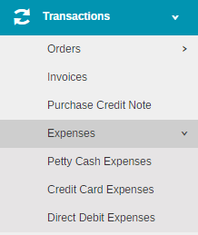

Please note – expenses to feed through to the VAT 126 must have a supplier (contact attached). If this is not included, it will not appear, however, it will appear on the VAT return.

Expenses

Petty Cash Expenses - Create

Click on to add a Petty Cash Expense

Date | Enter the date of petty cash
Description | Enter the description of the goods or services
Period | Enter the period
Ref | Enter the reference for the petty cash for audit trail.

Click on to add a Petty Cash Expense Item Line

Enter the relevant information.

Supplier | Enter the Supplier from the pick list. Not a mandatory field but feeds through to the VAT 126.
Reference | Enter a reference number for the goods and services
Description | Enter a description of the goods and services
Date | Enter a date for the items
Value | Enter the NET value
Cost Centre | Enter the code from the pick list
Ledger | Enter the code from the pick list
Analysis | Enter the code from the pick list
Fund | Enter the code from the pick list
VAT | Enter the code from the pick list

Lines can be added for additional analysis, and a line can be deleted by clicking the icon

To include attachments click on at the bottom of the screen. 5 attachments can be added or 3mb.

To save click on Submit or Submit and Add Another this saves the Petty Cash Transaction and allows you to add to it.

Once all the petty cash transactions for that period have been added click on Save and Post. This will post the item lines against the selected codes and you will not be able to add any more lines to it.

Note: You will get a warning if you are over the tolerance level set in System Settings reminding you to Top Up your account prior to the next use

Petty Cash Expenses – Cancel

The transaction must be unposted
Put a tick in the petty cash transaction and click in the Actions box.

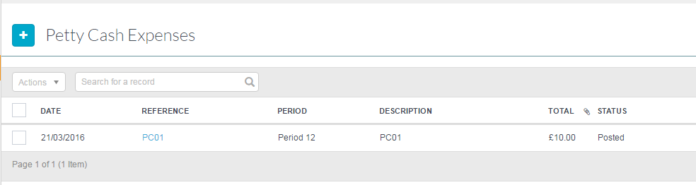

Select Cancel

Click on Confirm

Petty Cash Expenses – Duplicate

Put a tick in the petty cash transaction and click in the Actions box.

Select Duplicate

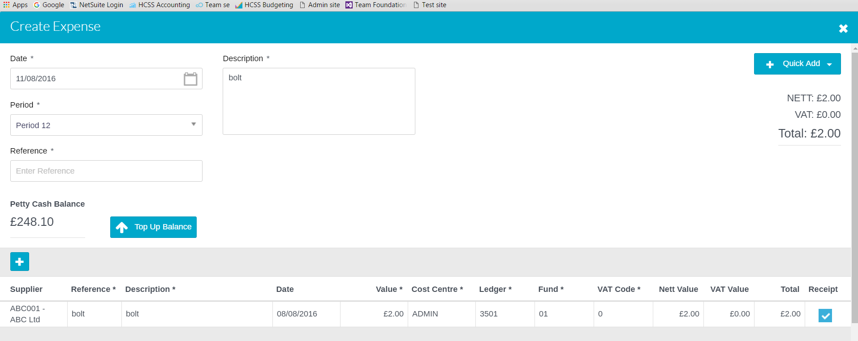

Enter a Ref number and add any new items required then either click on Submit, Submit and Add Another or Save and Post.

Credit Card Expenses – Create

Click on to add a Credit Card Expense

Enter the relevant details

Date | Enter the date of Credit Card
Description | Enter the description of the goods or services
Period | Enter the period
Ref | Enter the reference for the Credit Card for audit trail.
Owner | Select the Owner from the pick list

Add a line by clicking on the and enter the relevant information

Supplier | Enter the Supplier from the pick list.
Reference | Enter a reference number for the goods and services
Description | Enter a description of the goods and services
Date | Enter a date for the items
Value | Enter the NET value
Cost Centre | Enter the code from the pick list
Ledger | Enter the code from the pick list
Analysis | Enter the code from the pick list
Fund | Enter the code from the pick list
VAT | Enter the code from the pick list

To include attachments click on at the bottom of the screen. 5 attachments can be added or 3mb.

To save click on Submit or Submit and Add Another this saves the Credit Card Transaction and allows you to add to it.

Once all the credit card transactions for that period have been added click on Save and Post. This will post the item lines against the selected codes and you will not be able to add any more lines to it.

Credit Card Expenses – Cancel

The credit card transaction must be unposted

Put a tick in the Credit Card transaction and click in the Actions box.

Select Cancel

Click on Confirm

Credit Card Expenses – Duplicate

Put a tick in the Credit Card transaction to be duplicated and click in the Actions box.

Select Duplicate

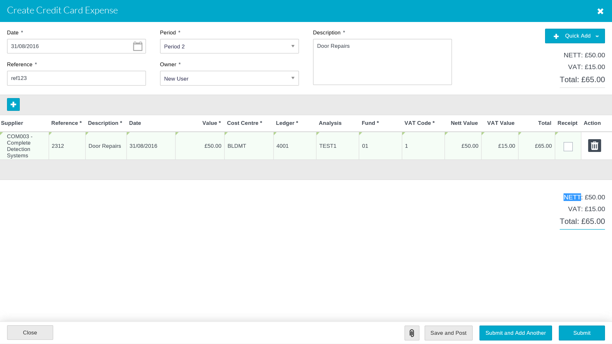

Enter a Ref number and change the item lines as required then click on Submit, Submit and Add Another or Save and Post.

Direct Debit Expenses – Create

Click on to add a Direct Debit Expense

Enter the relevant information

Date | Enter the date
Period | Enter the period
Reference | Enter the reference for the Direct Debit for audit trail.
Description | Enter the description of the goods or services
Period | Enter the period
Ref | Enter the reference for the petty cash for audit trail.

Click on to add a Direct Debit Expense Item line, adding the relevant information

Debit/Credit | Enter if debit or credit.
Contact | Enter the Contact from the pick list. This will feed to the VAT 126 report
Reference | Enter a reference number for the goods and services
Description | Enter a description of the goods and services
Date | Enter a date for the items
Value | Enter the NET value
Budget | Enter the code from the pick list
Ledger | Enter the code from the pick list
Analysis | Enter the code from the pick list
Fund | Enter the code from the pick list
VAT | Enter the code from the pick list

To include attachments click on at the bottom of the screen. 5 attachments can be added or 3mb.

To save click on Submit or Submit and Add Another this saves the Direct Debit Transaction and allows you to add to it.

Once all the Direct Debit transactions for that period have been added click on Save and Post. This will post the item lines against the selected codes and you will not be able to add any more lines to it.

Direct Debit Expenses – Cancel

The direct debit expense transaction must be unposted

Put a tick in the Direct Debit transaction and click in the Actions box.

Select Cancel

Click on Confirm

Direct Debit Expenses – Duplicate

Put a tick in the Direct Debit Transaction and click in the Actions box.

Select Duplicate

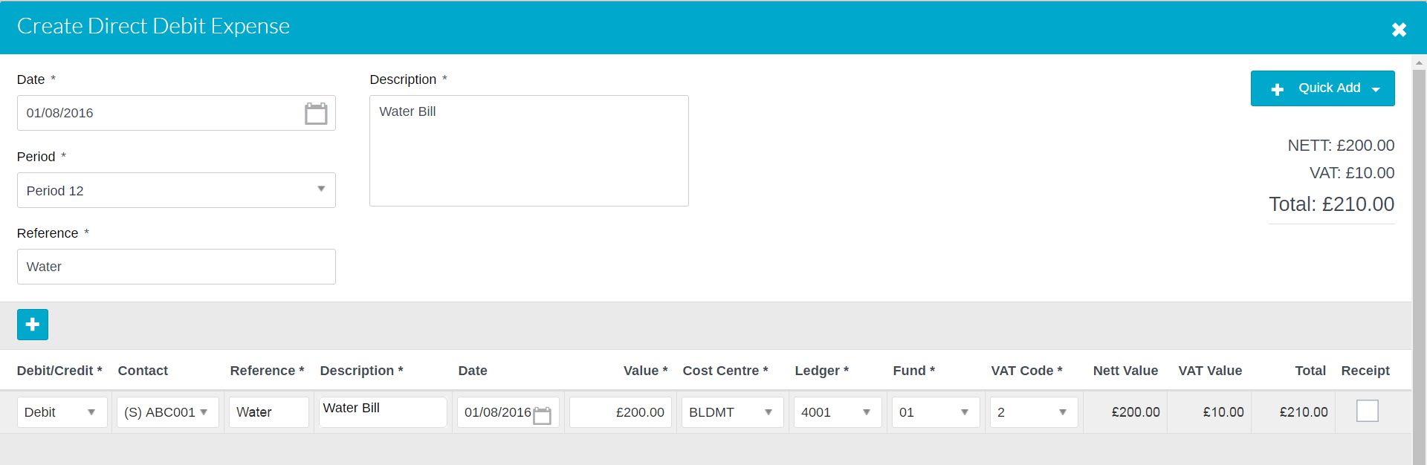

Click on to add a Direct Debit Expense Item line, adding the relevant information

Enter a Ref number and click on Submit, Submit and Add Another or Save and Post.

