HCSS Accounting

User Manual

Customers and Suppliers including Catalogue

Contents
1 Introduction 3
2 Suppliers 4
a Add a Supplier 4
b Edit a Supplier 8
c Duplicate a Supplier 9
d Delete a Supplier 10
e Search on Suppliers 11
f Export Current Supplier details into Excel 11
3 Customers 12
a Add a Customer 12
b Edit a Customer 15
c Duplicate a Customer 16
d Delete a Customer 17
e Search on Customers 18
4 Catalogue Codes 19
a Add a Catalogue Code 19
b Edit a Catalogue Code 20
c Duplicate a Catalogue Code 21
d Delete a Catalogue Code 22
e Search on Catalogue Codes 23
f Import Catalogue Codes/Manage Catalogue Codes 23

Introduction

The suppliers, customers and Catalogues are found under the menu Codes followed by:

- Suppliers
- Customers
- Catalogues

Key points:

To ensure suppliers are emailed PO’s and remittance advices when a BAC’s run is completed ensure that the following fields are completed:

- PO email address
- Remittance email address (BACs run will not allow you to select)
- BACs – supplier bank details

Suppliers

Add a Supplier

To view or add a Supplier click once on Suppliers and a list of suppliers will appear.

To add a new Supplier Click on

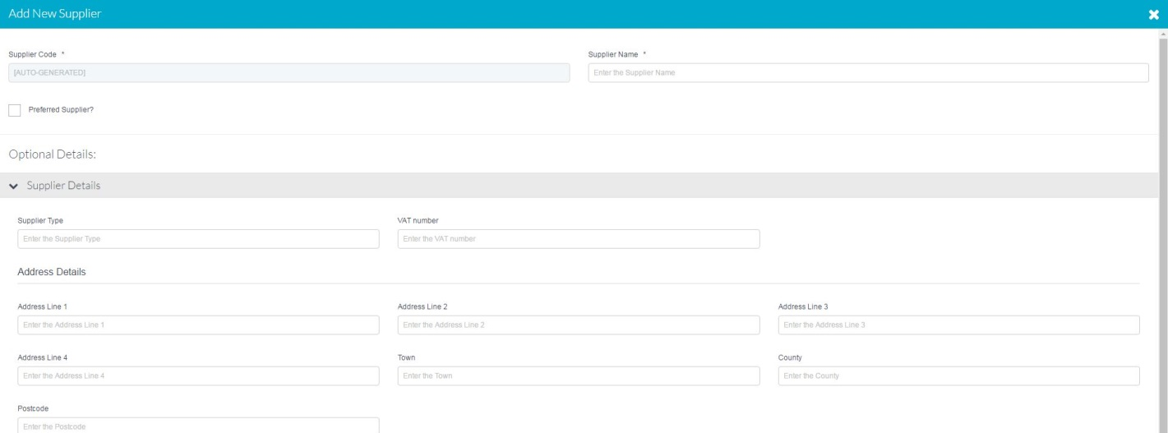

Required Fields

Supplier Code | Either generated automatically or manually – dependant on default settings (Go to System Set Up for more information)
Supplier Name | Supplier Name
Preferred Supplier | This can be marked to show preferred suppliers in the school and an option can be set in Defaults to show only preferred supplier in the drop down selection lists

Supplier Details

Supplier Type | Enter the type of supplier here such as plumber or electrician. This will allow easier searching
VAT Number | VAT Number
Address Details | Supplier Address Details including postcode

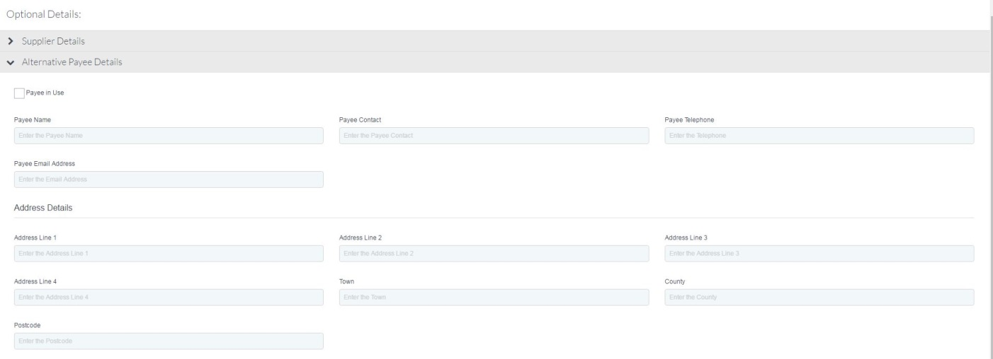

Alternative Payee Details

Payee in Use* | Select this if the school or Academy is using an Alternative Payee to pay supplier invoices.(i.e. they are factoring their debt).
Payee Name* | Payee name
Payee Contact* | Payee Contact
Payee Telephone | Payee telephone number
Payee Email Address | Payee email
Address Details* | Supplier Address Details including postcode
*mandatory fields

NOTE: If alternative payee is selected for a Supplier their name and bank details should be entered under the BANK DETAILS section.

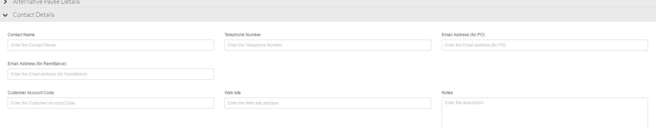
Contact Details

Contact Name | Not a mandatory Field
Telephone | Not a mandatory Field
Email Address(for PO) | Supplier email address. If left blank users will not be able to email POs to suppliers *
Email Address(for Remittance) | Supplier email address. If left blank users will not be able to email POs to suppliers and i  It will also not be selectable on the BACs run list until completed. *
Customer Account Code | Not a mandatory Field
Web Site | Not a mandatory Field
Notes | Not a mandatory Field

* please note that it may be easier to put the school email address in here to ensure that it has been sent and a record is also in your sent items.

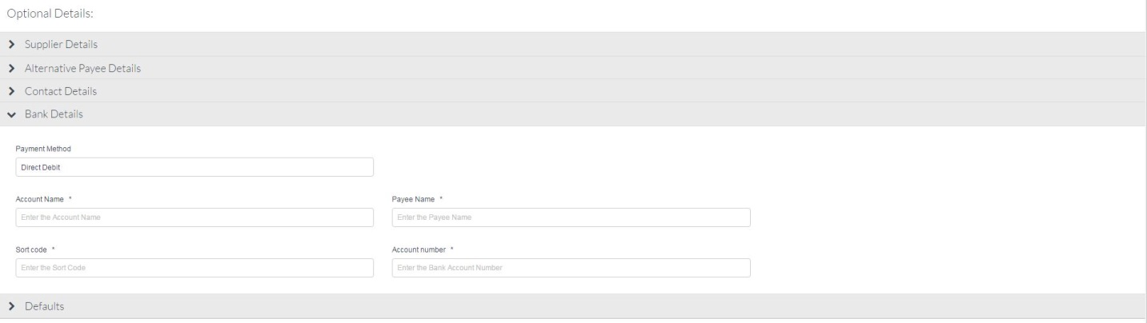
Bank Details

Payment Method | Cheque, BACS or Direct Debit.  The below will only appear if BACS or Direct Debit are chosen
Account name | Mandatory Field
Payee name | If the Supplier has an alternative payee their name and bank details should be entered here
Sort Code | Mandatory Field
Account Number | Mandatory Field

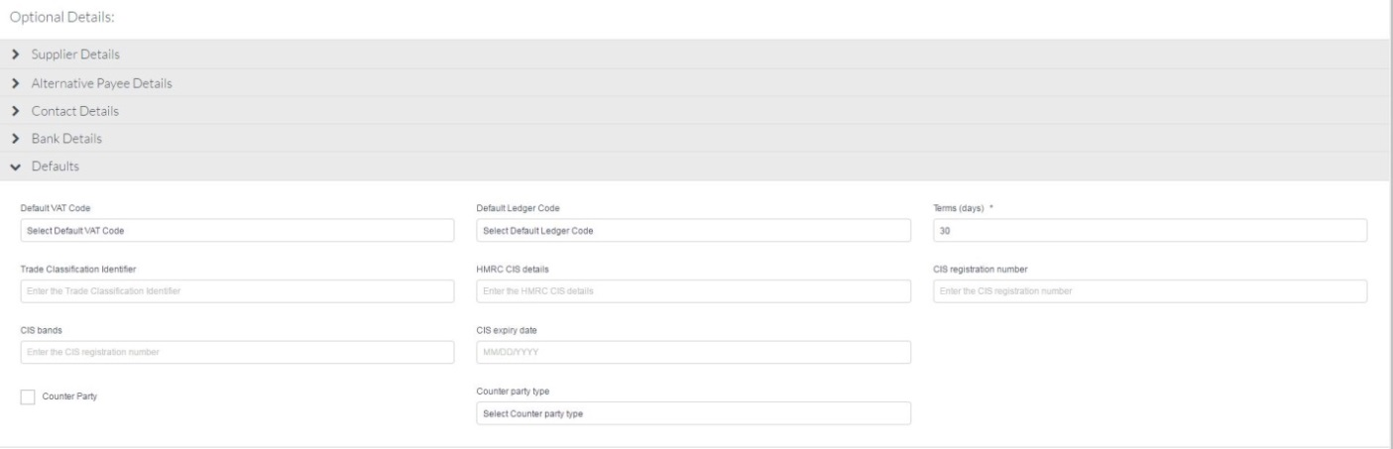

Defaults

Default VAT Code | This can be set against the supplier to allow quicker data entry it can be changed in the transaction
Default Ledger Code | This can be set against the supplier to allow quicker data entry it can be changed in the transaction
Terms | This is used to calculate when an invoice is due for payment
Trade Classification | These details will only be required if they are in the Construction Industry Scheme.
HMRC CIS Details | As above, this will be on the suppliers registration details
CIS Registration Number | As above, this will be on the suppliers registration details
CIS Expiry Date | As above, this will be on the suppliers registration details
Counter Party | Once this tick box is set the supplier will be marked as counter party and a report can be run to show the supplier, county party type balance and their balance
Counter Party Type | This lists the Counter Party types as required by the EFA

Once all the data you require has been entered click on Save or Save and Add Another.

You will get a message telling you the Supplier has been added successfully.

Edit a Supplier

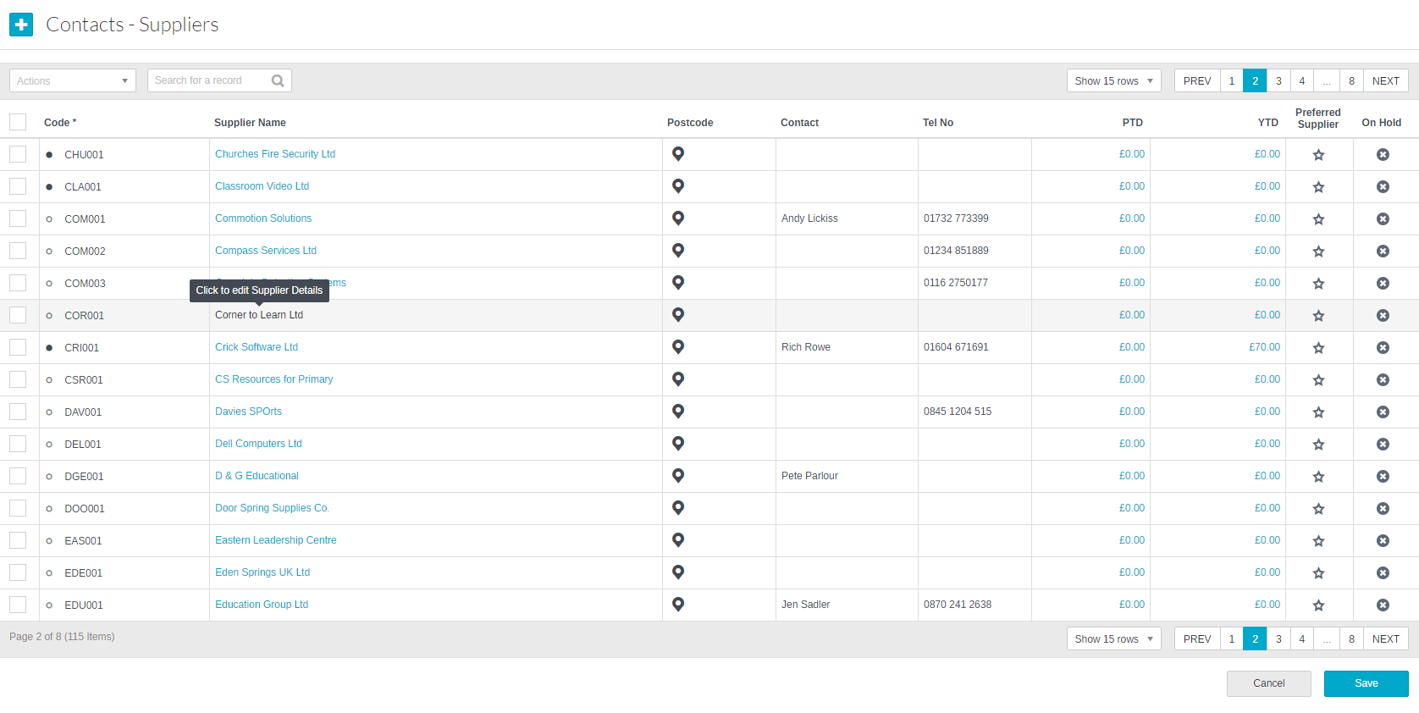

To Edit a Supplier simply click on the Supplier name (it has a hyper link).

This will open up the screens as above and allow you to go directly to the area that needs updating.

Please Note: A dot appears against a Supplier once transactions have been posted against it and it is not possible to change the code.

The browse supplier grid also allows you to edit core supplier information such as contact, email address or telephone number.

To view information on transaction posted against a supplier click on blue hyper link for YTD (Year) or PTD (Current Period).

Duplicate a Supplier

To Duplicate a Supplier, click in the tick box next to the supplier code. At the top of the screen is an actions button

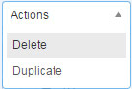

Click on Duplicate and the Supplier screen will open with a copy of the selected supplier information

To create the duplicate Supplier simply enter a new reference and amend any details

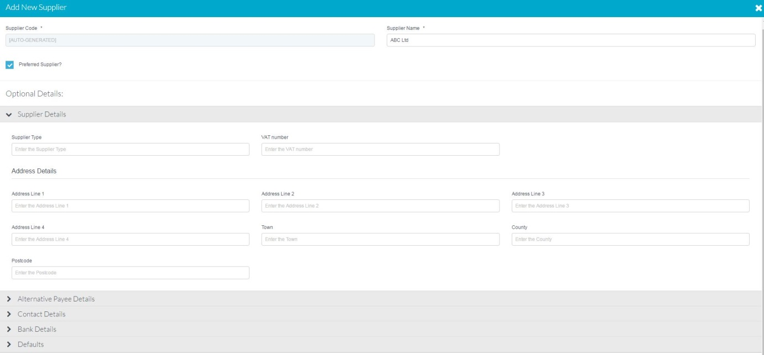

Delete a Supplier

To delete a Supplier, click in the tick box next to the supplier code. At the top of the screen is an actions button

Click on the Delete button, a message will appear asking you to confirm your action.

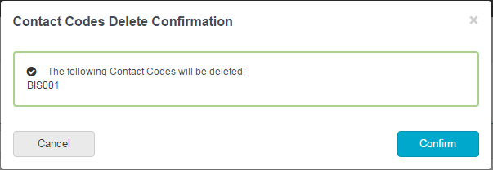

Please note

It is possible to delete more than one supplier at a time by clicking in the tick box next to the suppliers you wish to delete.

It is not possible to delete a Supplier record if there are transactions posted.

Search on Suppliers

Above the grid list of suppliers is a search box. Typing into this box will search on all the fields and bring back a list of suppliers who match the criteria entered.

Click on the column headers in the grid will sort them in ascending or descending order for scrolling through to search.

Export Current Supplier details into Excel

As part of the migration and scoping day your supplier details will be uploaded when you go live. To check these click on Actions and Export to Excel. This will then open supplier details in Excel.

Customers

Add a Customer

To view or add a Customer click once on Customers
A list of existing customers will appear

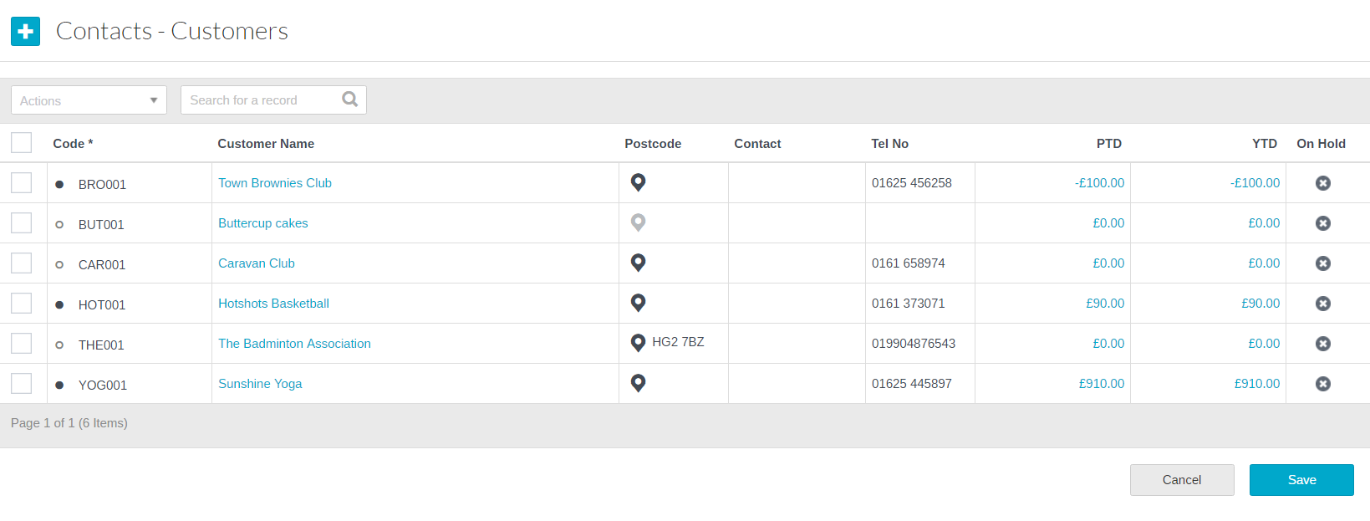
To add a new Customer click on

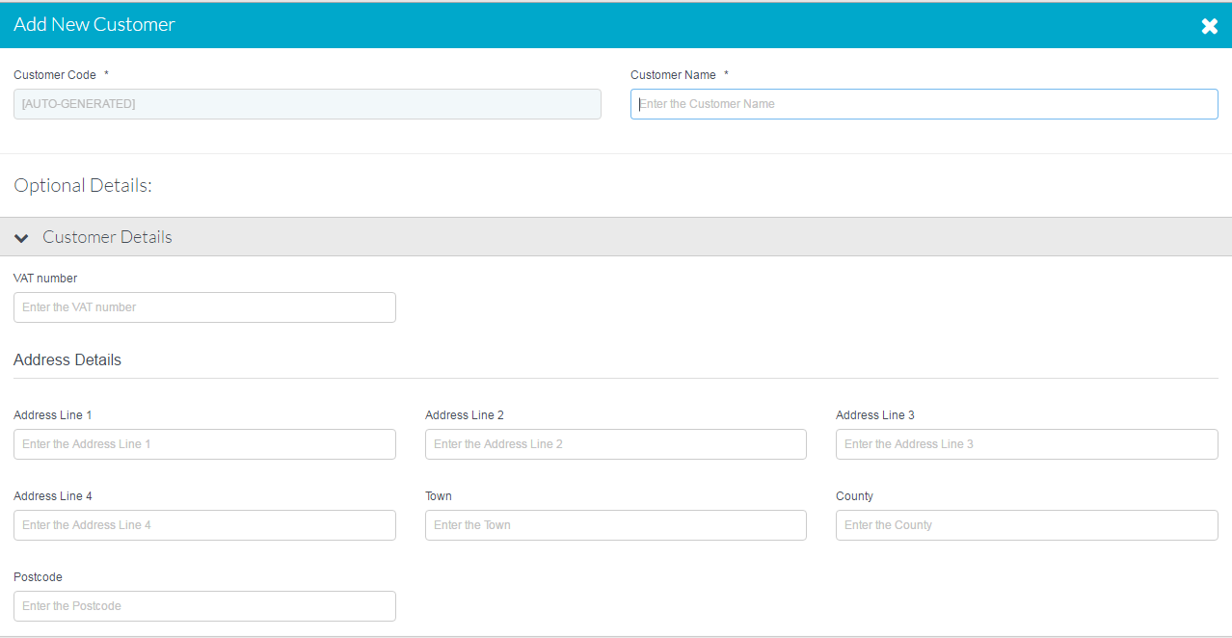

Required Details

Customer Codes | Either generated automatically or manually – dependant on system setting
Customer Name | Customer Name

Customer Details

VAT Number | Not a Mandatory Field
Customer Address | Not a Mandatory Field
Postcode | Not a Mandatory Field

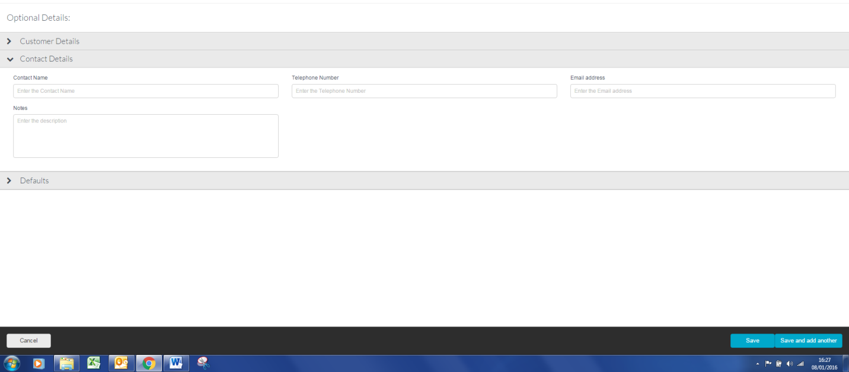

Contact Details

Telephone | Not a mandatory Field
Contact Name | Not a mandatory Field
Email Address | Not a mandatory Field
Notes | Not a mandatory Field

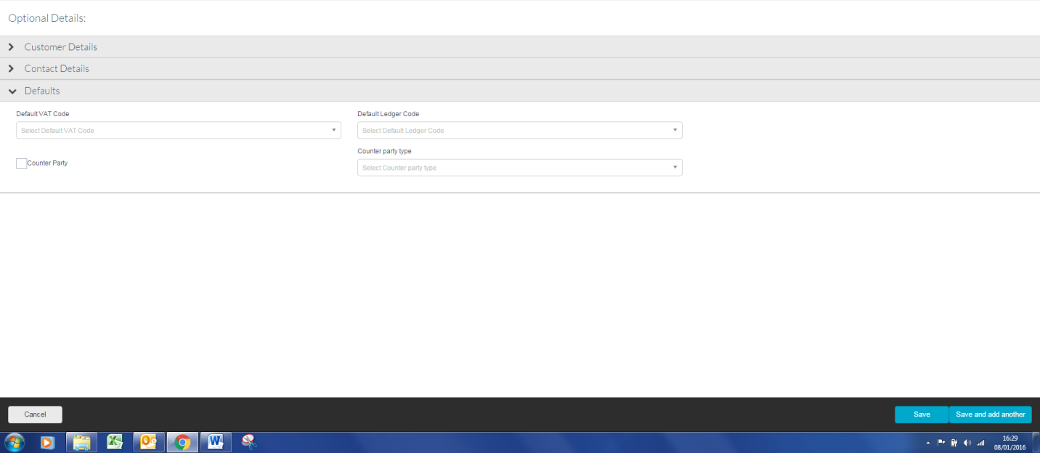

Defaults

Default VAT Code | This can be set against the customer to allow quicker data entry it can be changed in the transaction
Default Ledger Code | This can be set against the customer to allow quicker data entry it can be changed in the transaction
Terms | Terms can be set up so that the information goes to the invoice
Counter Party | Once this tick box is set the customer will be marked as counter party and a report can be run to show the customer, county party type balance and their balance
Counter Party Type | This lists the Counter Party types as required by the EFA

Once all the data you require has been entered click on Save or Save and Add Another.

Edit a Customer

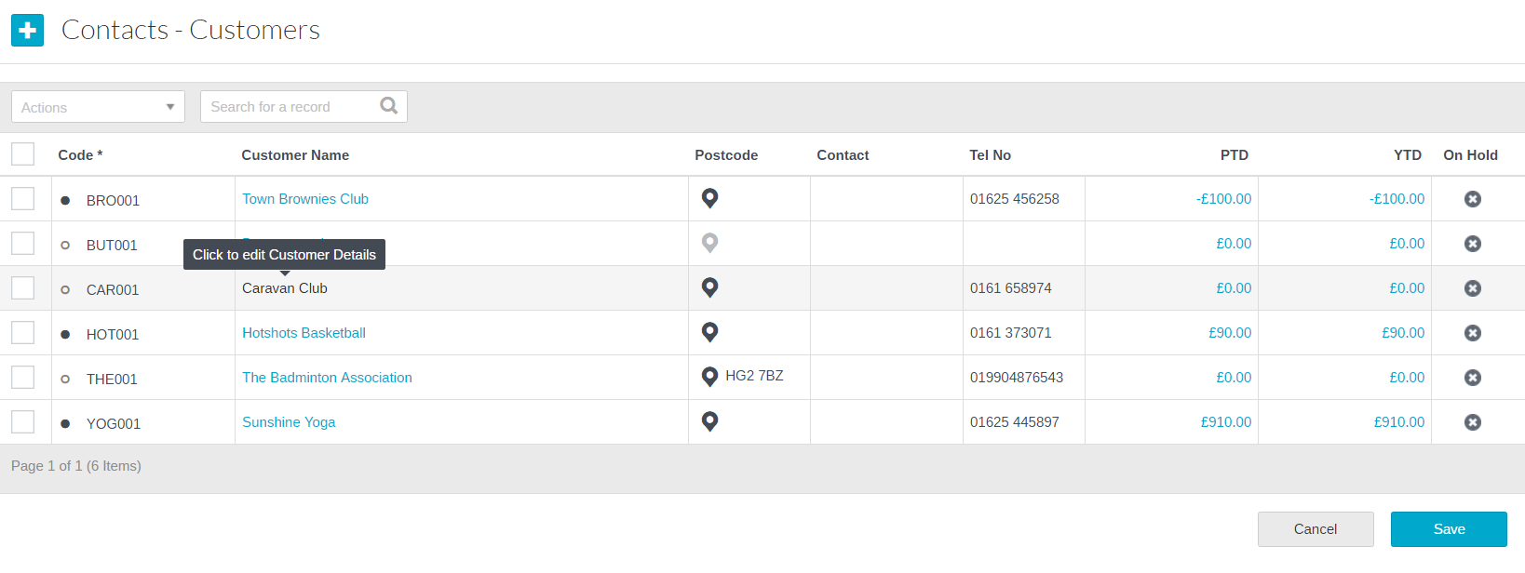
To Edit a Customer simply click on the Customer name (it has a hyper link).

This will open up the wizard again and allow you to go directly to the area that needs updating.

Please Note: A dot appears against a Customer once transactions have been posted against and it is not possible to change the code.

The browse customer grid also allows you to edit core customer information such as contact name, email address or telephone number

To view information on transaction posted against a supplier click on blue hyper link for YTD (Year) or PTD (Current Period).

Duplicate a Customer

To duplicate a Customer, click in the tick box next to the customer code. At the top of the screen is an actions button

Click on the Duplicate button and an input wizard will appear with a copy of the customer information.

To create the duplicate Customer simply enter a new reference and amend any details

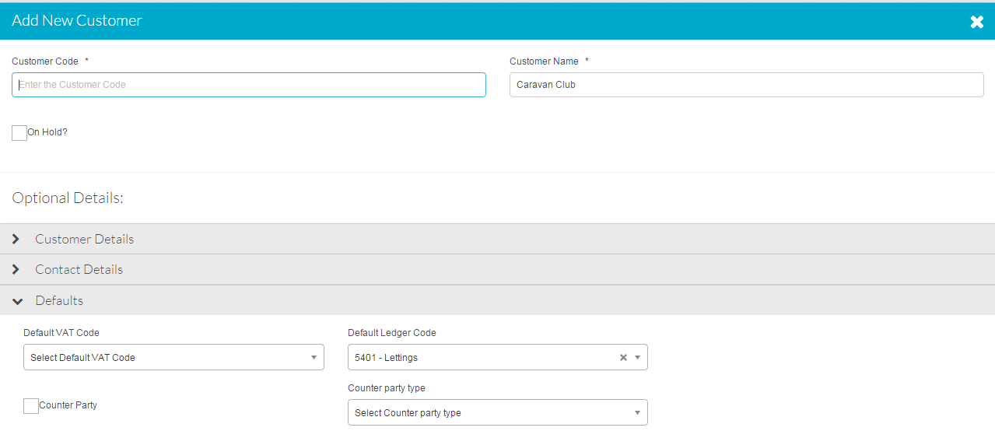

Delete a Customer

To delete a Customer, click in the tick box next to the customer code. . At the top of the screen is an actions button

Click on the Delete button, a message will appear asking you to confirm your action

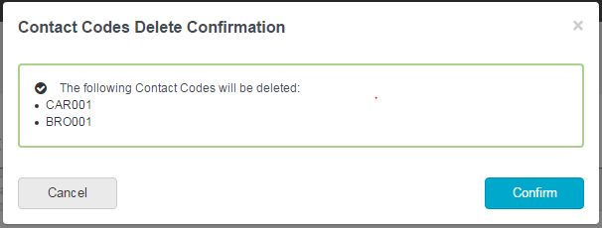

It is possible to delete more than one customer at a time by clicking in the tick box next to the customers you wish to delete.

It is not possible to delete a Customer record if there are transactions posted.

Search on Customers

Above the grid list of customers is a search box. Typing into this box will search on all the fields and bring back a list of customers who match the criteria entered.

Simply clicking on the column headers in the grid will sort them in ascending or descending order for scrolling through to search.

Catalogue Codes

Add a Catalogue Code

A list of existing Catalogue Codes will appear

The option to either Browse or Import will be given.
Select Browse

A list of existing Catalogue Codes will appear

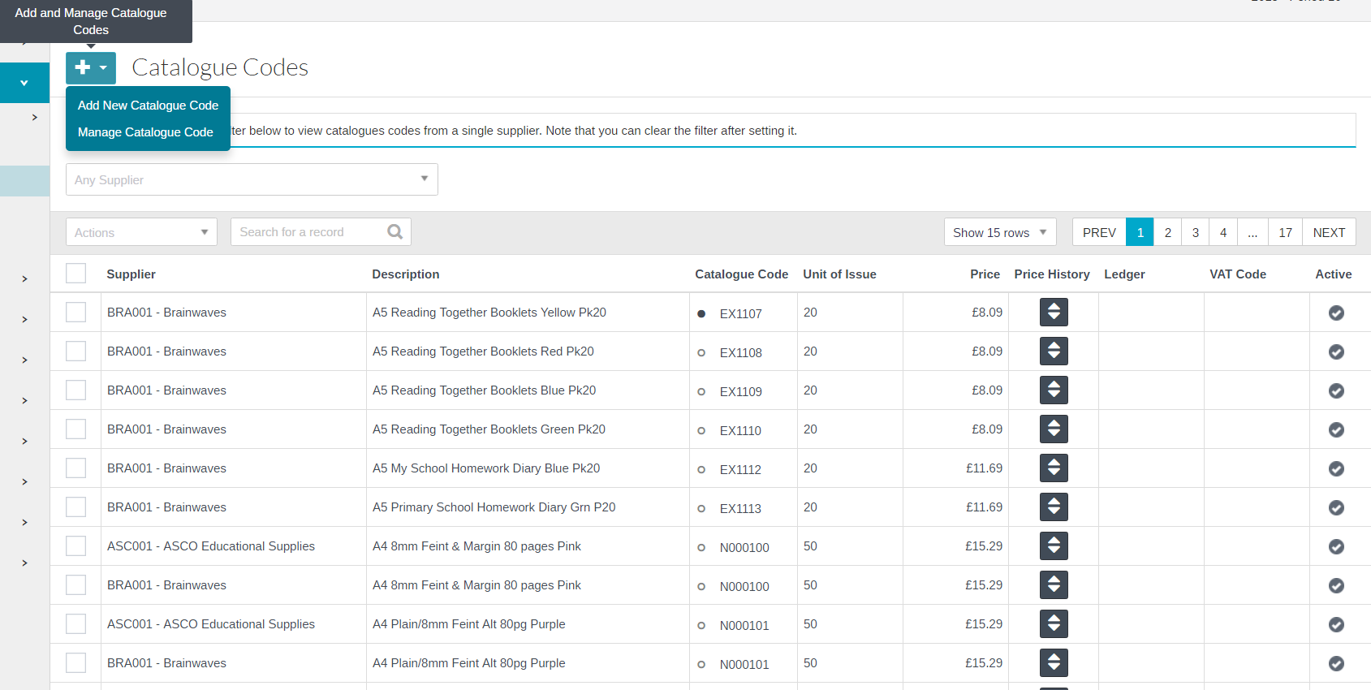

To add a new Catalogue Code click on and select add a new catalogue code

The following screen will appear:

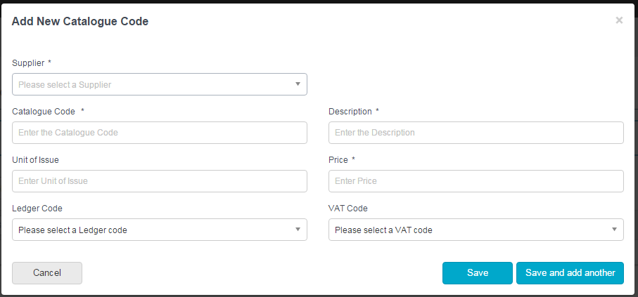

Add a New Catalogue Code

Supplier | Add a Supplier Name
Catalogue Code | Enter the Catalogue Code
Description | Enter the description of the catalogue item
Unit of Issue | Enter the units of issue for the product/service
Price | Enter the price
Ledger Code | To set default ledger Code for the catalogue code, making data entry on transactions quicker.
VAT Code | To set default VAT code for the catalogue code, making data entry on transactions quicker.

Click on Save or Save & add another to save down the code. It will be added to the bottom of the list.

Edit a Catalogue Code

Editing a Catalogue Code can be done with in the browse grid list of Catalogue codes

Click in any of the fields to change the relevant details then click on Save Changes at the bottom of the screen.
A dot appears against a Catalogue Code once transactions have been posted against it and it is not possible to change the code.

To make Catalogue codes not active tick the action box next to the code and select Make Inactive from the drop down list and click on Save

To change the price history click on by the side of the catalogue item. This will allow you to add a new price to the code and the start date in comes into effect.

Duplicate a Catalogue Code

To duplicate a Catalogue Code, click in the tick box next to the Catalogue code. Then Click on Duplicate under Actions box

Click on the Duplicate button an entry screen will appear with a copy of the Catalogue code information. To create the duplicate Catalogue Code simply enter a new code.

Delete a Catalogue Code

To delete a Catalogue Code, click in the tick box next to the Catalogue code. Then Click on Delete under Actions box

A message will appear asking you to confirm your action

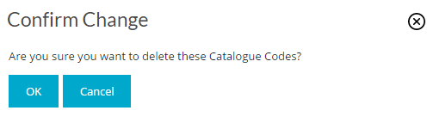

It is possible to delete more than one Catalogue code at a time by clicking in the tick box next to the Catalogue codes you wish to delete.

It is not possible to delete a Catalogue Code if there are transactions posted however it is possible to inactivate a Catalogue Code which would stop them appearing in any selection lists

Search on Catalogue Codes

Above the grid list of Catalogue codes is a search box. Typing into this box will search on all the fields and bring back a list of Catalogue codes which match the criteria entered.

Simply clicking on the column headers in the grid will sort them in ascending or descending order for scrolling through to search, or a specific supplier, ledger code or description can be chosen through the search field above each column.

f Import Catalogue Codes/Manage Catalogue Codes

Click on Manage Catalogue Codes

Select a Supplier

Click on Browse Files followed by to update supplier information or to remove a supplier catalogue

HCSS Accounting can accept CSV or TXT files with a header. The column order is:
Code Description Unit Price
If the file does not have a header or is not that column format it will not upload. The user will get an error message telling them to contact the Customer Support Desk.
Customer Support can remotely access and get the file from the school using TeamViewer
The steps to be taken on the file:
- Check that the file is CSV or TXT
- If it isn’t either of these open the file in Excel and save as CSV or TXT (Development can help)
- Open the file and check the column order
- If the column order is incorrect, change it to
  - Code Description Unit Price
- Check the file has a header
- If it doesn’t insert a header in format
  - Code Description Unit Price
- Re-upload

