HCSS Accounting

User Manual

Chart of Accounts

Contents
1 Introduction 4
2 Fund Codes 5
a Add a Fund Code 5
b Edit a Fund Code 6
c Duplicate a Fund Code 6
d Delete a Fund Code 7
e Search on Fund Codes 7
3 Ledger Codes 9
a Add a Ledger Code 9
b Edit a Ledger Code 10
c Duplicate a Ledger Code 11
d Delete a Ledger Code 11
e Search on Ledger Codes 13
f Export transactions on Ledger Codes 13
4 Cost Centres 14
a Add a Cost Centre 14
b Edit a Cost Centre 14
c Duplicate a Cost Centre 15
c Delete a Cost Centre 16
d Search on Cost Centres 17
5 Cost Centre Groups 18
a Add a Cost Centre Group 18
b Edit a Cost Centre Group 19
c Duplicate a Cost Centre Group 20
d Delete a Cost Centre Group 21
6 Cost Centre Group Sequence 22
7 Code Mapping 23
a Map a Ledger Code with a Cost Centre 23
b Unmap a Ledger Code and a Cost Centre 24
c View Mappings and Export to Excel 25
8 Analysis Codes 26
a Add an Analysis Code 26
b Edit an Analysis Code 26
c Duplicate an Analysis Code 27
d Delete an Analysis Code 27
e Search on Analysis Codes 29
9 ISB Codes 29
10 VAT Codes 30
a Add a VAT Code 30
b Edit a VAT Code 30
c Duplicate a VAT Code 31
d Delete a VAT Code 32
e Search on VAT Codes 33

Introduction

The menu path for chart of accounts is under Codes > Chart of Accounts followed by which area you would like to look at. These areas are:

- Fund Codes
- Ledger Codes
- Cost Centres
- Cost Centre Groups
- Code Mapping
- Analysis Codes

Please note: Where there is an Actions Box within the screen for fund codes, ledger codes and cost centres this is where you can ‘Set to Active OR Inactive’ via the drop down box.

Fund Codes

Add a Fund Code

Click on Fund Codes, and a list of existing Fund Codes will appear

To add a new Fund Code click on

The following screen will appear:

Fund Code | Enter a Fund Code
Description | Enter a Fund description
Fund Type | Enter a Fund Type from the pick list

Click on Save or Save & add another to save down the code. It will be added to the bottom of the list.

Edit a Fund Code

Editing a Fund Code can be done with in the browse grid list of fund codes

Click in either the Code or Description field to change the relevant details then click on Save at the bottom of the screen.
A dot appears against a Fund Code once transactions have been posted against it and it is not possible to change the code.

To make Fund codes inactive tick the action box next to the code and select ‘Set To Inactive’ from the drop down list and click on Save

Duplicate a Fund Code

To duplicate a Fund Code, click in the tick box next to the fund code. At the top of the screen is an actions button

Click on the Duplicate button and entry screen will appear with a copy of the fund code information. To create the duplicate Fund Code simply enter a new reference.

Once completed click on Save or Save and add another

Delete a Fund Code

To delete a Fund Code, click in the tick box next to the fund code. At the top of the screen is an actions button
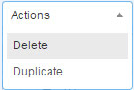
Click on the Delete button a message will appear asking you to confirm your action

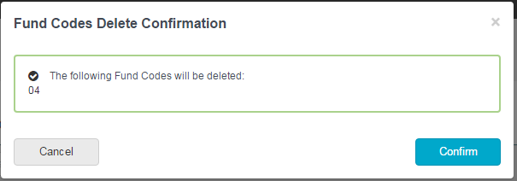

It is possible to delete more than one fund code at a time by clicking in the tick box next to the fund codes you wish to delete.

It is not possible to delete a Fund Code if there are transactions posted.

Search on Fund Codes

Above the grid list of fund codes is a search box. Typing into this box will search on all the fields and bring back a list of fund codes which match the criteria entered.

Simply clicking on the column headers in the grid will sort them in ascending or descending order for scrolling through to search.

Ledger Codes

Add a Ledger Code

Click on Ledger Codes, and a list of existing Ledger Codes will appear

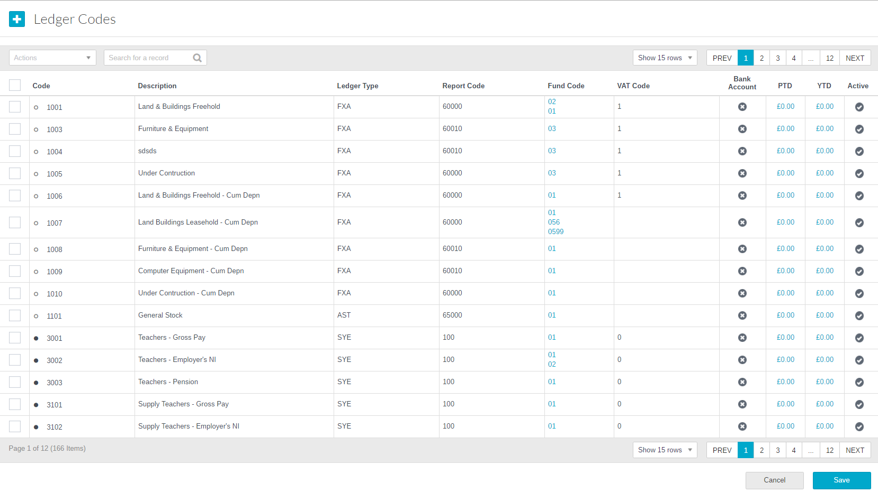
To add a new Ledger Code click on

The following screen will appear:

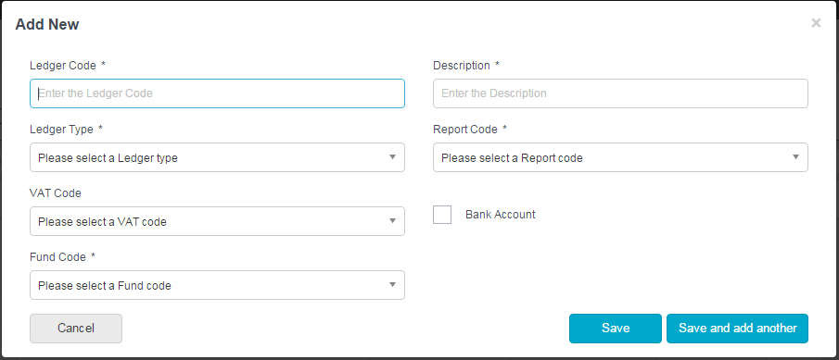

The minimum requirements for a Ledger code are Code, Description, Report Code and Ledger Type.

Ledger Code | Enter a Ledger Code
Description | Enter a Ledger Description
Fund Code | A drop down list showing Funds available. If Funds are not used will automatically default System Fund *
Report Code | A drop down list of Report codes which will be used to create standard reports. Pre Defined
Ledger Type | Drop Down list of ledger type Pre Defined – See Below
VAT Code | A default VAT for the ledger code can be selected here
Bank Account | Tick to denote if the ledger code is a bank account or petty cash account (Please note only one active bank account allowed.

* Please note – this denotes where in the P and L or Balance Sheet the ledger is accounted for, so these do need to be carefully selected.

Click on Save or Save & add another to save down the code. It will be added to the bottom of the list.

Edit a Ledger Code

Editing a Ledger Code can be done with in the browse grid list of ledger codes

Click in any of the fields to change the relevant details then click on Save Changes at the bottom of the screen.
A dot appears against a Ledger Code once transactions have been posted against it and it is not possible to change the code.

To make Ledger codes inactive tick the action box next to the code and select ‘Set To Inactive’ from the drop down list and click on Save. (the Active column will change to a X)

Duplicate a Ledger Code

To duplicate a Ledger Code, click in the tick box next to the ledger code. At the top of the screen is an actions button

Click on the Duplicate button and an entry screen will appear with a copy of the ledger code information. To create the duplicate Ledger Code simply enter a new code.

All the fields are editable so changes can be made to any of the fields.

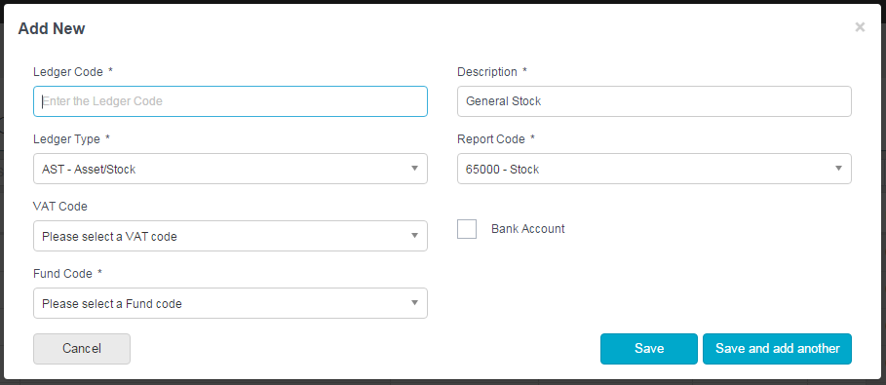

Delete a Ledger Code

To delete a Ledger Code, click in the tick box next to the ledger code. At the top of the screen is an actions button

Click on the Delete button and the following message will appear asking you to confirm your action

It is possible to delete more than one ledger code at a time by clicking in the tick box next to the ledger codes you wish to delete.

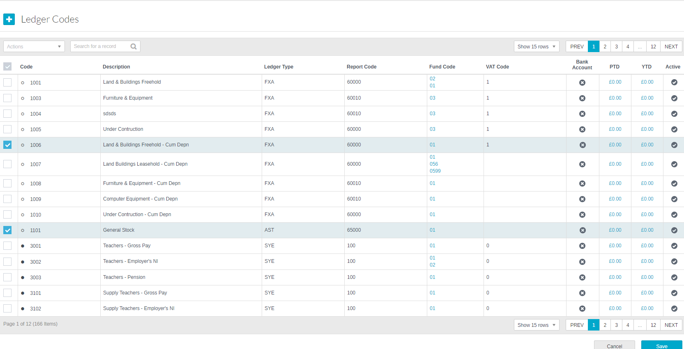

It is not possible to delete a Ledger Code if there are transactions posted.

Search on Ledger Codes

Above the grid list of ledger codes is a search box. Typing into this box will search on all the fields and bring back a list of ledger codes which match the criteria entered.

Simply clicking on the column headers in the grid will sort them in ascending or descending order for scrolling through to search.

Export transactions on Ledger Codes

To download the transactions that are against a ledger, click in the relevant hyperlink PTD and YTD. Once in this screen click on Export to export list to excel

Cost Centres

Add a Cost Centre
To add a new Cost Centre click on

The following screen will appear:

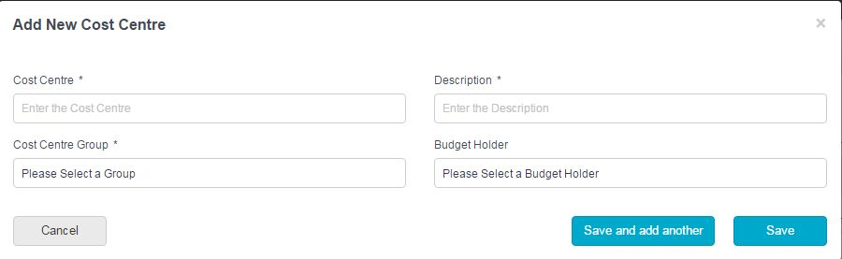

The minimum requirements for a Cost Centre are Code, Description and Budget Group

Cost Centre | Enter the Cost Centre Code
Description | Enter the Cost Centre Description
Cost Centre Group | A drop down list of all available cost centre groups.  These groups allow quicker reporting.
Budget Holder | Selecting a budget holder it denotes them as the budget owner and will automatically default the Cost Centre on Purchase Requisitions.  Defines what a user/profile will be able to access.

Click on Save or Save & add another to save down the code. It will be added to the bottom of the list.

Edit a Cost Centre

Editing a Cost Centre can be done with in the browse grid list of Cost Centres

Click in the Code, Description or Group field to change the relevant details then click on Save Changes at the bottom of the screen.
A dot appears against a Cost Centre once transactions have been posted against it and it is not possible to change the code.

To make Cost Centres not active tick the action box next to the code and select Make Inactive from the drop down list and click on Save

c Duplicate a Cost Centre

To duplicate a Cost Centre, click in the tick box next to the Cost Centre. At the top of the screen is an actions button

Click on the Duplicate button and entry screen will appear with a copy of the Cost Centre information. To create the duplicate Cost Centre, simply enter a new reference.

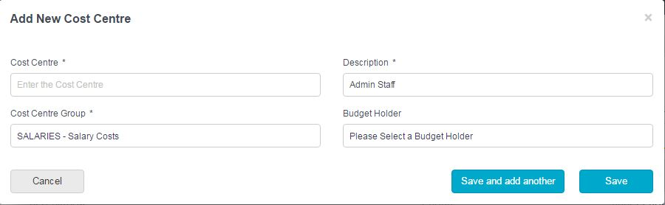

All the fields are editable so changes can be made to any of the fields.

Delete a Cost Centre

To delete a Cost Centre, click in the tick box next to the Cost Centre. At the top of the screen is an actions button

Click on the Delete button a message will appear asking you to confirm your action

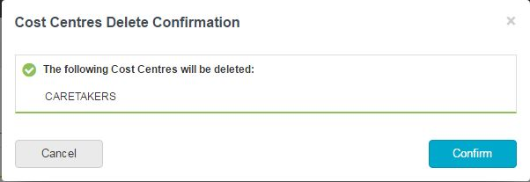

It is possible to delete more than one Cost Centre at a time by clicking in the tick box next to the Cost Centres you wish to delete.

A Cost Centre cannot be deleted if there are transactions posted.

A dot appears against a Cost Centre once transactions have been posted against it and it is not possible to change the code.

To make cost centres inactive tick the action box next to the code and select ‘Set To Inactive’ from the drop down list and click on Save.

Search on Cost Centres

Above the grid list of Cost Centres is a search box. Typing into this box will search on all the fields and bring back a list of Cost Centres which match the criteria entered.

Simply clicking on the column headers in the grid will sort them in ascending or descending order for scrolling through to search.

Cost Centre Groups

Add a Cost Centre Group

Cost Centre Groups are attached to cost centres and can be sequenced making enquiries and reporting simpler.
To add a new Cost Centre Group click on

The following screen will appear:

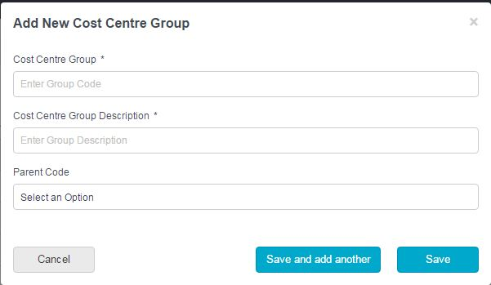

Cost Centre Group | Enter the Cost Centre Group
Cost Centre Group Description | Enter the Cost Centre Group Description
Parent Code | If you want to add a sub-group to a Cost Centre Group, add a code in the way described above and then select the Parent Group you wish it to be part of.

Click on Save or Save & add another to save down the code. It will be added to the bottom of the list.

Edit a Cost Centre Group

To edit a Cost Centre Group click on
The following screen will appear
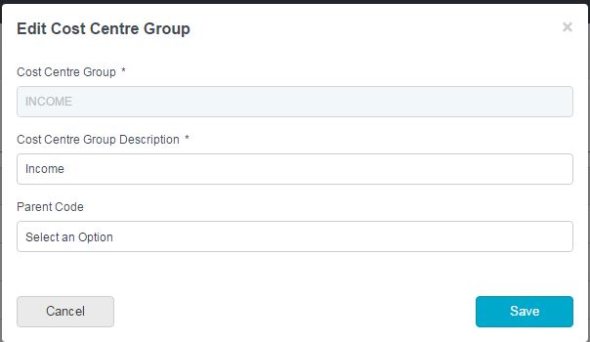

Click in the Code, Description or Parent Group field to change the relevant details then click on Save Changes at the bottom of the screen. If the Cost Centre Group is a Parent Group this cannot be edited.
A dot appears against a Cost Centre Groups once transactions have been posted and it is not possible to change the code.

Duplicate a Cost Centre Group
To duplicate a Cost Centre Group, click on

An entry screen will appear with a copy of the Cost Centre Groups’ information. To create the duplicate Cost Centre Group simply enter a new reference.
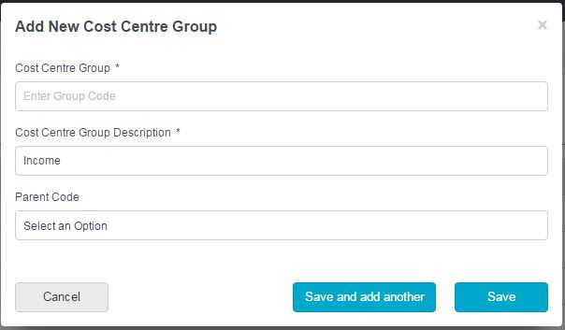

Delete a Cost Centre Group

To delete a Cost Centre Group, click on

Click on the Delete button a message will appear asking you to confirm your action

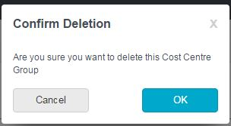

It is not possible to delete a Cost Centre Group if it has a Cost Centre against it. All Cost Centres will need to be removed and then the budget group can be deleted.

Cost Centre Group Sequence
To set the Cost Centre Group Sequence click on to the left of the Cost Centre Group Name and drag the code to where it is required.

Code Mapping

Map a Ledger Code with a Cost Centre

Cost Centres can be linked to Ledger Codes to ensure that when transactions are posted they go to the correct code and budget.

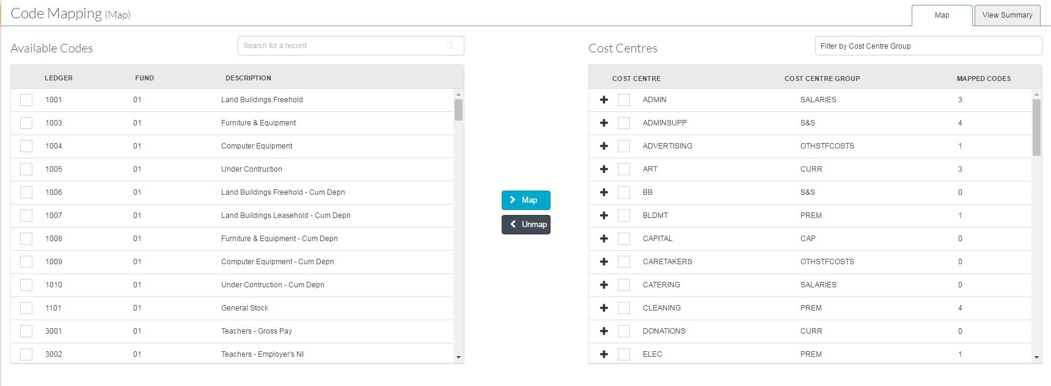

To link the codes together simply chose the ledger code and the Cost Centres by ticking in the box alongside them and click on .

* Please note - There are search facilities at the top of the screen:

For Leger codes – you can type code in and click on search
For Cost Centres – you can click on pick list to filter by Budget Group

A message will appear saying that the codes have been mapped successfully.
By clicking on the arrow next to the Cost Centre, a list of mapped Ledger Codes will be shown.
Click on to open Cost Centre and see which Leger Codes have been mapped.

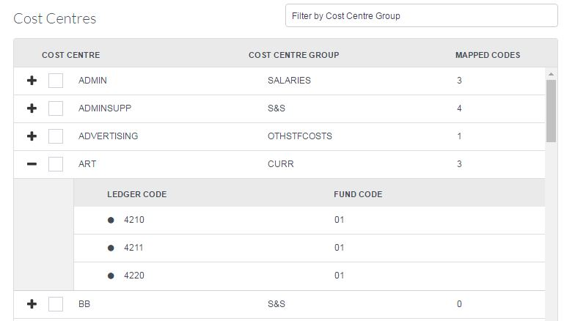

Unmap a Ledger Code and a Cost Centre

The Ledger Codes can be unmapped from the Cost Centres by clicking in the tick box next to the ledger code and clicking on

A warning message will appear to confirm the unmap

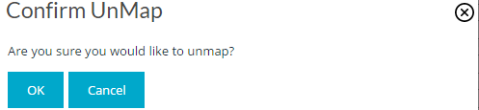

Clicking on OK will unmap the codes.

View Mappings and Export to Excel

It is possible to view and export the codes that have been mapped by clicking on the Summary tab

The following screen shows:

The grid can be sorted by clicking on the column headers or filtered by Cost Centre.
To clear the filter click on

If the Cost Centre/ledger link is no longer valid this can be removed by clicking on

Please Note a link cannot be removed if transactions have been posted against it

To export to excel click on the Export to Excel button. This will then produce a report for information.

Analysis Codes

Add an Analysis Code
To add a new Analysis Code click on

The following screen will appear:

Analysis Code | Enter an Analysis Code
Description | Enter an Analysis Code Description
Fund Type | Enter the fund code type

Click on Save or Save & add another to save down the code. It will be added to the bottom of the list.

Edit an Analysis Code

Editing an Analysis Code can be done with in the browse grid list of analysis codes

Click in either the Code or Description field to change the relevant details then click on Save at the bottom of the screen.
A dot appears against an Analysis Code once transactions have been posted against it and it is not possible to change the code.

To make Analysis codes not active tick the action box next to the code and select Make Inactive from the drop down list and click on Save

Duplicate an Analysis Code

To duplicate an Analysis Code, click in the tick box next to the analysis code. At the top of the screen is an actions button

Click on the Duplicate button and entry screen will appear with a copy of the analysis code information.

To create the duplicate Analysis Code simply enter a new reference and click on Save or Save and Add Another

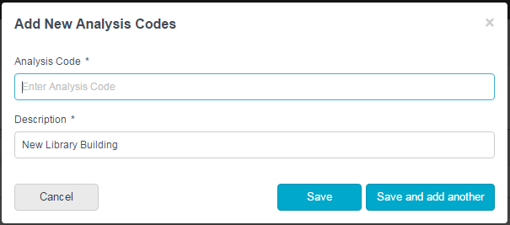

Delete an Analysis Code

To delete an Analysis Code, click in the tick box next to the analysis code. At the top of the screen is an actions button

Click on the Delete button a message will appear asking you to confirm your action

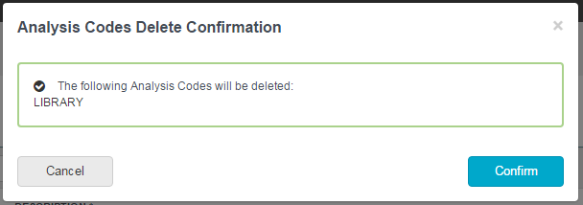

It is possible to delete more than one analysis code at a time by clicking in the tick box next to the analysis codes you wish to delete.

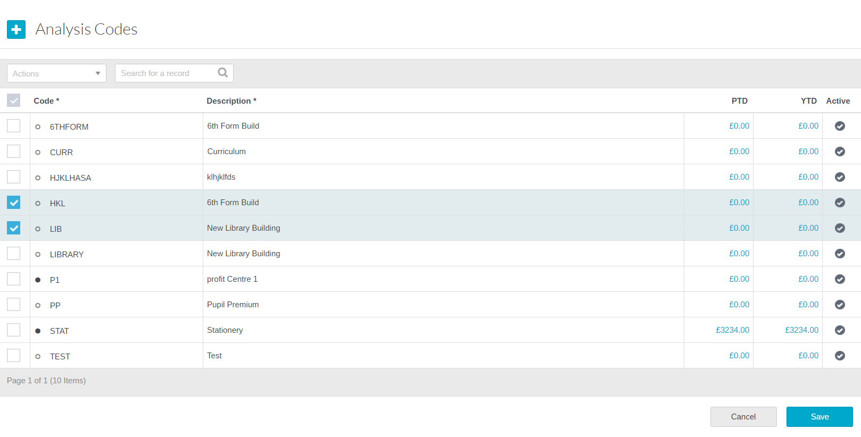

It is not possible to delete an Analysis Code if there are transactions posted.

Search on Analysis Codes

Above the grid list of analysis codes is a search box. Typing into this box will search on all the fields and bring back a list of analysis codes which match the criteria entered.

Simply clicking on the column headers in the grid will sort them in ascending or descending order for scrolling through to search.

ISB Codes

Pre defined – System generated

VAT Codes

Add a VAT Code
To add a new VAT Code click on

The following screen will appear:

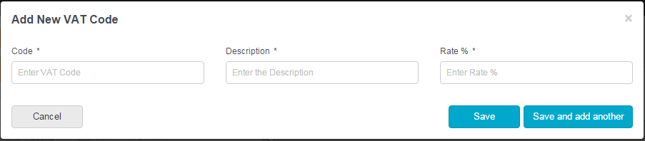
Code | Enter a code to be used
Description | Enter VAT description
Rate % | Enter VAT rate as a percentage

Click on Save or Save & add another to save down the code. It will be added to the bottom of the list.

Edit a VAT Code

Editing a VAT Code can be done with in the browse grid list of VAT codes
Click in either the Code or Description field to change the relevant details then click on Save Changes at the bottom of the screen.
To make VAT codes not active tick the action box next to the code and select Make Inactive from the drop down list and click on Save – must not be in use.
To change the VAT rate click on by the side of the code. This will allow you to add a new % rate to the code and the start date in comes into effect.
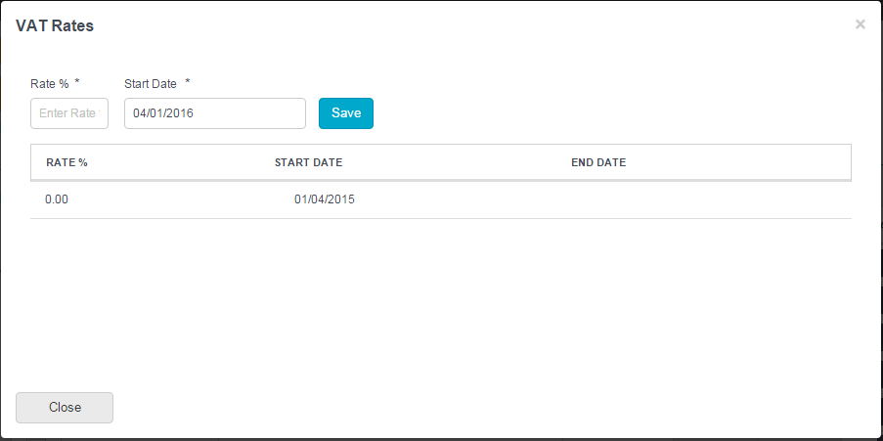
The new rate will be applied to transactions based on the invoice date entered.
A dot appears against a VAT Code once transactions have been posted against it and it is not possible to change the code.

Duplicate a VAT Code

To duplicate a VAT Code, click in the tick box next to the VAT code. At the top of the screen is an actions button

Click on the Duplicate button and an entry screen will appear with a copy of the VAT code information. To create the duplicate VAT Code simply enter a new reference and click on Save

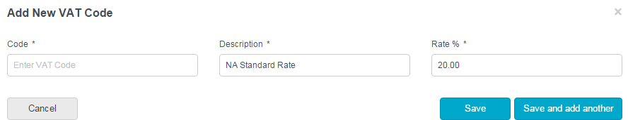

Delete a VAT Code

To delete a VAT Code, click in the tick box next to the VAT code. . At the top of the screen is an actions button

Click on the Delete button a message will appear asking you to confirm your action

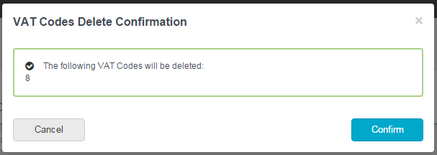

It is possible to delete more than one VAT code at a time by clicking in the tick box next to the VAT codes you wish to delete.

It is not possible to delete a VAT Code if there are transactions posted.

Search on VAT Codes

Above the grid list of VAT codes is a search box. Typing into this box will search on all the fields and bring back a list of VAT codes which match the criteria entered.

Simply clicking on the column headers in the grid will sort them in ascending or descending order for scrolling through to search.

