

HCSS Accounting

User Manual

*Budgets*

Contents

1 Budgets 3

a Manage Budgets 3

b Profiles 4

c Edit a Profile 5

d Duplicate a Profile 7

e Delete a Profile 7

f Search on Profiles 9

g Virements 10

2 Link to HCSS Budgeting 13

# Budgets

## Manage Budgets

Manage Budgets allows the Finance Manager to create budgets within HCSS Accounting to monitor income and expenditure against budget

Click on **Budgets** and **Manage Budgets**

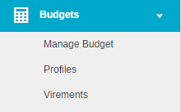

The following screen will appear:

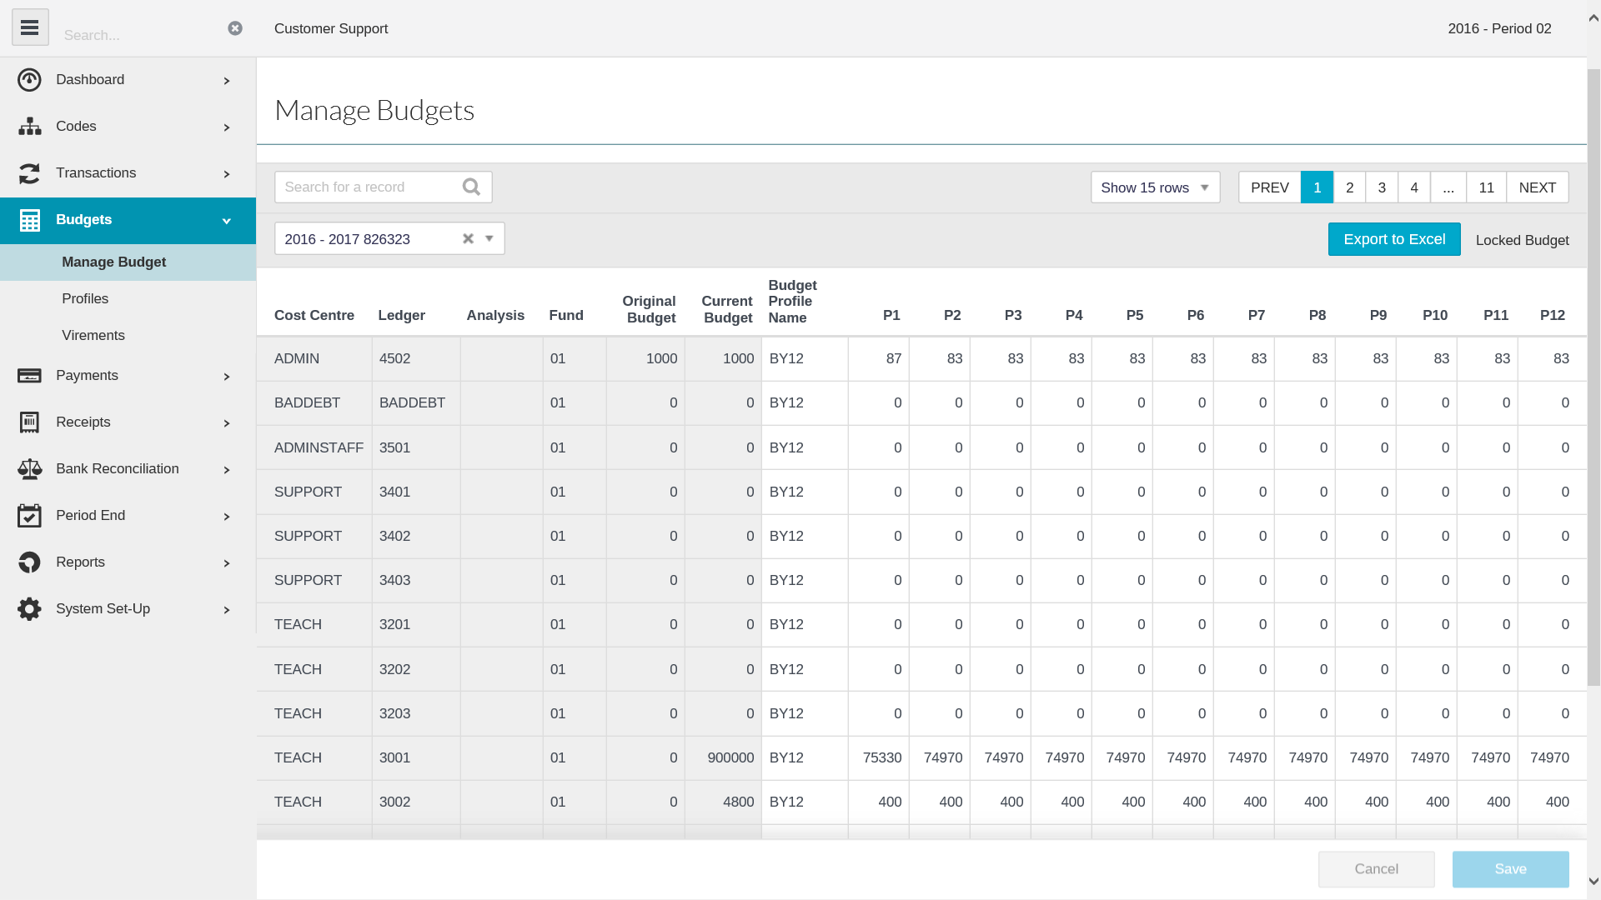

A list of all Cost Centre mapped to Ledger Codes will appear.

Enter the relevant budget against each in the **Original Budget** Column and select a profile to spread the budget over the 12 periods

Click on **Save** to save the profiled budgets.

The **Original Budget** can be locked once approved by the Governors by clicking. (wording changes to Locked Budget)

Any future adjustments will take place in the Current Budget.

To export the budgets to excel click on 

## Profiles



To view or add a Profile click once on **Profiles**

A list of existing profiles will appear

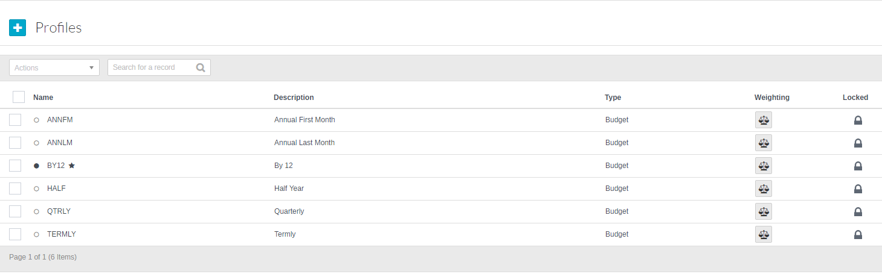

To **add** a new **Profile** click on 

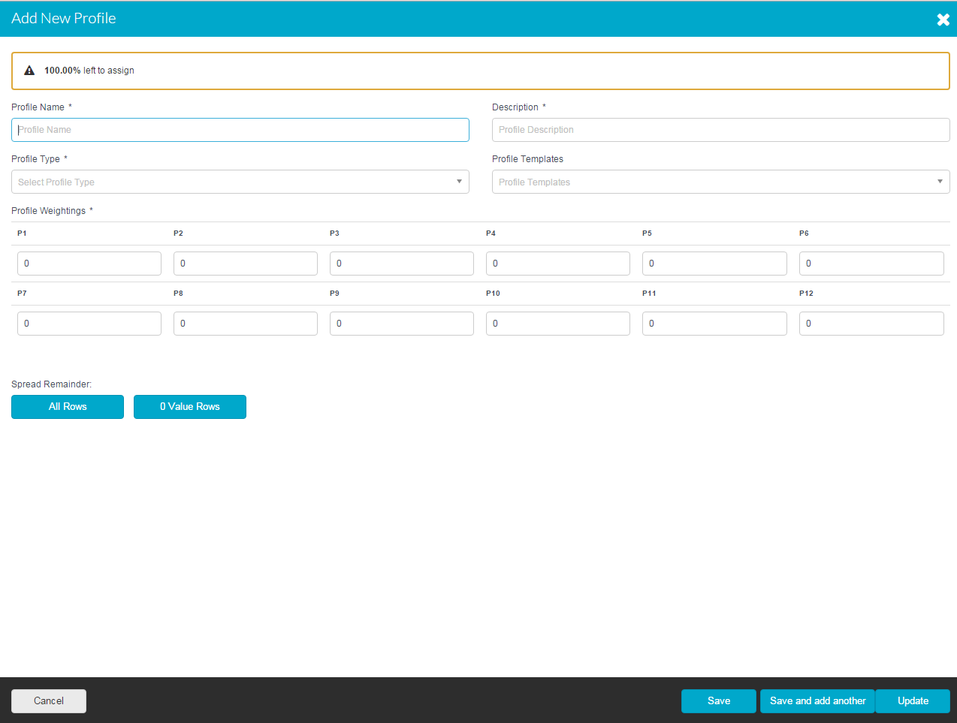

**Required Details**

|  |  |
| --- | --- |
| **Profile Name** | Provide a name for the profile |
| **Description** | Profile description |
| **Profile Type** | Budgeting or Cash Flow |
| **Profile Weightings** | The spread over the 12 periods |
| **Profile Templates** | A list of templates that can be used |

Once all the data you require has been entered click on **Save** or **Save and Add Another.**

The profile is added to the list.

## Edit a Profile

Editing a **Profile** can be done with in the browse grid list of profiles

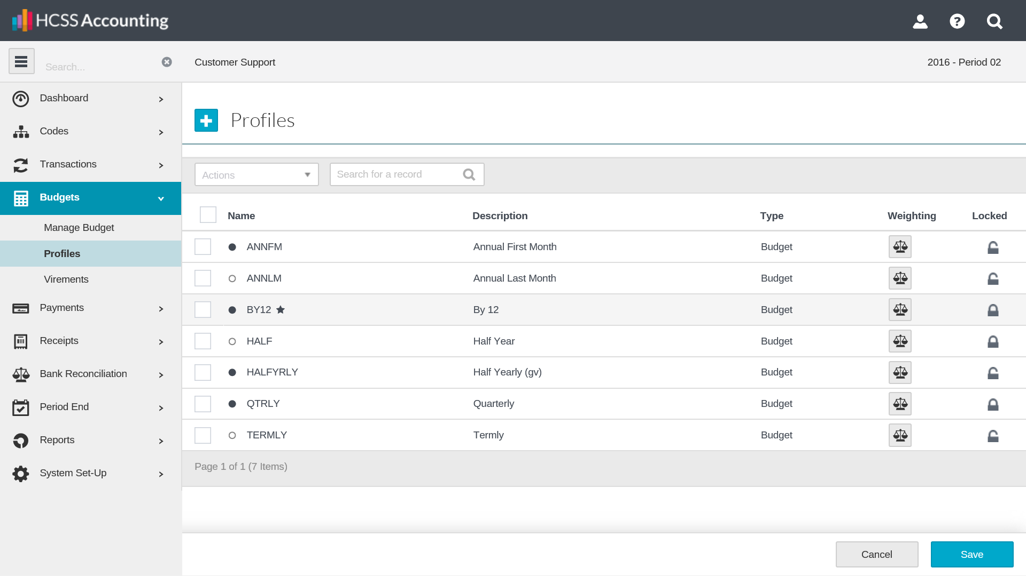

Click in either the **Code** or **Description** field to change the relevant details then click on **Save** at the bottom of the screen.

The weightings can be reviewed/edited by clicking on C:\Users\Danni.Rutherford\Desktop\profiles.png

A new screen will appear:

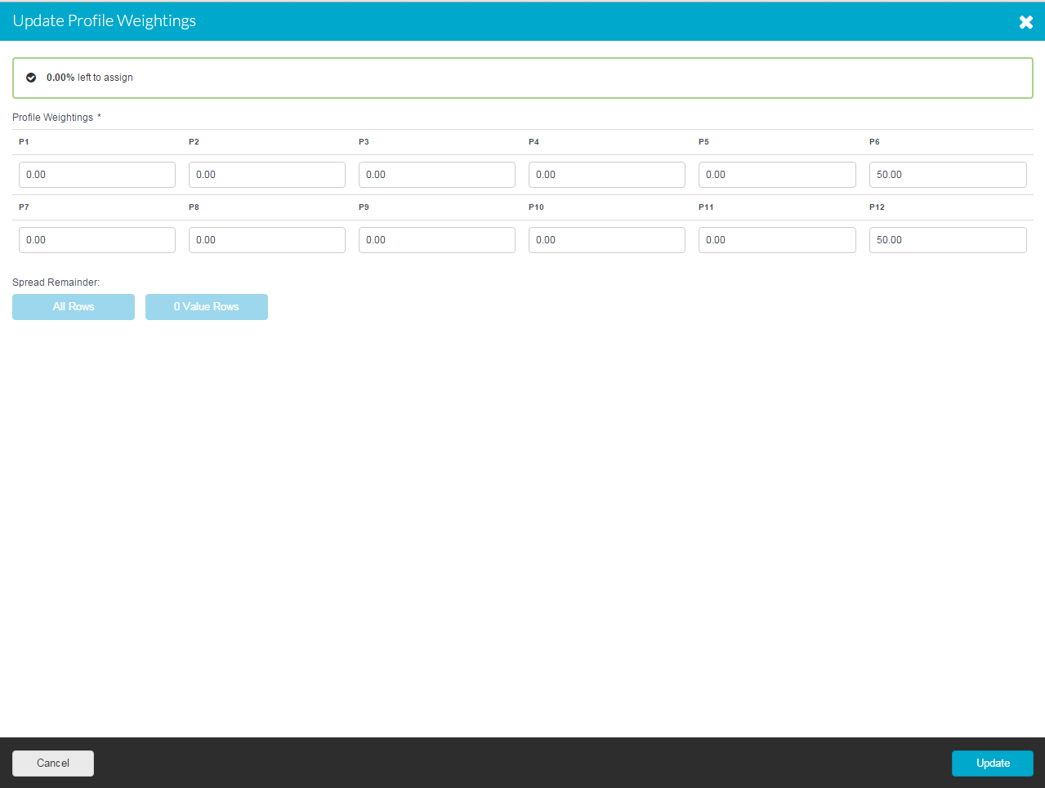

Simply update the details as required and click on **Update**

A dot appears against a **profile** once it has been used against a budget/ledger code. It is not possible to change the Name but all other details can be amended.

To make Profiles not active tick the action box next to the code and select  **Lock** from the drop down list and click on **Save**

## Duplicate a Profile

To **duplicate** a **Profile,** click in the tick box next to the profile. At the top of the screen is an actions button

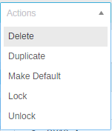

Click on the **Duplicate** button and entry screen will appear with a copy of the profile information.

To create the duplicate **Profile** simply enter a new reference and click on **Save** or **Save and Add Another**

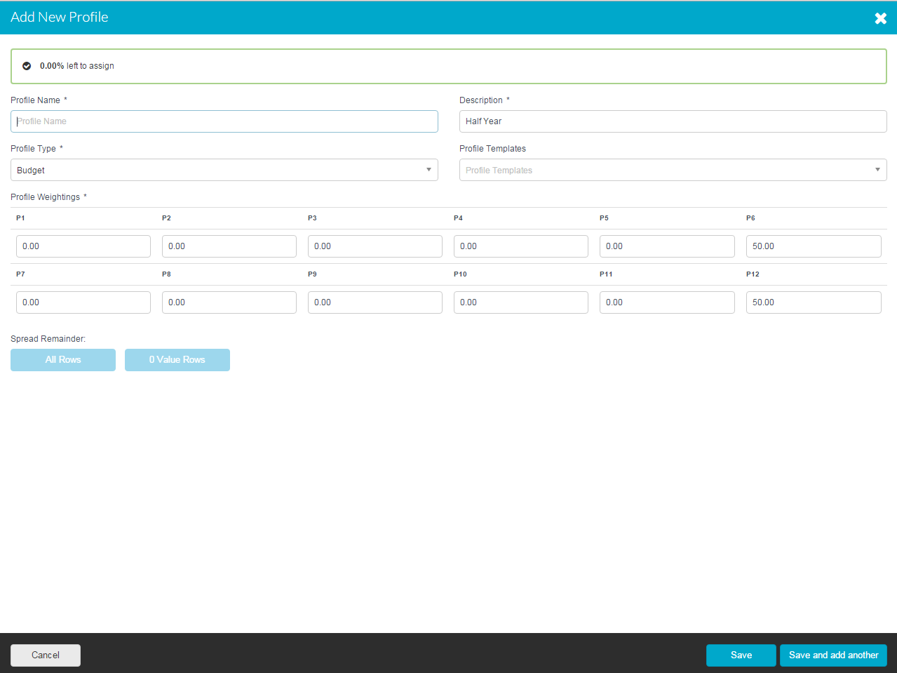

## Delete a Profile

To **delete** **profile,** click in the tick box next to the profile. . At the top of the screen is an actions button



Click on the **Delete** button a message will appear asking you to confirm your action

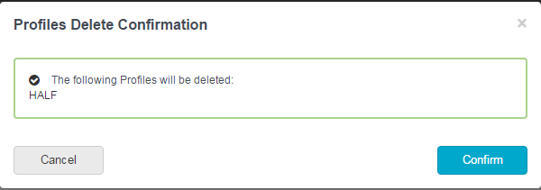

It is possible to delete more than one Profile at a time by clicking in the tick box next to the profiles you wish to delete.

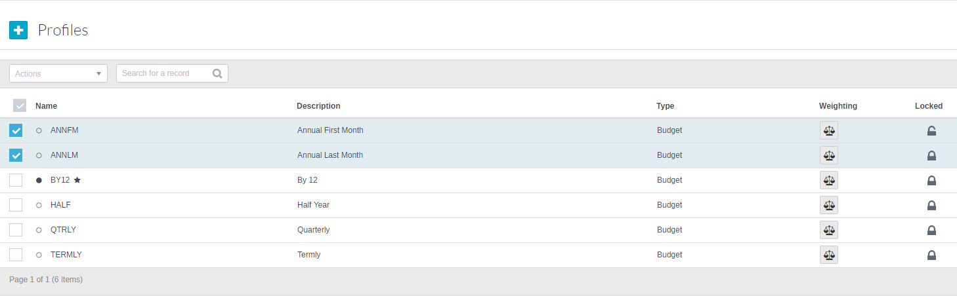

It is not possible to delete a **profile** if budgets are against it however it is possible to **Lock** a **Profile** which would stop them appearing in any selection lists

## Search on Profiles

Above the grid list of profiles is a search box. Typing into this box will search on all the fields and bring back a list of analysis codes which match the criteria entered.

Simply clicking on the column headers in the grid will sort them in ascending or descending order for scrolling through to search.

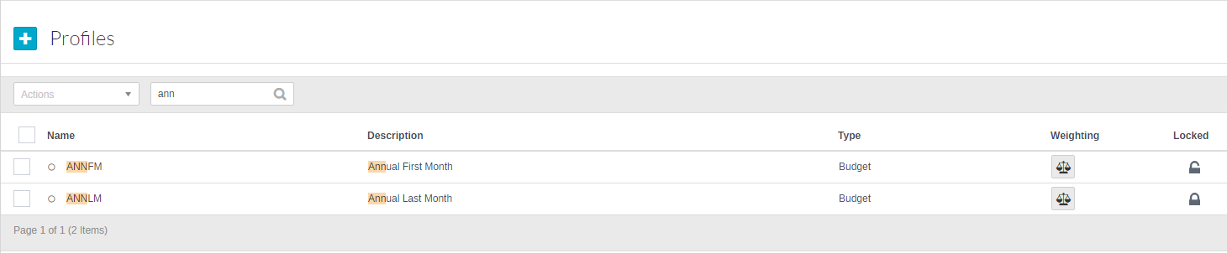

## Virements

Virements allows the Finance Manager to move a budget amount from one budget to another.

To create a Virement click on **Budgets** and **Virements**



The following screen will open

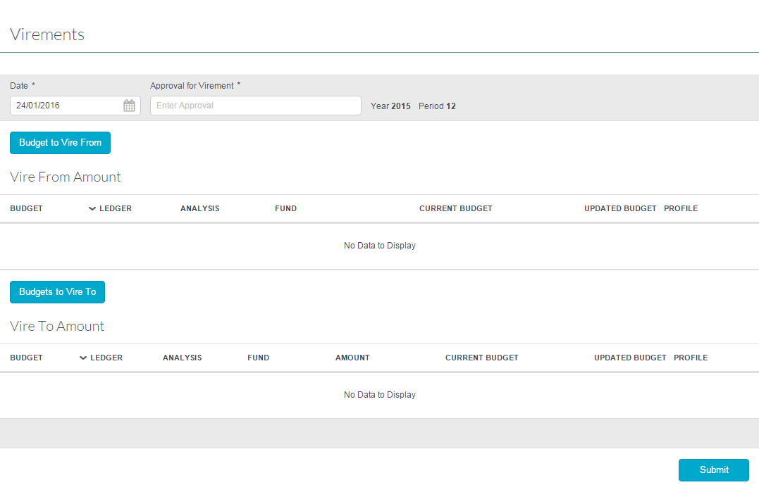

Enter the date and an **Approval for Virement** reason

Click on  to select the budget to **Vire From** (only codes that have budgets against them will appear)

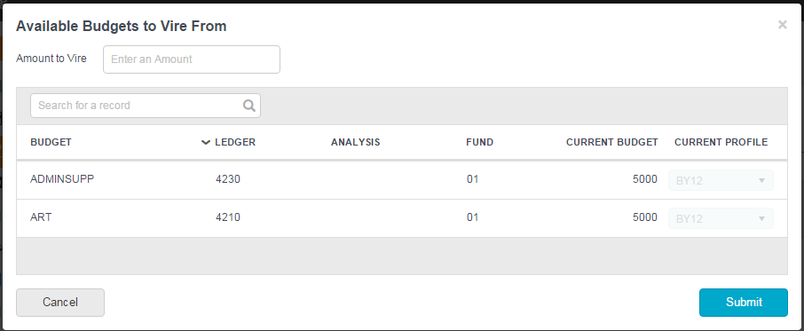

Enter the Amount to Vire and select a budget to vire the amount from.

Click on **Submit**

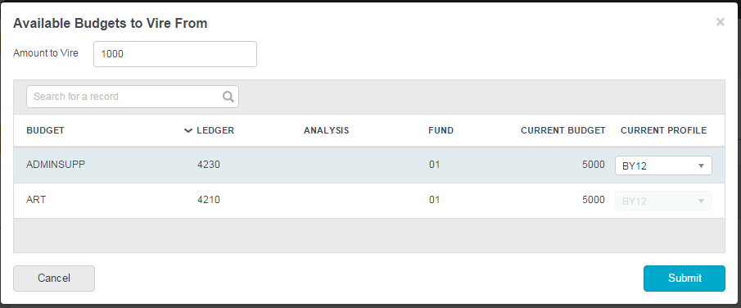

Click on  to select the budget to **Vire To** (all budget/ledger code combinations will appear)

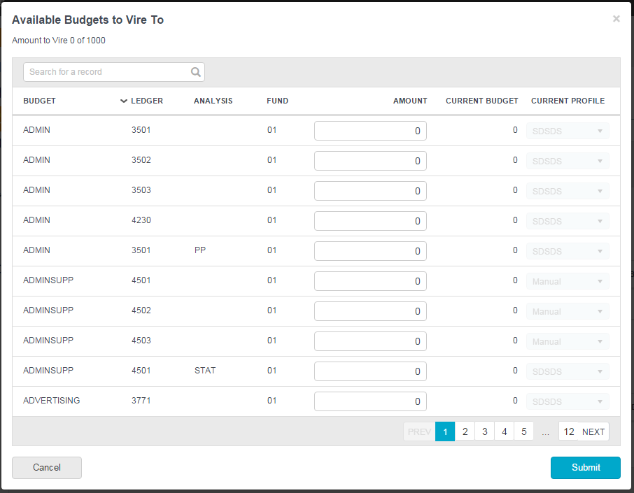

The amount can be split over several budgets but must equal the total to be vired before it can be submitted.

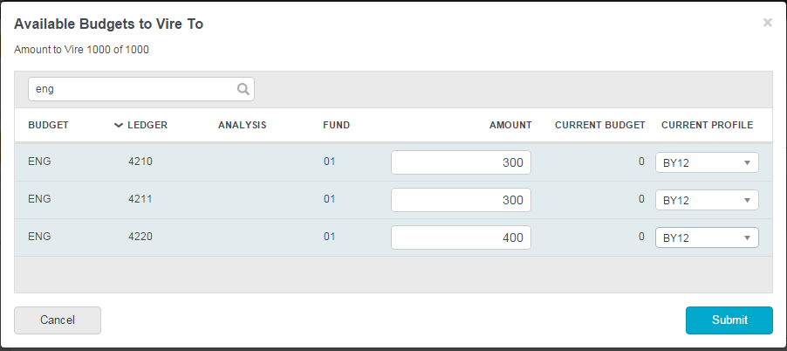

Select the relevant profile to be used for the budget and click on **Submit**

To post the changes click on **Submit**

The budget will be re-profiled automatically; you will be asked if you wish to view it.

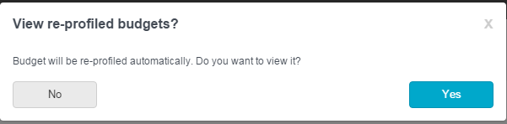

Select Yes or No

# Link to HCSS Budgeting

Go to **System Set Up > Establishment**

Put a tick in Link to HCSS Budgeting followed by Save

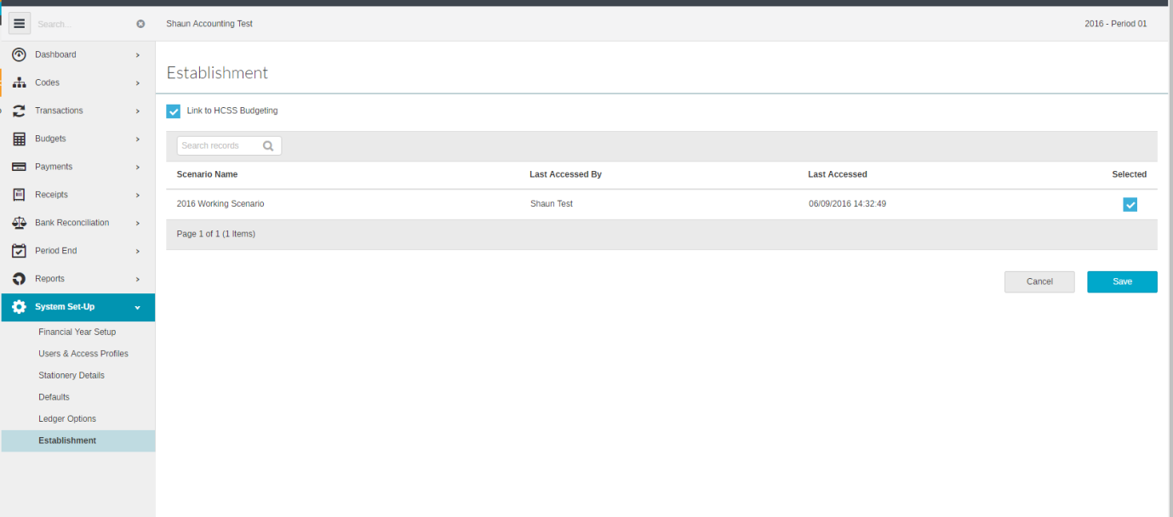

The link is now initiated so you can launch Budgeting and then from the menu go to **Setup Coding**, click on the tab called **“Import Account Codes”** pressing the update button will show you a confirmation message which will tell you how many codes will be imported/removed etc.

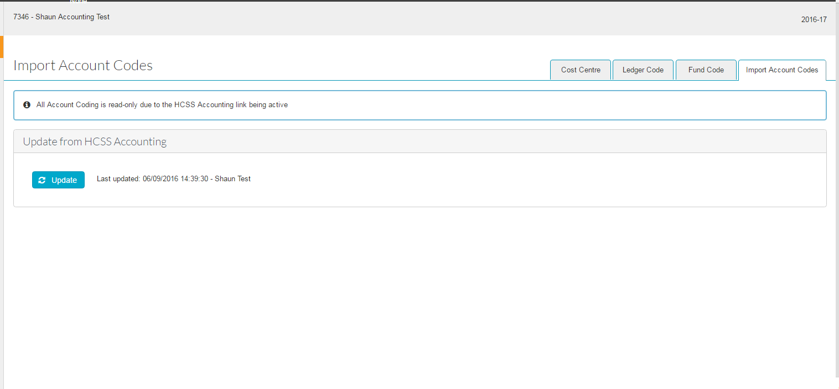

You codes should have now imported so you can assign them to various lines in a scenario.  Once you are happy and want to export the data from Budgeting to Accounting, you need to launch Accounting, got to **Budgets > Manage Budgets** and press the **“Update from HCSS Budgeting”** button.

