HCSS Accounting

User Manual

Bank Reconciliation

Contents
1 Bank Reconciliation 3
a Manual Reconciliation 3
b Undo Reconciliation 6

Bank Reconciliation

Manual Reconciliation

Manual reconciliation is under Bank Reconciliation and Manual Reconciliation

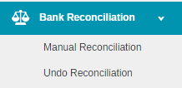

The following screen will appear

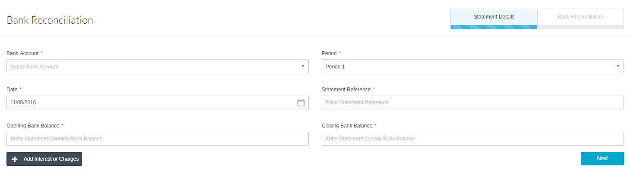

Enter the relevant information. Mandatory Fields are denoted with an *

Current Bank Account | This defaults to the current account but can be changed to other accounts.
Period | Enter the period
Date | Enter the date of the reconciliation
Statement Reference | Enter the statement reference from the original document  Second time of use the Statement Reference will be prepopulated with the last statement number + 1
Opening Bank Balance | This defaults in from the previous bank reconciliation  The first time the Bank Reconciliation is used the opening bank balance from the bank statement must be entered
Closing Bank Balance | Enter the closing balance on the bank statement
Nett or Gross Radio Button | For Centrally Funded Schools the Central Fund Bank must be set to Nett

Click on to add Bank Interest and Charges

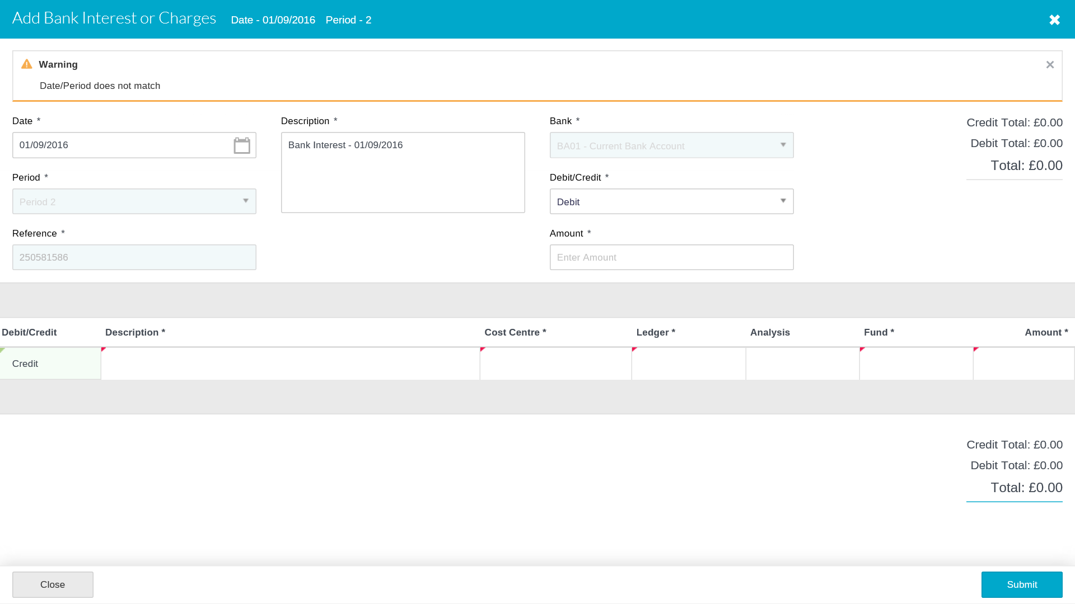
Interest and Charges (same fields for both areas)

Date | Enter in the date for the interest/charge was applied
Amount | Enter the amount of the interest or charge
Debit/Credit | Select Debit in the header and Credit in the detail Line for Bank Interest  Select Credit in the header and Debit in the detail Line for Bank Charges
Cost Centre | Enter the code from the pick list
Ledger | Enter the code from the pick list
Analysis | Enter the code from the pick list
Fund | Enter the code from the pick list

Click on Submit.

Once the Interest or Charges have been submitted they are can only be cancelled by reversing the transaction. Cancelling the Bank Reconciliation will NOT cancel the transaction.

Or click on to move to the Bank Reconciliation screen

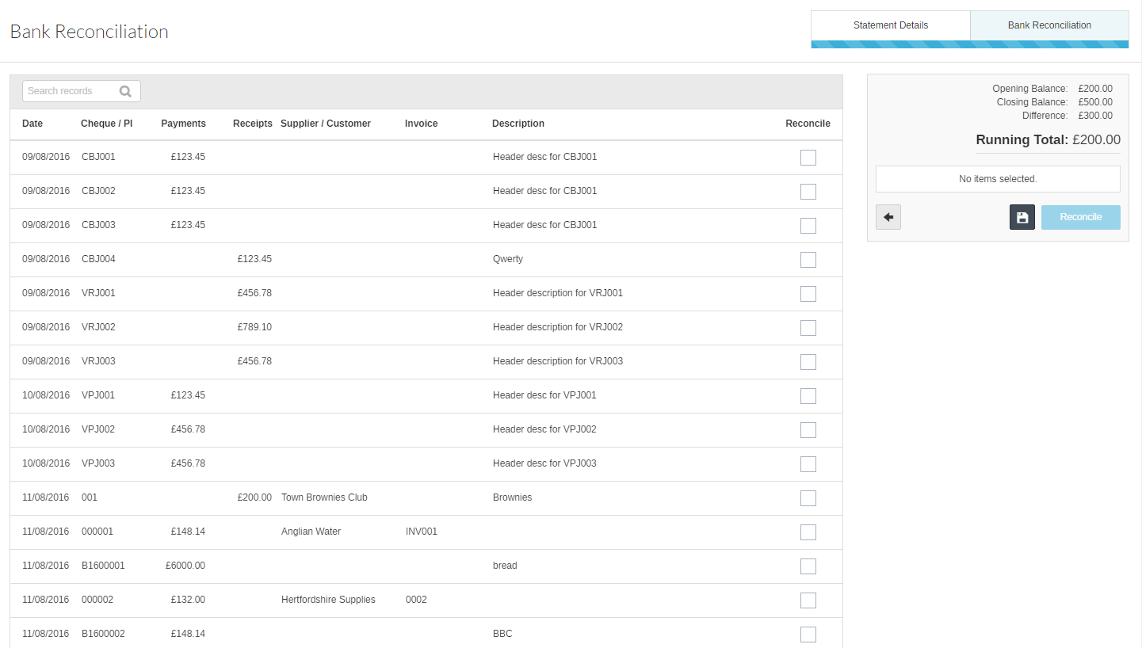

Pick the items that match with your bank statement. The Running Total will adjust to match your Bank Statement balance

There is a back button in each stage of the process if you need to go back at any point for corrections or updates.

Once the Running Total agrees with your Bank Statement Closing Balance click on Reconcile

The receonciliation can be saved at any point by clicking on Save. This will not reconcile the transactions but lock them from being selected on a different Bank Reconciliation.

To enter a saved reconciliation

Click on Manual Reconciliation and select the same bank

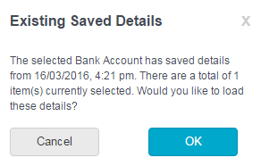

Selecting OK will bring up the Saved reconciliation details

Undo Reconciliation

To undo reconciliation got to Bank Reconciliation and Undo Reconciliation

The following screen will appear:

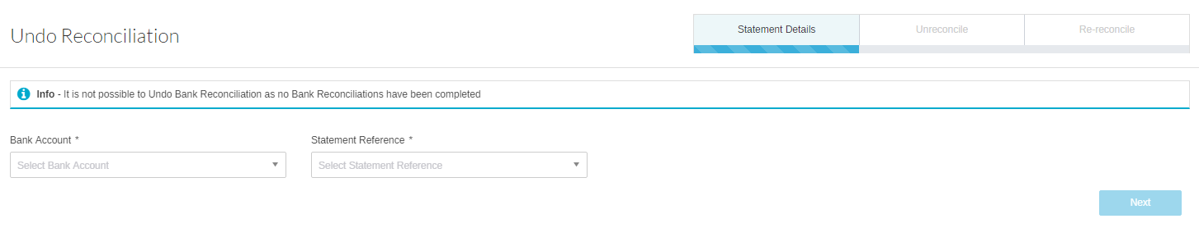

Enter the relevant information. Mandatory Fields are denoted with an *

Bank Account * | Select the Bank Account from the drop down list.
Statement Reference | Please select the statement no form the list.

Then click on Next.

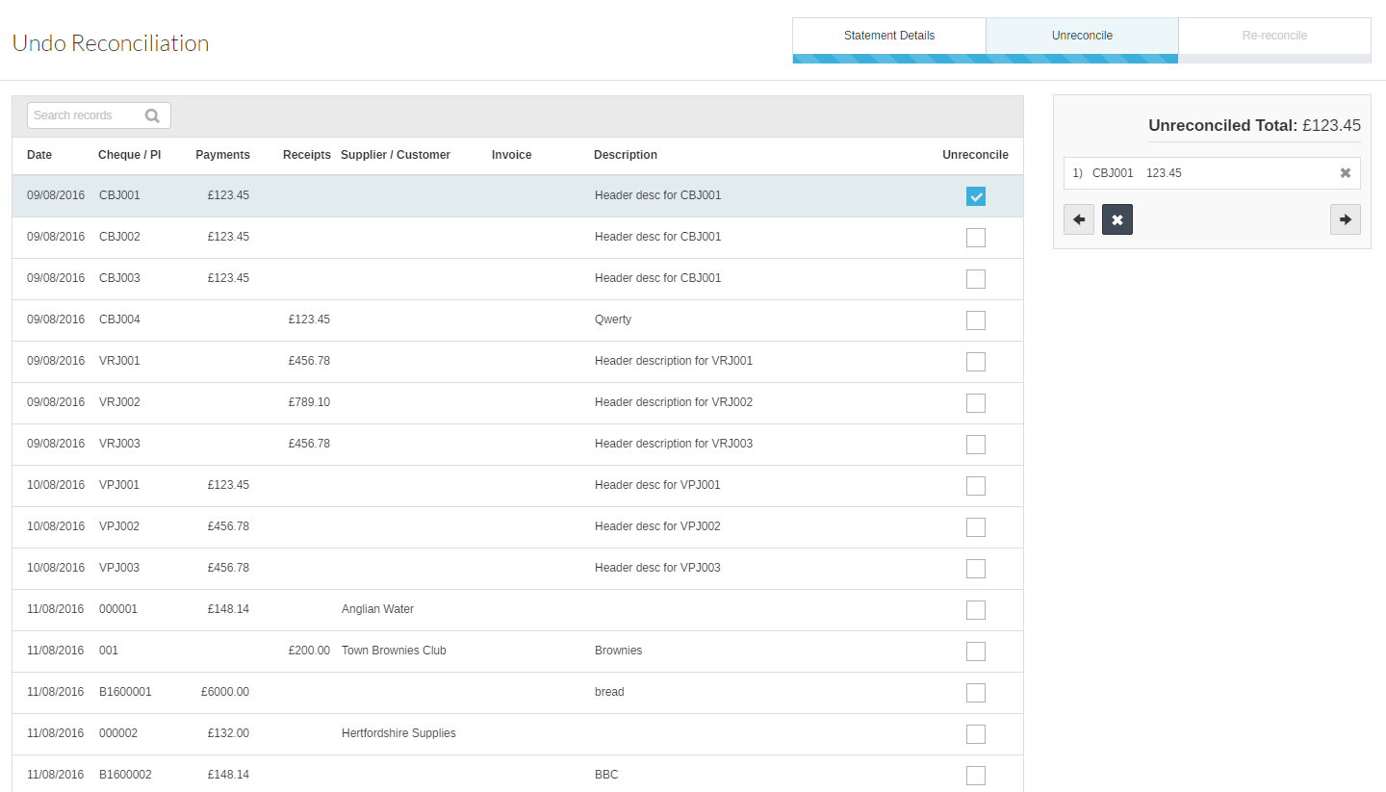

Pick the items you want to unreconcile. The Unreconciled Total will adjust to match your selection. Then click on Next. again.

In the following screen you will have to select alternate transcation(s) to be reconciled. These MUST match the total of the items unreconciled before they can be submitted.

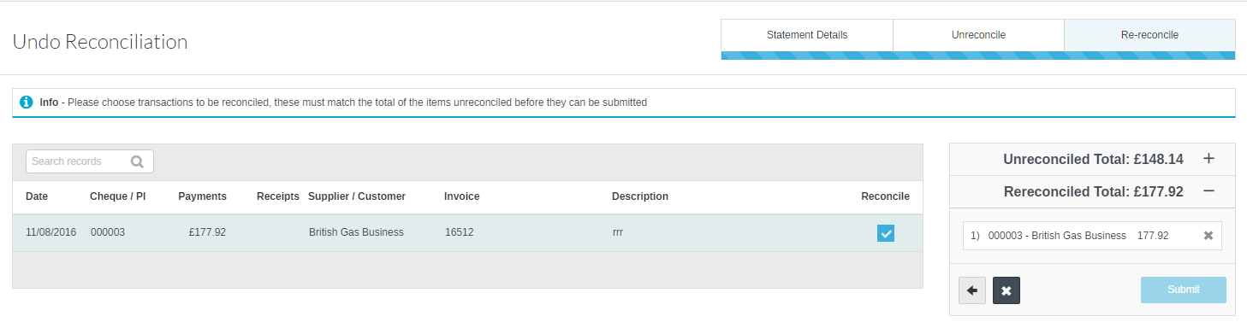

If the totals do not match, the submit button will not be avaliable.

There is a back button in each stage of the process if you need to go back at any point for corrections or updates.

Once submitted a confirmation message will show up.
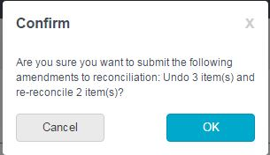

Selecting OK will undo reconciliation and a success message will appear to confirm this.

